**REVISING QUESTIONS**

**236: Shortest path in binary matrix**

Given an n x n binary matrix grid, return *the length of the shortest****clear path****in the matrix*. If there is no clear path, return -1.

A **clear path** in a binary matrix is a path from the **top-left** cell (i.e., (0, 0)) to the **bottom-right** cell (i.e., (n - 1, n - 1)) such that:

* All the visited cells of the path are 0.
* All the adjacent cells of the path are **8-directionally** connected (i.e., they are different and they share an edge or a corner).

The **length of a clear path** is the number of visited cells of this path.

**Example 1:**

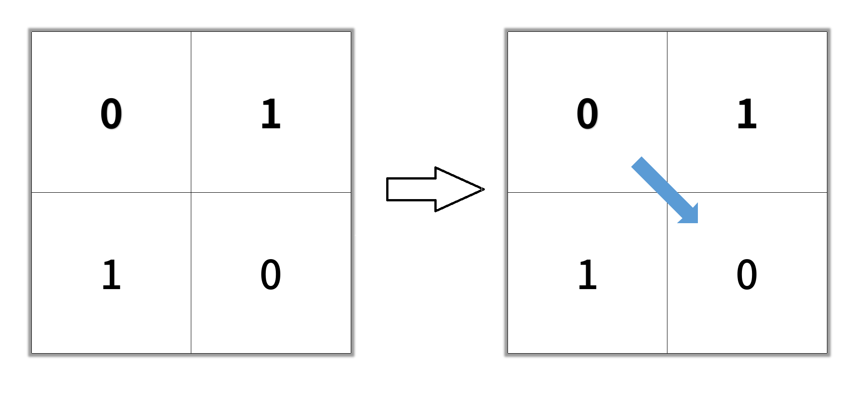

**Input:** grid = [[0,1], [1,0]]

**Output:** 2

**Example 2:**

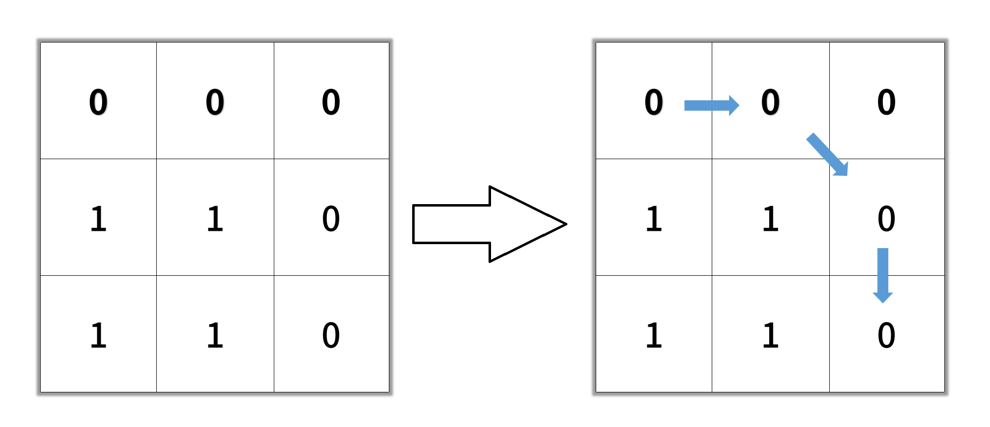

**Input:** grid = [[0,0,0], [ 1,1,0], [1,1,0]]

**Output:** 4

**Example 3:**

**Input:** grid = [[1,0,0], [1,1,0], [ 1,1,0]]

**Output:** -1

**Solution using bfs**

class Solution {

public:

        int shortestPathBinaryMatrix(vector<vector<int>>& grid) {

        int res = 1;

        int row = grid.size();

        if (row == 0) return -1;

        int col = grid[0].size();

        if (col == 0 ) return -1;

        if (grid[0][0] != 0 | grid[row-1][col-1] != 0) return -1;

        queue<pair<int, int>> queue;

        queue.push(make_pair(0,0)); //forming pair of row and column

        vector<vector<int>> directions = {{1,1}, {0,1},{1,0},{0,-1},{-1,0},{-1, -1},{1, -1},{-1, 1}};

        grid[0][0] = 1; //mark visited

        while(!queue.empty()){

            auto curr = queue.front();

            int x = curr.first, y = curr.second;

            if( x == row -1 && y == col -1) return grid[x][y];

            for(auto direction : directions){

                int nx = x + direction[0];

                int ny = y + direction[1];

                if(nx >= 0 && nx < row && ny >= 0 && ny < col && grid[nx][ny] == 0){

                    queue.push(make_pair(nx,ny));

                    grid[nx][ny] = grid[x][y] + 1;

                }

            }

            queue.pop();

        }

        return -1;

    }

};

**237: Time needed to inform all employees**

A company has n employees with a unique ID for each employee from 0 to n - 1. The head of the company is the one with headID.

Each employee has one direct manager given in the manager array where manager[i] is the direct manager of the i-th employee, manager[headID] = -1. Also, it is guaranteed that the subordination relationships have a tree structure.

The head of the company wants to inform all the company employees of an urgent piece of news. He will inform his direct subordinates, and they will inform their subordinates, and so on until all employees know about the urgent news.

The i-th employee needs informTime[i] minutes to inform all of his direct subordinates (i.e., After informTime[i] minutes, all his direct subordinates can start spreading the news).

Return *the number of minutes* needed to inform all the employees about the urgent news.

**Example 1:**

**Input:** n = 1, headID = 0, manager = [-1], informTime = [0]

**Output:** 0

**Explanation:** The head of the company is the only employee in the company.

**Example 2:**

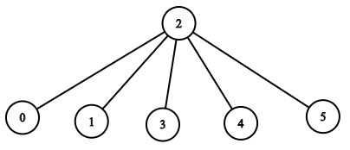

**Input:** n = 6, headID = 2, manager = [2,2,-1,2,2,2], informTime = [0,0,1,0,0,0]

**Output:** 1

**Explanation:** The head of the company with id = 2 is the direct manager of all the employees in the company and needs 1 minute to inform them all.

The tree structure of the employees in the company is shown.

**Sol1: using dfs (the graph will be directed as only manager can contact their employee not employee can contact)**

class Solution {

public:

    int maxi=0;

    int dfs(unordered_map<int,vector<int>>&adj,vector<int>& informTime,int curr_empl,int curr_time){

        maxi=max(maxi,curr_time);

        for(auto &v:adj[curr_empl]){

            dfs(adj,informTime,v,curr_time+informTime[curr_empl]);

        }

        return maxi;

    }

    int numOfMinutes(int n, int headID, vector<int>& manager, vector<int>& informTime) {

        unordered_map<int,vector<int>>adj;

        for(int i=0;i<manager.size();i++){

            if(manager[i]!=-1){

                adj[manager[i]].push_back(i); //mapping manager[i]--->employee_i

            }

        }

        return dfs(adj,informTime,headID,0);

    }

};

**Sol2 : using bfs**

class Solution {

public:

    int maxi=0;

    int bfs(unordered_map<int,vector<int>>&adj,vector<int>& informTime,int headID){

        queue<pair<int,int>>q;

        q.push({headID,0}); //employ,time

        while(!q.empty()){

            pair<int,int>temp=q.front();

            q.pop();

            int curr_empl=temp.first;

            int curr_time=temp.second;

            maxi=max(maxi,curr_time);

            for(auto &v:adj[curr_empl]){

                q.push({v,curr_time+informTime[curr_empl]});

            }

        }

        return maxi;

    }

    int numOfMinutes(int n, int headID, vector<int>& manager, vector<int>& informTime) {

        unordered_map<int,vector<int>>adj;

        for(int i=0;i<manager.size();i++){

            if(manager[i]!=-1){

                adj[manager[i]].push_back(i); //mapping manager[i]--->employee_i

            }

        }

        return bfs(adj,informTime,headID);

    }

};

**238: Number of provinces**

There are n cities. Some of them are connected, while some are not. If city a is connected directly with city b, and city b is connected directly with city c, then city a is connected indirectly with city c.

A **province** is a group of directly or indirectly connected cities and no other cities outside of the group.

You are given an n x n matrix isConnected where isConnected[i][j] = 1 if the ith city and the jth city are directly connected, and isConnected[i][j] = 0 otherwise.

Return *the total number of****provinces***.

**Example 1:**

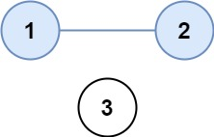

**Input:** isConnected = [[1,1,0],[1,1,0],[0,0,1]]

**Output:** 2

**Example 2:**

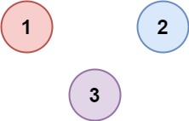

**Input:** isConnected = [[1,0,0],[0,1,0],[0,0,1]]

**Output:** 3

**Sol1 : using dfs**

class Solution {

public:

    int n;

    void dfs(vector<bool>&visited,unordered_map<int,vector<int>>&adj,int i){

        visited[i]=true;

        for(auto &v:adj[i]){

            if(visited[v]==false){

                dfs(visited,adj,v);

            }

        }

    }

    int findCircleNum(vector<vector<int>>& isConnected) {

        unordered_map<int,vector<int>>adj;

        n=isConnected.size();

        for(int i=0;i<n;i++){

            for(int j=0;j<n;j++){

                if(isConnected[i][j]==1){

                    adj[i].push_back(j);

                    adj[j].push_back(i);

                }

            }

        }

        vector<bool>visited(n,false);

        int count=0;

        for(int i=0;i<n;i++){

            if(visited[i]==false){

                dfs(visited,adj,i);

                count++;

            }

        }

        return count;

    }

};

**Sol2 : using bfs**

class Solution {

public:

    int n;

    void bfs(vector<bool>&visited,unordered_map<int,vector<int>>&adj,int i){

        queue<int>q;

        q.push(i);

        visited[i]=true;

        while(!q.empty()){

            int x=q.front();

            q.pop();

            for(auto &v:adj[x]){

                if(visited[v]==false){

                    //q.push(v);

                    bfs(visited,adj,v);

                }

            }

        }

    }

    int findCircleNum(vector<vector<int>>& isConnected) {

        unordered_map<int,vector<int>>adj;

        n=isConnected.size();

        for(int i=0;i<n;i++){

            for(int j=0;j<n;j++){

                if(isConnected[i][j]==1){

                    adj[i].push_back(j);

                    adj[j].push_back(i);

                }

            }

        }

        vector<bool>visited(n,false);

        int count=0;

        for(int i=0;i<n;i++){

            if(visited[i]==false){

                bfs(visited,adj,i);

                count++;

            }

        }

        return count;

    }

};

**239: Minimum flips to make a OR b equals to c**

It’s a question of bit manipulation , things to remember while solving this question is :

**1:** To find the rightmost bit , we will do (num&1) eg:

Num=1001 🡪 num&1 🡪

1001

0001 , we will get 0001, therefore rightmost bit is 1.

**2:** To find the right shift of num:

Eg: 1001’s right shift by 1 is 0100 (num>>1), we generally do this when we have performed work on right bit and move forward then we do right shift.

Given 3 positives numbers a, b and c. Return the minimum flips required in some bits of a and b to make ( a OR b == c ). (bitwise OR operation).  
Flip operation consists of change **any** single bit 1 to 0 or change the bit 0 to 1 in their binary representation.

**Example 1:**

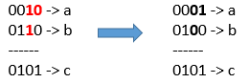

**Input:** a = 2, b = 6, c = 5

**Output:** 3

**Explanation:** After flips a = 1 , b = 4 , c = 5 such that (a OR b == c)

**Example 2:**

**Input:** a = 4, b = 2, c = 7

**Output:** 1

**Example 3:**

**Input:** a = 1, b = 2, c = 3

**Output:** 0

**Sol1: using bit wise comparing**

class Solution {

public:

    int minFlips(int a, int b, int c) {

        int flips=0;

        while(a!=0 || b!=0 || c!=0){

            if((c&1)==1){ // if rightmost bit is 1

                if((a&1)==0 && (b&1)==0){

                    flips++;

                }

            }

            else if((c&1)==0){

                if((a&1)==1){

                    flips++;

                }

                if((b&1)==1){

                    flips++;

                }

            }

            //right shift

            a>>=1; //a=a>>1;

            b>>=1;

            c>>=1;

        }

        return flips;

    }

};

**Sol2: using xor and __builtin_popcount**

class Solution {

public:

    int minFlips(int a, int b, int c) {

        int temp=((a|b)^c);

        return __builtin_popcount(temp) + __builtin_popcount(temp&(a&b));

    }

};

**__builtin_popcount(num): count the no of set bits or 1 num when represented in binary form**

**240: Sum of matrix after queries**

You are given an integer n and a **0-indexed** **2D array** queries where queries[i] = [typei, indexi, vali].

Initially, there is a **0-indexed** n x n matrix filled with 0's. For each query, you must apply one of the following changes:

* if typei == 0, set the values in the row with indexi to vali, overwriting any previous values.
* if typei == 1, set the values in the column with indexi to vali, overwriting any previous values.

Return *the sum of integers in the matrix after all queries are applied*.

**Example 1:**

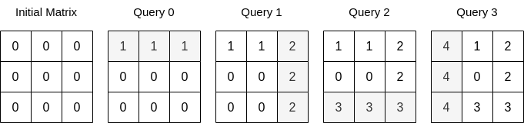

**Input:** n = 3, queries = [[0,0,1],[1,2,2],[0,2,3],[1,0,4]]

**Output:** 23

**Explanation:** The image above describes the matrix after each query. The sum of the matrix after all queries are applied is 23.

**Example 2:**

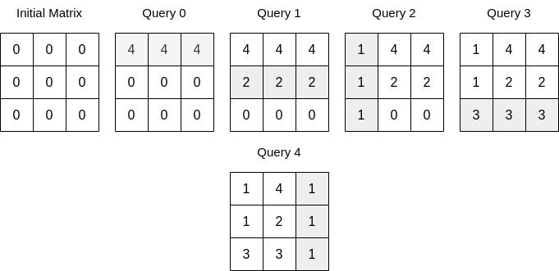

**Input:** n = 3, queries = [[0,0,4],[0,1,2],[1,0,1],[0,2,3],[1,2,1]]

**Output:** 17

**Explanation:** The image above describes the matrix after each query. The sum of the matrix after all queries are applied is 17.

**Sol1 : Brute force: (tle)**

class Solution {

public:

    typedef long long ll;

    long long matrixSumQueries(int n, vector<vector<int>>& queries) {

        vector<vector<ll>>mat(n,vector<ll>(n,0));

        for(int i=0;i<queries.size();i++){

            ll x=queries[i][0], y=queries[i][1],z=queries[i][2];

            if(x==0){

                for(int j=0;j<n;j++){

                    mat[y][j]=z;

                }

            }

            else if(x==1){

                for(int i=0;i<n;i++){

                    mat[i][y]=z;

                }

            }

        }

        ll total =0;

        for(int i=0;i<n;i++){

            for(int j=0;j<n;j++){

                total+=mat[i][j];

            }

        }

        return total;

    }

};

**Sol2: Learn the solution**

class Solution {

public:

        long long matrixSumQueries(int n, vector<vector<int>>& q) {

        vector<bool> rowFlag(n, 1), colFlag(n, 1);

        long long ans = 0, rowRemain = n, colRemain = n;

        for(int i = q.size()-1; i >= 0; --i){

            if(q[i][0] == 0 && rowFlag[q[i][1]]) {

                ans += colRemain * q[i][2];

                 rowFlag[q[i][1]] = 0;

                 rowRemain--; }

            if(q[i][0] == 1 && colFlag[q[i][1]]) {

                ans += rowRemain * q[i][2];

                 colFlag[q[i][1]] = 0;

                 colRemain--; }

        }

        return ans;

    }

};

**241: Maximum sum BST in binary tree**

This question is of type like largest size in binary tree which is noted and solved from binary tree playlist from striver , we can also solve this question using that concept , just replacing 1 with root->val , as in this question we need to find maxsum of nodes , but using that concept we are getting wrong answer for -ve values of nodes , therefore we do this approach . this approach is also very similar to what we have noted from striver’s binary tree

Given a **binary tree** root, return *the maximum sum of all keys of****any****sub-tree which is also a Binary Search Tree (BST)*.

Assume a BST is defined as follows:

* The left subtree of a node contains only nodes with keys **less than** the node's key.
* The right subtree of a node contains only nodes with keys **greater than** the node's key.
* Both the left and right subtrees must also be binary search trees.

**Example 1:**

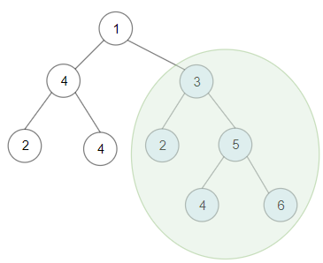

**Input:** root = [1,4,3,2,4,2,5,null,null,null,null,null,null,4,6]

**Output:** 20

**Explanation:** Maximum sum in a valid Binary search tree is obtained in root node with key equal to 3.

**Example 2:**

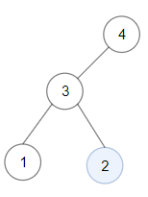

**Input:** root = [4,3,null,1,2]

**Output:** 2

**Explanation:** Maximum sum in a valid Binary search tree is obtained in a single root node with key equal to 2.

**Example 3:**

**Input:** root = [-4,-2,-5]

**Output:** 0

**Explanation:** All values are negatives. Return an empty BST.

int ans;

class Node {

public:

    bool bst;       // to check if tree is bst

    int maxi;       // max value in a tree

    int mini;       // min value in a tree

    int max_sum;    // current maximum sum

    Node() {

        bst = true;

        maxi = INT_MIN;

        mini = INT_MAX;

        max_sum = 0;

    }

};

class Solution {

public:

    Node calcSum(TreeNode* root){

        if (root == NULL){

            return Node();

        }

        Node temp;

        Node left = calcSum(root->left);   // recursive call for left sub-tree

        Node right = calcSum(root->right); // recursive call for right sub-tree

        // if sub-tree including this node is bst

        if (left.bst == true && right.bst == true && root->val > left.maxi && root->val < right.mini){

            temp.bst = true;                               // current tree is a bst

            temp.max_sum = left.max_sum + right.max_sum + root->val;

            temp.mini = min(root->val, left.mini);

            temp.maxi = max(root->val, right.maxi);

        }

        // if current tree is not a bst

        else {

            temp.bst = false;

            temp.max_sum = max(left.max_sum, right.max_sum);

        }

        ans = max(ans, temp.max_sum);

        return temp;

    }

    int maxSumBST(TreeNode* root){

        ans = 0;

        calcSum(root);

        return ans;

    }

};

**242: Maximum value at a given index in a bounded array**

**Intuition and explanation is below the code, first see the intuition and expl..**

You are given three positive integers: n, index, and maxSum. You want to construct an array nums (**0-indexed**)that satisfies the following conditions:

* nums.length == n
* nums[i] is a **positive** integer where 0 <= i < n.
* abs(nums[i] - nums[i+1]) <= 1 where 0 <= i < n-1.
* The sum of all the elements of nums does not exceed maxSum.
* nums[index] is **maximized**.

Return nums[index]*of the constructed array*.

Note that abs(x) equals x if x >= 0, and -x otherwise.

**Example 1:**

**Input:** n = 4, index = 2, maxSum = 6

**Output:** 2

**Explanation:** nums = [1,2,**2**,1] is one array that satisfies all the conditions.

There are no arrays that satisfy all the conditions and have nums[2] == 3, so 2 is the maximum nums[2].

**Example 2:**

**Input:** n = 6, index = 1, maxSum = 10

**Output:** 3

**Constraints:**

* 1 <= n <= maxSum <= 10^9
* 0 <= index < n
* //Using Binary Search
* class Solution {
* public:
* typedef long long ll;
* ll getSumElements(ll count, ll val) {
* return val*count - (count*(count+1))/2;
* }
* int maxValue(int n, int index, int maxSum) {
* ll left  = 1;
* ll right = maxSum;
* ll mid_val;
* int result = 0;

* while(left <= right) {
* mid_val = left + (right - left)/2;
* //.....leftsum......
* ll left_count = min((ll)index, mid_val-1);
* ll left_sum  = getSumElements(left_count, mid_val);
* left_sum += max((ll)0, index - (mid_val-1)); //extra ones if any
* //.........rightsum..........
* ll right_count = min((ll)n-index-1, mid_val-1);
* ll right_sum  = getSumElements(right_count, mid_val);
* right_sum += max((ll)0, n-index-1 – (mid_val-1));

* //calculation................
* if(left_sum + right_sum + mid_val <= maxSum) {
* result = max((ll)result, mid_val);
* left = mid_val+1;
* } else {
* right = mid_val-1;
* }
* }

* return result;
* }
* };

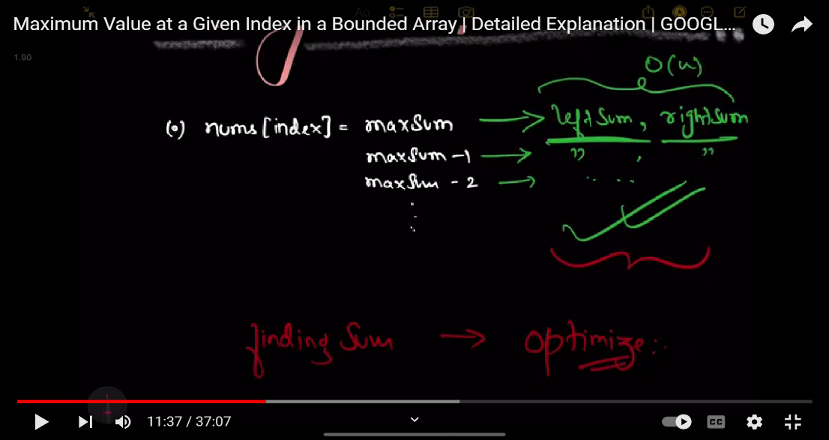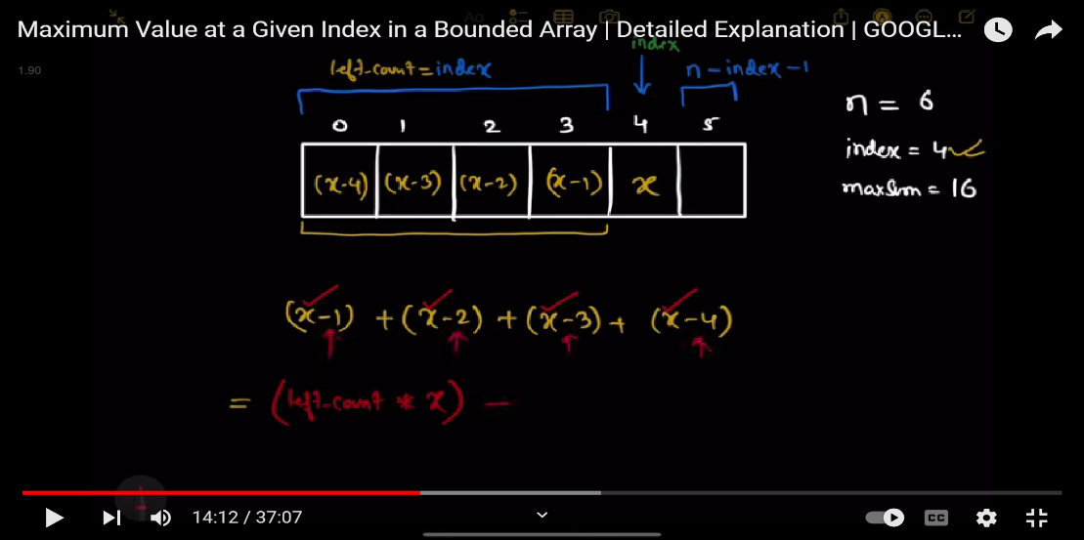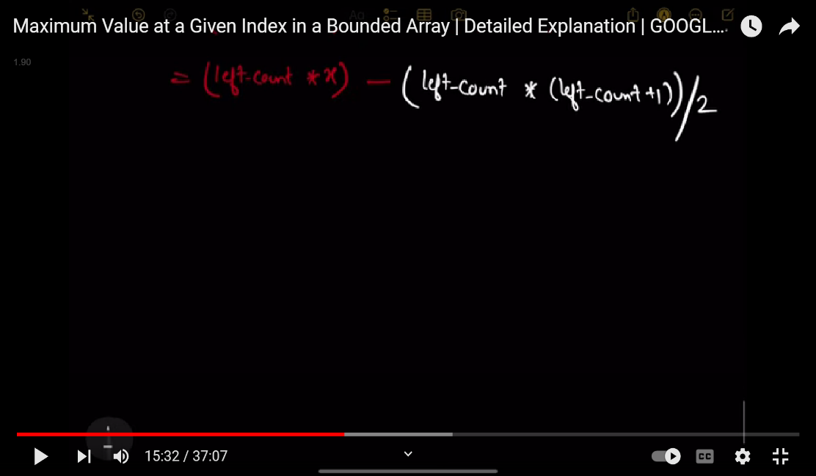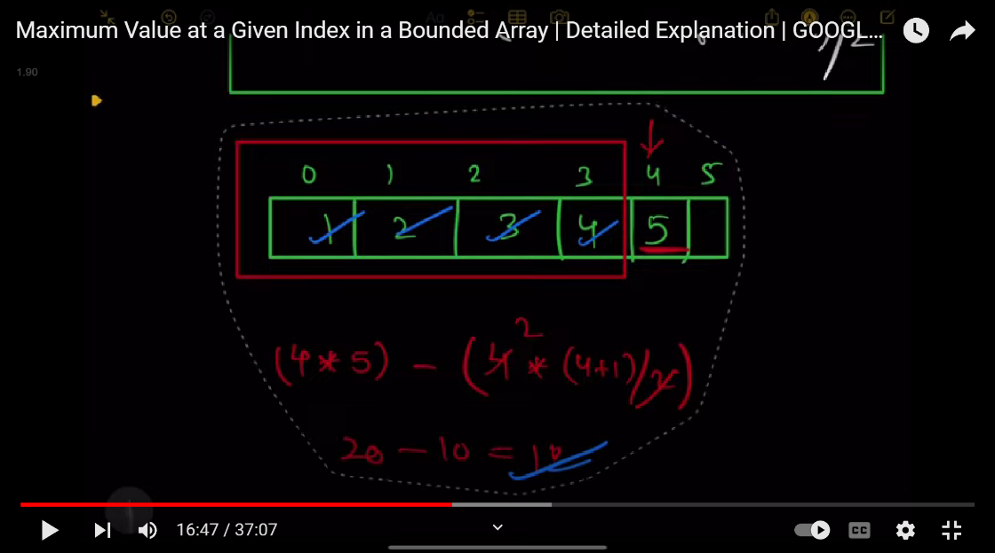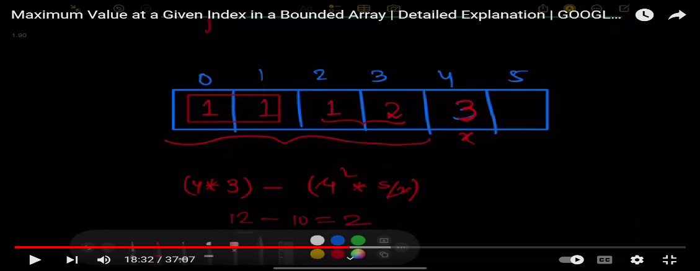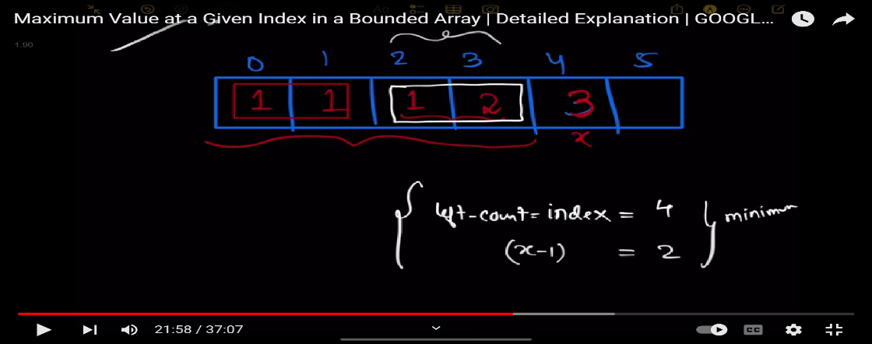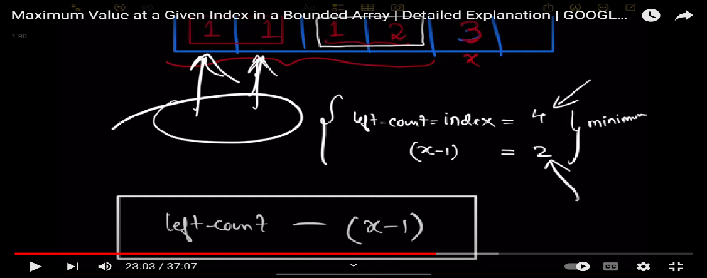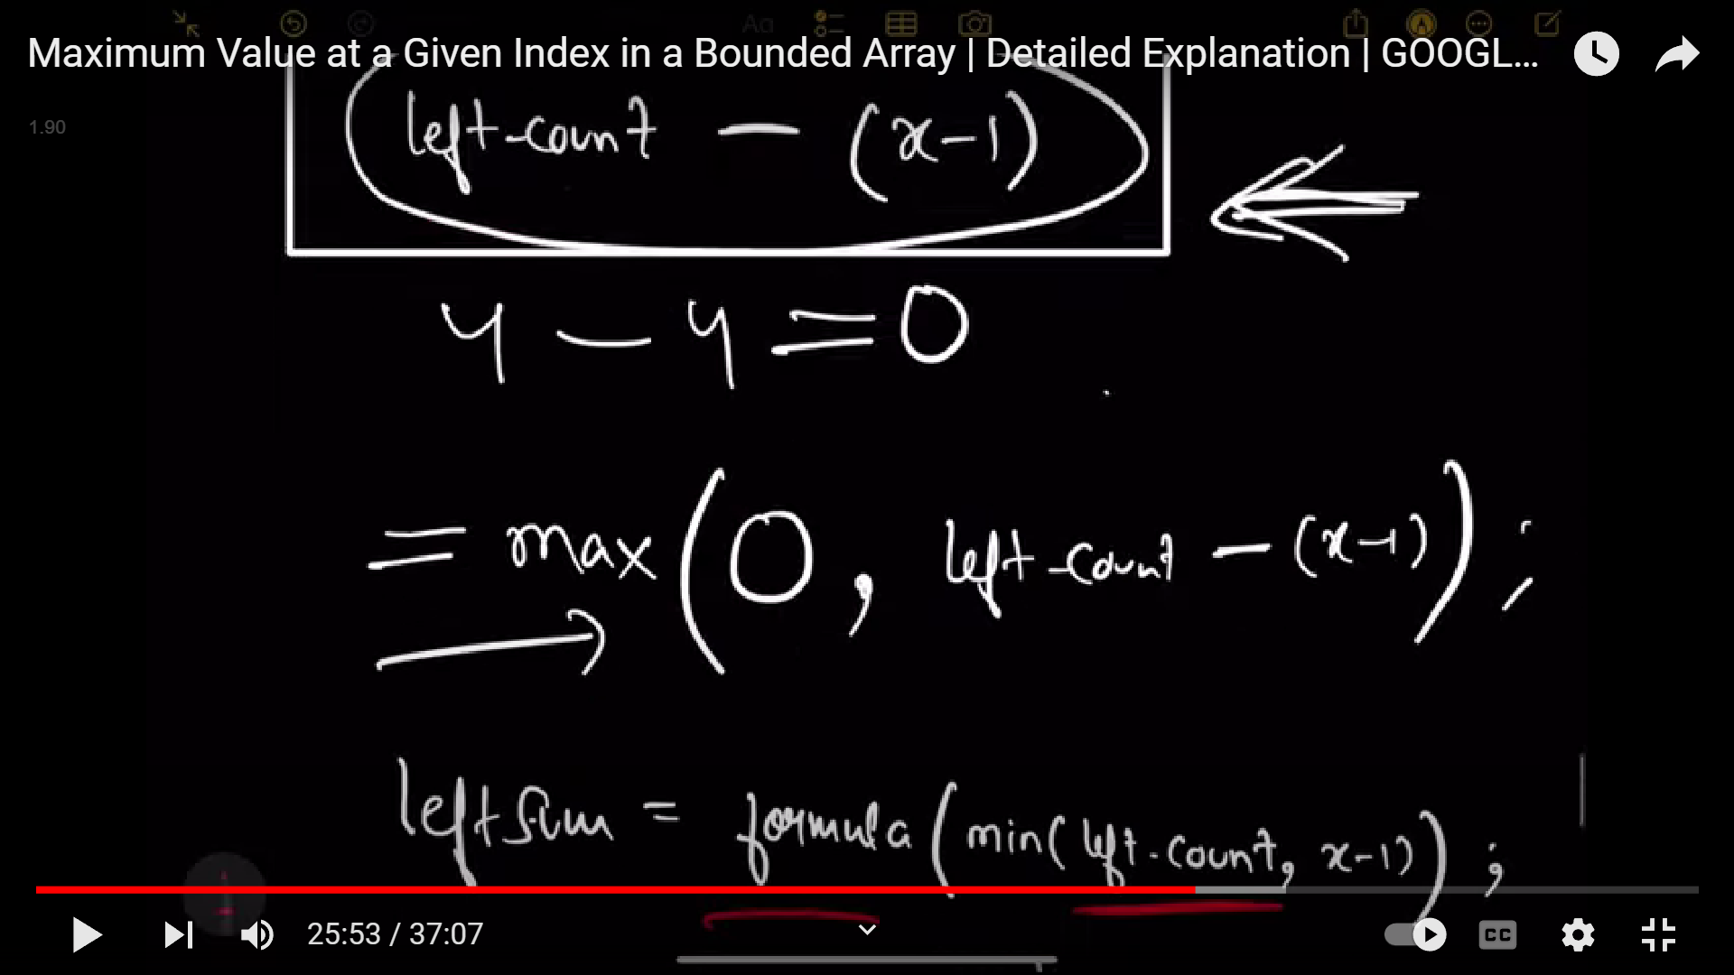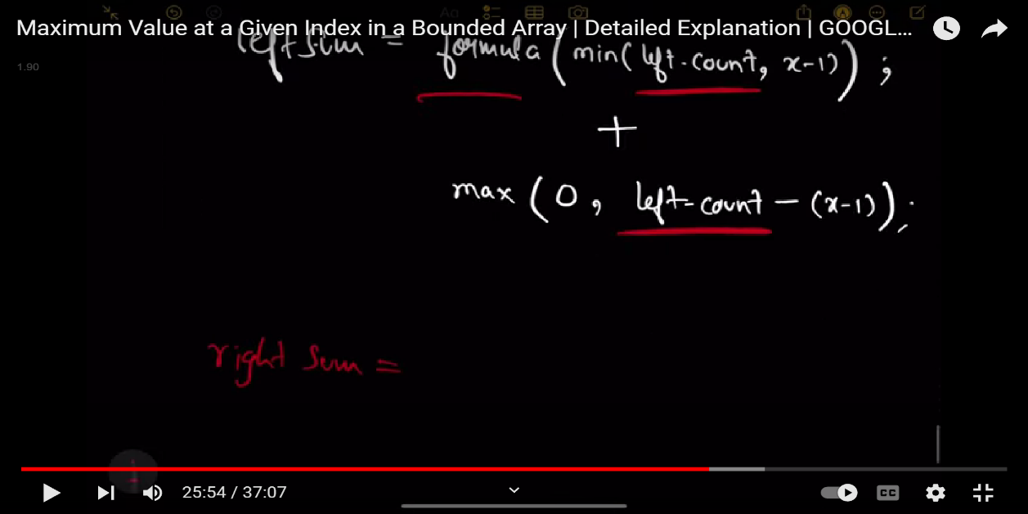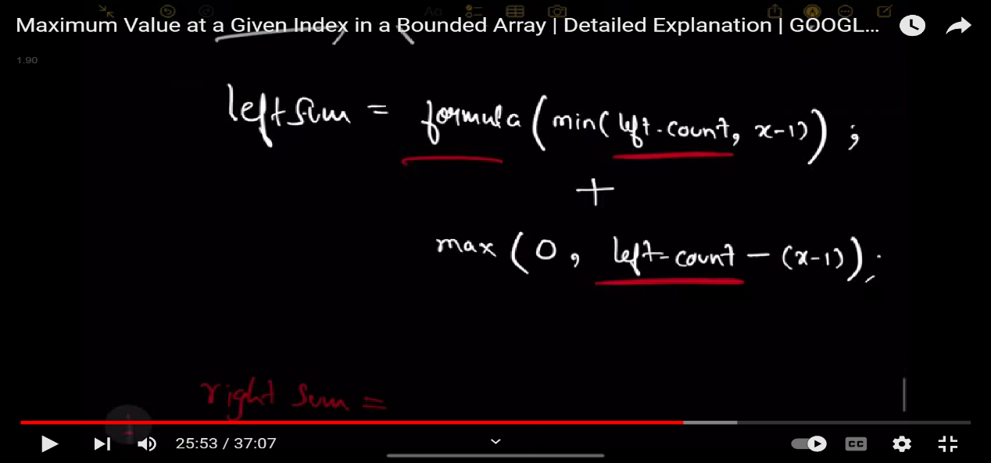

**243: Collecting Chocolates (asked in contest)**

You are given a **0-indexed** integer array nums of size n representing the cost of collecting different chocolates. The cost of collecting the chocolate at the index i is nums[i]. Each chocolate is of a different type, and initially, the chocolate at the index i is of ith type.

In one operation, you can do the following with an incurred **cost** of x:

* Simultaneously change the chocolate of ith type to ((i + 1) mod n)th type for all chocolates.

Return *the minimum cost to collect chocolates of all types, given that you can perform as many operations as you would like.*

**Example 1:**

**Input:** nums = [20,1,15], x = 5

**Output:** 13

**Explanation:** Initially, the chocolate types are [0,1,2]. We will buy the 1st type of chocolate at a cost of 1.

Now, we will perform the operation at a cost of 5, and the types of chocolates will become [1,2,0]. We will buy the 2nd type of chocolate at a cost of 1.

Now, we will again perform the operation at a cost of 5, and the chocolate types will become [2,0,1]. We will buy the 0th type of chocolate at a cost of 1.

Thus, the total cost will become (1 + 5 + 1 + 5 + 1) = 13. We can prove that this is optimal.

**Example 2:**

**Input:** nums = [1,2,3], x = 4

**Output:** 6

**Explanation:** We will collect all three types of chocolates at their own price without performing any operations. Therefore, the total cost is 1 + 2 + 3 = 6.

**Constraints:**

* 1 <= nums.length <= 1000
* 1 <= nums[i] <= 109
* 1 <= x <= 109

**Sol1: Brute force accepted**

class Solution {

public:

    long long minCost(vector<int>& nums, int x) {

        long long ans = 0;

        long long n = nums.size();

        vector<long long> vec(n,1e9);

        for(int i=0;i<n;i++)

        {

            vec[i] = nums[i];

            ans+=vec[i];

        }

        for(long long i=1;i<n;i++)

        {

            long long f = x;

            long long cost = i*f;

            for(long long j=0;j<n;j++)

            {

                //long long d = nums[(j+i)%n];

                vec[j] = min(vec[j],nums[(j+i)%n]);

                cost+=vec[j];

            }

            ans=min(ans,cost);

        }

        return ans;

    }

};

**Sol2: using deque and binary search**

class Solution {

public:

long long minCost(vector<int>& nums, int x) {

    long long cost1, cost2, l = 0, r = nums.size();

    while (l < r) {

        long long m = (l + r) / 2;

        cost1 = m * x, cost2 = (m + 1) * x;

        deque<int> d; //min queue

        for (int i = 0; i < nums.size() + m + 1; ++i) {

            while (!d.empty() && d.back() > nums[i % nums.size()])

                d.pop_back();

            d.push_back(nums[i % nums.size()]);

            if (i >= m + 1) {

                cost2 += d.front();

                if (d.front() == nums[i – (m + 1)])

                    d.pop_front();

            }

            if (i >= m && i < nums.size() + m)

                cost1 += d.front();

        }

        if (cost1 > cost2)

            l = m + 1;

        else

            r = m;

    }

    return min(cost1, cost2);

}

};

**244:**Problem Statement Suggest Edit For a given integer array/list 'ARR' of size 'N' containing all distinct values, find the total number of 'Inversions' that may exist. An inversion is defined for a pair of integers in the array/list when the following two conditions are met. A pair ('ARR[i]', 'ARR[j]') is said to be an inversion when: 1. 'ARR[i] > 'ARR[j]' 2. 'i' < 'j' Where 'i' and 'j' denote the indices ranging from [0, 'N'). Detailed explanation ( Input/output format, Notes, Images ) Constraints : 1 <= N <= 10^5 1 <= ARR[i] <= 10^9 Where 'ARR[i]' denotes the array element at 'ith' index.

**Sample input:**

**3**

**3 2 1**

**Output: 3**

We have a total of 3 pairs which satisfy the condition of inversion. (3, 2), (2, 1) and (3, 1).

**Sol1 : using brute force o(n^2)**

#include <bits/stdc++.h>

long long getInversions(long long *arr, int n){

    // Write your code here.

    //long long n=arr.size();

    long long cnt=0;

    for(int i=0;i<n;i++){

        for(int j=i+1;j<n;j++){

            if(arr[i]>arr[j]){

                cnt++;

            }

        }

    }

    return cnt;

}

**Sol2: using merge sort , actually we have to do this question using merge sort**

#include <bits/stdc++.h>

long long merge(long long* arr, int n, int left, int mid, int right) {

    long long leftArrSize = (mid - left + 1);

    long long rightArrSize = (right - (mid + 1)) + 1; // (right - mid)

    long long ret = 0;

    long long *leftArr = new long long[leftArrSize];

    long long *rightArr = new long long[rightArrSize];

    for (int i = 0; i < leftArrSize; i++) leftArr[i] = arr[left + i];

    for (int j = 0; j < rightArrSize; j++) rightArr[j] = arr[mid + 1 + j];

    int i, j, k;

    i = j = 0;

    k = left; //……

    while (i < leftArrSize && j < rightArrSize) {

        if (leftArr[i] <= rightArr[j]) {

            arr[k] = leftArr[i];

            i++;

        } else {

            ret += (mid - (left + i) + 1); //………

            arr[k] = rightArr[j];

            j++;

        }

        k++;

    }

    while (i < leftArrSize) {

        arr[k++] = leftArr[i++];

    }

    while (j < rightArrSize) {

        arr[k++] = rightArr[j++];

    }

    delete[] leftArr;

    delete[] rightArr;

    return ret;

}

long long mergeSort(long long* arr, int n, int left, int right) {

    long long ret = 0;

    if (left < right) {

        long long mid = (left + ((right - left) >> 1));

        ret += mergeSort(arr, n, left, mid);

        ret += mergeSort(arr, n, mid + 1, right);

        ret += merge(arr, n, left, mid, right);

    }

    return ret;

}

long long getInversions(long long *arr, int n){

    // Write your code here.

    return mergeSort(arr, n, 0, n - 1);

}

**245: Majority element I**

Given an array nums of size n, return *the majority element*.

The majority element is the element that appears more than ⌊n / 2⌋ times. You may assume that the majority element always exists in the array.

**Example 1:**

**Input:** nums = [3,2,3]

**Output:** 3

**Example 2:**

**Input:** nums = [2,2,1,1,1,2,2]

**Output:** 2

**Intuition: we can find that the max no of elements can be only 1 which is greater than the floor value of [n/2]**

**Eg: if n=6 than 6/2 =3 , so element greater than 3 can be only one element as if there 2 or more element the array size exceeds as for this the array size would become 4+4 =8 but array size is 6.   
so we can deduce that for element greater than floor value of n/2 we will have only one element.**

**Sol1: brute force , tc=o(n) and space =o(n)**

class Solution {

public:

    int majorityElement(vector<int>& nums) {

        unordered_map<int,int>mp;

        int n=nums.size();

        for(int i=0;i<n;i++){

            mp[nums[i]]++;

            if(mp[nums[i]]>n/2){

                return nums[i];

            }

        }

        return -1;

    }

};

**Sol2: using observing the intuition , tc=o(n) , space o(1)**

class Solution {

public:

    int majorityElement(vector<int>& num) {

        int major, count = 0;

        for(int i=0; i<num.size();i++){

            if(count==0){

                count++;

                major=num[i];

            }else if(major==num[i]){

                count++;

            }else count--;

        }

        return major;

    }

};

**246: Majority element ||**

Given an integer array of size n, find all elements that appear more than ⌊ n/3 ⌋ times.

**Example 1:**

**Input:** nums = [3,2,3]

**Output:** [3]

**Example 2:**

**Input:** nums = [1]

**Output:** [1]

**Example 3:**

**Input:** nums = [1,2]

**Output:** [1,2]

**Intuition: we can find that the max no of elements can be only 2 which is greater than the floor value of [n/3]**

**Eg: if n=6 than 6/3 =2 , so element greater than 2 can be only two element as if there three or more element the array size exceeds as for this the array size would become 3+3+3 =9 but array size is 6.   
so we can deduce that for element greater than floor value of n/3 we will have only two element.**

**Sol1: brute force , tc=o(n) && sc=o(n)**

class Solution {

public:

    vector<int> majorityElement(vector<int>& nums) {

        unordered_map<int,int>mp;

        vector<int>vec;

        int n=nums.size();

        int mini=(n/3) +1;

        for(int i=0;i<n;i++){

            mp[nums[i]]++;

            if(mp[nums[i]]==mini){

                vec.push_back(nums[i]);

            }

            if(vec.size()==2){

                break;

            }

        }

        return vec;

    }

};

**Sol2: using observation , same as majority element | concept but little changes , tc=o(n) and constant space**

class Solution {

public:

    vector<int> majorityElement(vector<int>& nums) {

        int cnt1=0,cnt2=0, ele1=INT_MIN,ele2=INT_MIN;

        for(int i=0;i<nums.size();i++){

            if(cnt1==0 && nums[i]!=ele2 ){

                cnt1=1;

                ele1=nums[i];

            }

            else if(cnt2==0 && nums[i]!=ele1){

                cnt2=1;

                ele2=nums[i];

            }

            else if(nums[i]==ele1){

                cnt1++;

            }

            else if(nums[i]==ele2){

                cnt2++;

            }

            else{

                cnt1--,cnt2--;

            }

        }

        cnt1=0,cnt2=0;

        for(int i=0;i<nums.size();i++){

            if(ele1==nums[i]){

                cnt1++;

            }

            else if(ele2==nums[i]){

                cnt2++;

            }

        }

        vector<int>vec;

        int mini=(nums.size()/3)+1;

        if(cnt1>=mini){

            vec.push_back(ele1);

        }

        if(cnt2>=mini){

            vec.push_back(ele2);

        }

        return vec;

    }

};

**247: Reverse Pairs**

Given an integer array nums, return *the number of****reverse pairs****in the array*.

A **reverse pair** is a pair (i, j) where:

* 0 <= i < j < nums.length and
* nums[i] > 2 * nums[j].

**Example 1:**

**Input:** nums = [1,3,2,3,1]

**Output:** 2

**Explanation:** The reverse pairs are:

(1, 4) --> nums[1] = 3, nums[4] = 1, 3 > 2 * 1

(3, 4) --> nums[3] = 3, nums[4] = 1, 3 > 2 * 1

**Example 2:**

**Input:** nums = [2,4,3,5,1]

**Output:** 3

**Explanation:** The reverse pairs are:

(1, 4) --> nums[1] = 4, nums[4] = 1, 4 > 2 * 1

(2, 4) --> nums[2] = 3, nums[4] = 1, 3 > 2 * 1

(3, 4) --> nums[3] = 5, nums[4] = 1, 5 > 2 * 1

**Constraints:**

* 1 <= nums.length <= 5 * 104
* -231 <= nums[i] <= 231 - 1

**Intuition : this problem uses the concept of count inverse pairs which is q.no 244**

**In this problem we also uses the same concept of merge sort**

**At an instant when we get nums left sorted and right sorted then we check and count if nums[left]>2*nums[right]…** 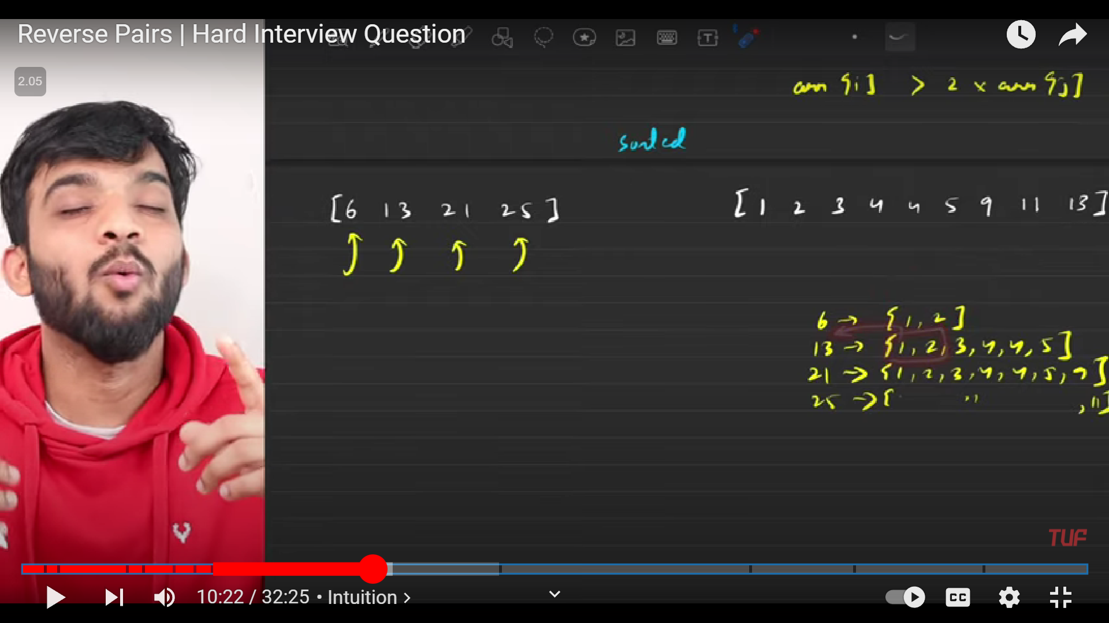

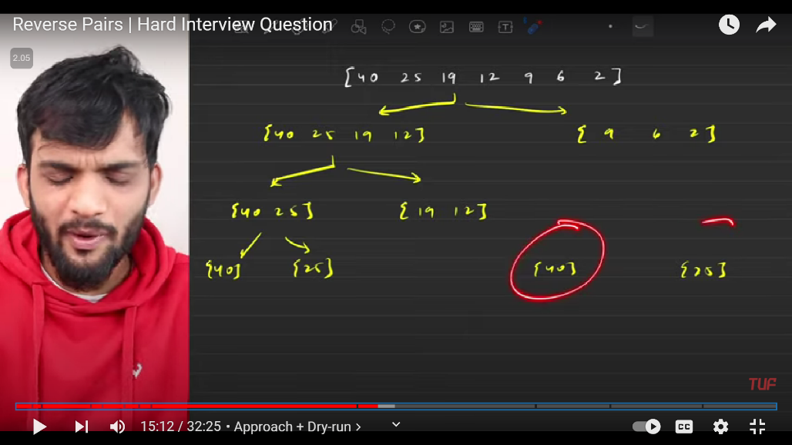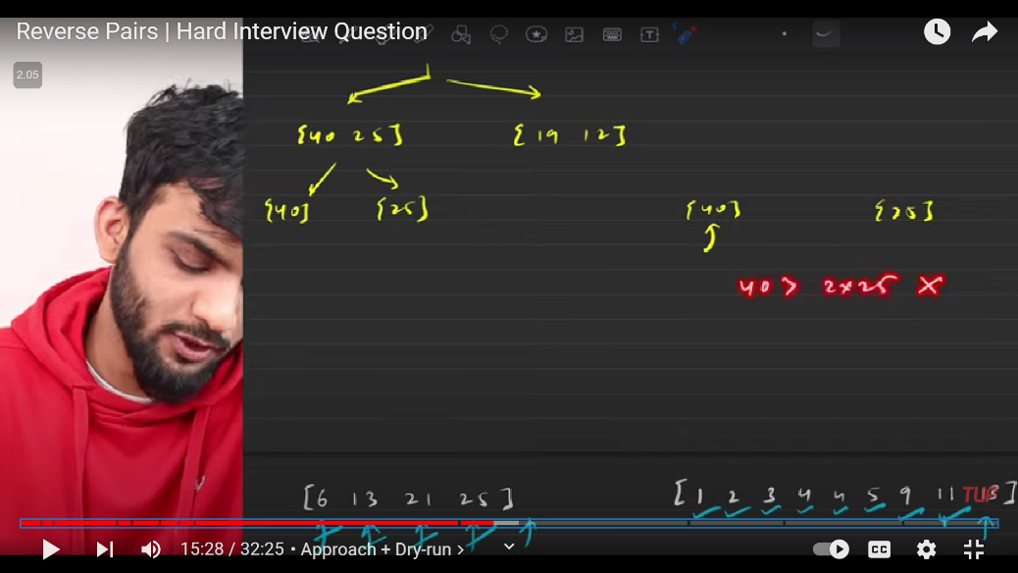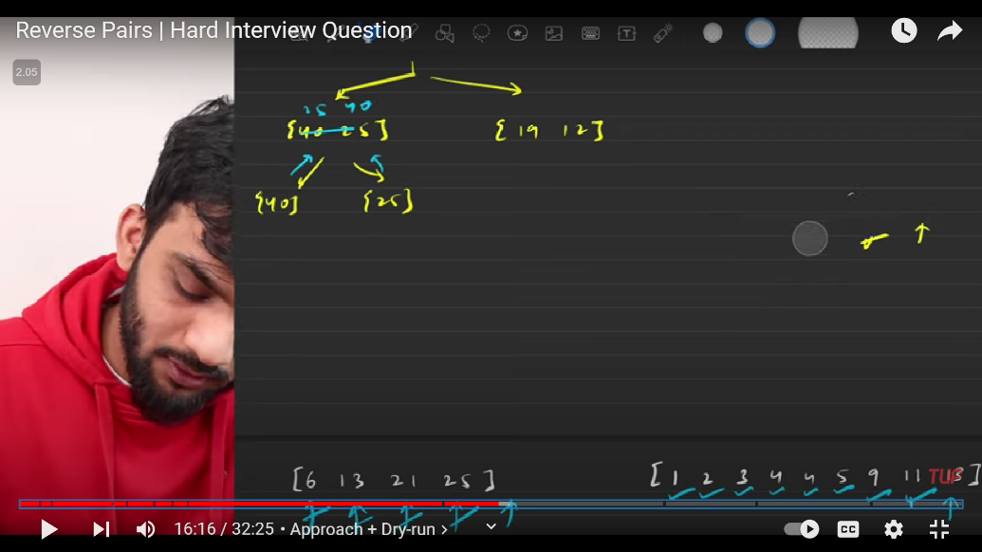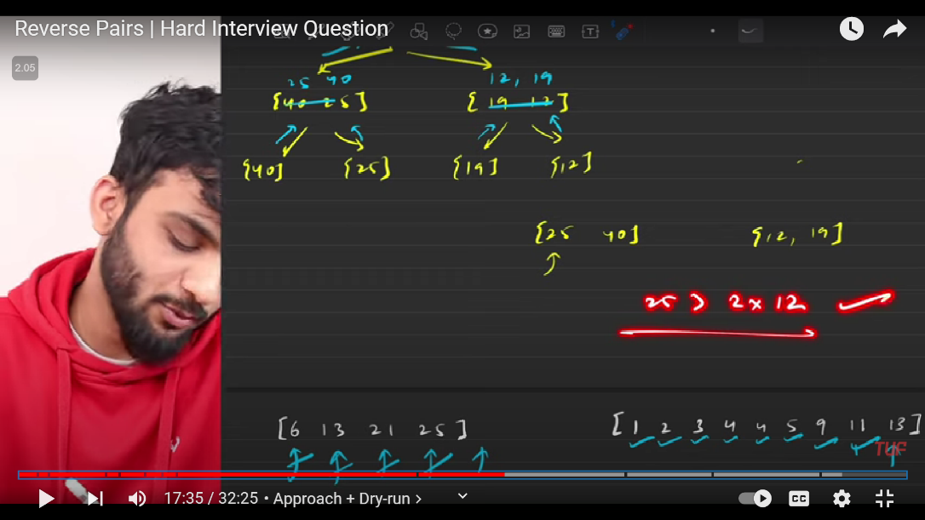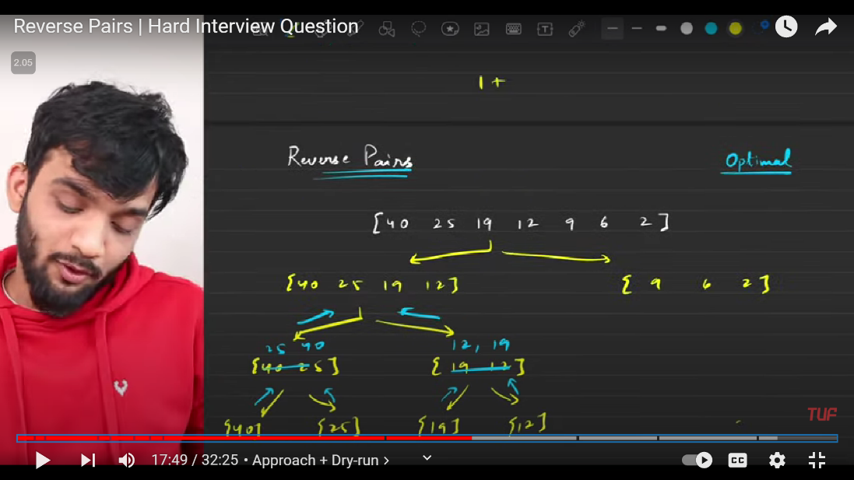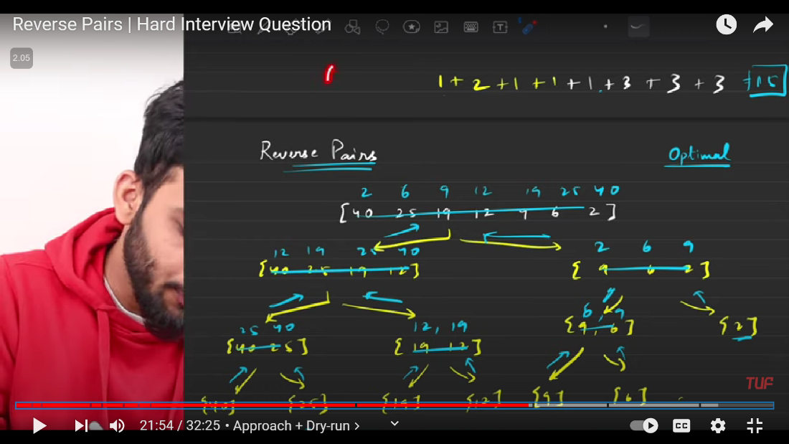

class Solution {

public:

int cnt=0;

    void merge(vector<int>&nums,int low,int mid,int high){

        vector<int>temp;

        int left=low;

        int right=mid+1;

        while(left<=mid && right<=high){

            if(nums[left]<=nums[right]){

                temp.push_back(nums[left]);

                left++;

            }

            else{

                temp.push_back(nums[right]);

                right++;

            }

        }

        while(left<=mid){

            temp.push_back(nums[left]);

            left++;

        }

        while(right<=high){

            temp.push_back(nums[right]);

            right++;

        }

        //transferring all temp elements to nums

        for(int i=low;i<=high;i++){

            nums[i]=temp[i-low];

        }

    }

    void countpairs(vector<int>& nums,int low, int mid, int high){

        int right=mid+1;

        for(int i=low;i<=mid;i++){

            while(right<=high &&nums[i] >2 * static_cast<long>(nums[right])){

                right++;

            }

            cnt+=(right-(mid+1));

        }

    }

    void mergesort(vector<int>&nums,int low,int high){

        if(low>=high){

            return;

        }

        int mid=low+(high-low)/2;

        mergesort(nums,low,mid);

        mergesort(nums,mid+1,high);

        countpairs(nums,low,mid,high);

        merge(nums,low,mid,high);

    }

    int reversePairs(vector<int>& nums) {

        int n=nums.size();

        mergesort(nums,0,n-1);

        return cnt;

    }

};

**248: Painting the walls**

**Hint : the problem is based on 0/1 Knapsack problem**

You are given two **0-indexed** integer arrays, cost and time, of size n representing the costs and the time taken to paint n different walls respectively. There are two painters available:

* A**paid painter** that paints the ith wall in time[i] units of time and takes cost[i] units of money.
* A**free painter** that paints **any** wall in 1 unit of time at a cost of 0. But the free painter can only be used if the paid painter is already **occupied**.

Return *the minimum amount of money required to paint the*n*walls.*

**Example 1:**

**Input:** cost = [1,2,3,2], time = [1,2,3,2]

**Output:** 3

**Explanation:** The walls at index 0 and 1 will be painted by the paid painter, and it will take 3 units of time; meanwhile, the free painter will paint the walls at index 2 and 3, free of cost in 2 units of time. Thus, the total cost is 1 + 2 = 3.

**Example 2:**

**Input:** cost = [2,3,4,2], time = [1,1,1,1]

**Output:** 4

**Explanation:** The walls at index 0 and 3 will be painted by the paid painter, and it will take 2 units of time; meanwhile, the free painter will paint the walls at index 1 and 2, free of cost in 2 units of time. Thus, the total cost is 2 + 2 = 4.

class Solution {

public:

    int solve(vector<int>& cost, vector<int>& time,int curr,int wallsremain){

        if(wallsremain<=0){

            return 0;

        }

        if(curr>=cost.size()){

            return 2000000000; //learn this part

        }

        if(dp[curr][wallsremain]!=-1){

            return dp[curr][wallsremain];

        }

        int take=cost[curr]+solve(cost,time,curr+1,wallsremain-time[curr]-1);

        int notake=solve(cost,time,curr+1,wallsremain);

        dp[curr][wallsremain]=min(take,notake);

        return dp[curr][wallsremain];

    }

    int dp[501][501];

    int paintWalls(vector<int>& cost, vector<int>& time) {

        memset(dp,-1,sizeof(dp));

        int n=time.size();

        return solve(cost,time,0,n);

    }

};

**249: Special Permutation**

**Hint: the problem is based on bit mask**

You are given a **0-indexed** integer array nums containing n **distinct** positive integers. A permutation of nums is called special if:

* For all indexes 0 <= i < n - 1, either nums[i] % nums[i+1] == 0 or nums[i+1] % nums[i] == 0.

Return *the total number of special permutations.*As the answer could be large, return it **modulo**109+ 7.

**Example 1:**

**Input:** nums = [2,3,6]

**Output:** 2

**Explanation:** [3,6,2] and [2,6,3] are the two special permutations of nums.

**Example 2:**

**Input:** nums = [1,4,3]

**Output:** 2

**Explanation:** [3,1,4] and [4,1,3] are the two special permutations of nums.

**Constraints:**

* 2 <= nums.length <= 14
* 1 <= nums[i] <= 109
* class Solution {
* public:
* int dp[15][(1<<14)+1];
* int mod = 1000000007;
* int solve(vector<int>& nums, int prevIndex, int currentIndex, int mask) {
* if (currentIndex == nums.size()) {
* return 1;
* }
* if (dp[prevIndex + 1][mask] != -1) {
* return dp[prevIndex + 1][mask];
* }
* int ans = 0;
* for (int j = 0; j < nums.size(); j++) {
* if ((mask & (1 << j))>0) { //1<<j means 2^j
* continue;
* }
* if (prevIndex == -1 || nums[prevIndex] % nums[j] == 0 || nums[j] % nums[prevIndex] == 0) {
* ans = (ans + solve(nums, j, currentIndex + 1, mask | (1 << j)))%mod;
* }
* }
* return dp[prevIndex + 1][mask] = ans;
* }
* int specialPerm(vector<int>& nums) {
* int n = nums.size();
* memset(dp,-1,sizeof(dp));
* return solve(nums, -1, 0,0);
* }
* };

**250: 4 sum**

Given an array nums of n integers, return *an array of all the****unique****quadruplets* [nums[a], nums[b], nums[c], nums[d]] such that:

* 0 <= a, b, c, d < n
* a, b, c, and d are **distinct**.
* nums[a] + nums[b] + nums[c] + nums[d] == target

You may return the answer in **any order**.

**Example 1:**

**Input:** nums = [1,0,-1,0,-2,2], target = 0

**Output:** [[-2,-1,1,2],[-2,0,0,2],[-1,0,0,1]]

**Example 2:**

**Input:** nums = [2,2,2,2,2], target = 8

**Output:** [[2,2,2,2]]

**Constraints:**

* 1 <= nums.length <= 200
* -109 <= nums[i] <= 109
* -109 <= target <= 109

**Sol1: brute force**

**We will run 4 for loops and take set<vector<int>> to avoid duplicate elements**

/*

    Time Complexity : O(N^4), Here Four nested loop creates the time complexity. Where N is the size of the

    array(nums).

    Space Complexity : O(N), Hash Table(set) space.

    Solved using Array(Four Nested Loop) + Sorting + Hash Table(set). Brute Force Approach.

    Note : this will give TLE.

*/

/***************************************** Approach 1 *****************************************/

class Solution {

public:

    vector<vector<int>> fourSum(vector<int>& nums, int target) {

        int n = nums.size();

        sort(nums.begin(), nums.end());

        set<vector<int>> set;

        vector<vector<int>> output;

        for(int i=0; i<n-3; i++){

            for(int j=i+1; j<n-2; j++){

                for(int k=j+1; k<n-1; k++){

                    for(int l=k+1; l<n; l++){

                        if((long long)nums[i] + (long long)nums[j] + (long long)nums[k] +

                        (long long)nums[l] == target){

                            set.insert({nums[i], nums[j], nums[k], nums[l]});

                        }

                    }

                }

            }

        }

        for(auto it : set){

            output.push_back(it);

        }

        return output;

    }

};

**Sol2 :**

/*

    Time Complexity : O(N^3), Here Three nested loop creates the time complexity. Where N is the size of the

    array(nums).

    Space Complexity : O(N), Hash Table(set) space.

    Solved using Array(Three Nested Loop) + Sorting + Hash Table(set).

*/

/***************************************** Approach 2 *****************************************/

class Solution {

public:

    vector<vector<int>> fourSum(vector<int>& nums, int target) {

        int n = nums.size();

        sort(nums.begin(), nums.end());

        set<vector<int>> set;

        vector<vector<int>> output;

        for(int i=0; i<n-3; i++){

            for(int j=i+1; j<n-2; j++){

                long long newTarget = (long long)target - (long long)nums[i] - (long long)nums[j];

                int low = j+1, high = n-1;

                while(low < high){

                    if(nums[low] + nums[high] < newTarget){

                        low++;

                    }

                    else if(nums[low] + nums[high] > newTarget){

                        high--;

                    }

                    else{

                        set.insert({nums[i], nums[j], nums[low], nums[high]});

                        low++; high--;

                    }

                }

            }

        }

        for(auto it : set){

            output.push_back(it);

        }

        return output;

    }

};

**Sol3:**

**Optimizing space complexity**

class Solution {

public:

    vector<vector<int>> fourSum(vector<int>& nums, int target) {

        sort(nums.begin(), nums.end());

        int n = nums.size();

        vector<vector<int>> ans;

        for (int i = 0; i < n; ++i) {

            for (int j = i + 1; j < n; ++j) {

                int l = j + 1, r = n - 1;

                long int remain = (long int)target - nums[i]- nums[j];

                while (l < r) {

                    if (nums[l] + nums[r] == remain) {

                        ans.push_back({nums[i], nums[j], nums[l], nums[r]});

                        ++l; --r;

                        while (l < r && nums[l-1] == nums[l]) ++l; // Skip duplicate nums[l]

                    } else if (nums[l] + nums[r] > remain) {

                        --r;

                    } else {

                        ++l;

                    }

                }

                while (j+1 < n && nums[j] == nums[j+1]) ++j; // Skip duplicate nums[j]

            }

            while (i+1 < n && nums[i] == nums[i+1]) ++i; // Skip duplicate nums[i]

        }

        return ans;

    }

};

**251: Largest subarray with 0 sum**

Given an array having both positive and negative integers. The task is to compute the length of the largest subarray with sum 0.

**Example 1:**

**Input:**

N = 8

A[] = {15,-2,2,-8,1,7,10,23}

**Output:** 5

**Explanation:** The largest subarray with

sum 0 will be -2 2 -8 1 7.

**// 1. prefix sum approach , very beautiful thought of prefix sum and unordered_map : if we find prefix sum then**

**// the subarray whose sum ==0, will get vanished in prefix sum and then again the same**

**// num would appear which gives us the idea about the longest subarray = 0**

**// eg: 15 13 15 7 8 15 25 48 // here 15 is appearing more times which gives us the idea about this**

class Solution{

    public:

    int maxLen(vector<int>&a, int n)

    {   int pre=0,longest_sub=0;

        vector<int>prefix;

        for(int i=0;i<n;i++){

            pre+=a[i];

            prefix.push_back(pre);

        }

        unordered_map<int,int>mp;

        mp[0]=-1;

        for(int i=0;i<n;i++){

            if(mp.find(prefix[i])!=mp.end()){

                longest_sub=max(longest_sub,i-mp[prefix[i]]);

            }

            else{

                mp[prefix[i]]=i;

            }

        }

        return longest_sub;

    }

};

**Sol2: //// little space optimised O(N) O(N)**

class Solution{

    public:

    int maxLen(vector<int>&a, int n)

    {   int pre=0,longest_sub=0;

        unordered_map<int,int>mp;

        mp[0]=-1;

        int sum=0;

        for(int i=0;i<n;i++){

            sum+=a[i];

            if(mp.find(sum)!=mp.end()){

                longest_sub=max(longest_sub,i-mp[sum]);

            }

            else{

                mp[sum]=i;

            }

        }

        return longest_sub;

    }

};

**252: Count subarrays with given xor**

**Problem Description**

Given an array of integers **A** and an integer **B**.

Find the total number of subarrays having bitwise XOR of all elements equals to B.

**Problem Constraints**

1 <= length of the array <= 105

1 <= A[i], B <= 109

**Input Format**

The first argument given is the integer array A.  
The second argument given is integer B.

**Output Format**

Return the total number of subarrays having bitwise XOR equals to B.

**Example Input**

Input 1:

A = [4, 2, 2, 6, 4]

B = 6

Input 2:

A = [5, 6, 7, 8, 9]

B = 5

**Example Output**

Output 1:

4

Output 2:

2

**Example Explanation**

Explanation 1:

The subarrays having XOR of their elements as 6 are:

[4, 2], [4, 2, 2, 6, 4], [2, 2, 6], [6]

Explanation 2:

The subarrays having XOR of their elements as 5 are [5] and [5, 6, 7, 8, 9]

**Sol1: brute force**

#include <bits/stdc++.h>

int subarraysXor(vector<int> &arr, int x)

{

    //    Write your code here.

    int total=0;

    for(int i=0;i<arr.size();i++){

        int xo=0;

        for(int j=i;j<arr.size();j++){

            xo^=arr[j];

            if(xo==x){

                total++;

            }

        }

    }

    return total;

}

**Sol2: this is based on same concept of previous question , just like we found prefix , but here we find prefix xor**

int subarraysXor(vector<int>a, int k) {

    int n = a.size(); //size of the given array.

    int xr = 0;

    map<int, int> mpp; //declaring the map.

    mpp[xr]=1; //setting the value of 0.

    int cnt = 0;

    for (int i = 0; i < n; i++) {

        // prefix XOR till index i:

        xr = xr ^ a[i];

        //By formula: x = xr^k:

        int x = xr ^ k;

        // add the occurrence of xr^k

        // to the count:

        if(mpp.find(x)!=mpp.end()){

            cnt+=mpp[x];

        }

        // Insert the prefix xor till index i

        // into the map:

        mpp[xr]++;

    }

    return cnt;

}

**253: Number of ways to reorder array to get same bst**

Given an array nums that represents a permutation of integers from 1 to n. We are going to construct a binary search tree (BST) by inserting the elements of nums in order into an initially empty BST. Find the number of different ways to reorder nums so that the constructed BST is identical to that formed from the original array nums.

* For example, given nums = [2,1,3], we will have 2 as the root, 1 as a left child, and 3 as a right child. The array [2,3,1] also yields the same BST but [3,2,1] yields a different BST.

Return *the number of ways to reorder* nums *such that the BST formed is identical to the original BST formed from* nums.

Since the answer may be very large, **return it modulo**109 + 7.

**Example 1:**

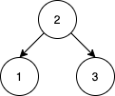

**Input:** nums = [2,1,3]

**Output:** 1

**Explanation:** We can reorder nums to be [2,3,1] which will yield the same BST. There are no other ways to reorder nums which will yield the same BST.

**Example 2:**

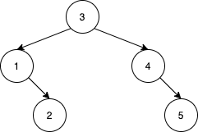

**Input:** nums = [3,4,5,1,2]

**Output:** 5

**Explanation:** The following 5 arrays will yield the same BST:

[3,1,2,4,5]

[3,1,4,2,5]

[3,1,4,5,2]b

[3,4,1,2,5]

[3,4,1,5,2]

**Example 3:**

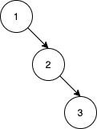

**Input:** nums = [1,2,3]

**Output:** 0

**Explanation:** There are no other orderings of nums that will yield the same BST.

**Constraints:**

* 1 <= nums.length <= 1000
* 1 <= nums[i] <= nums.length
* All integers in nums are **distinct**.

**Sol:**

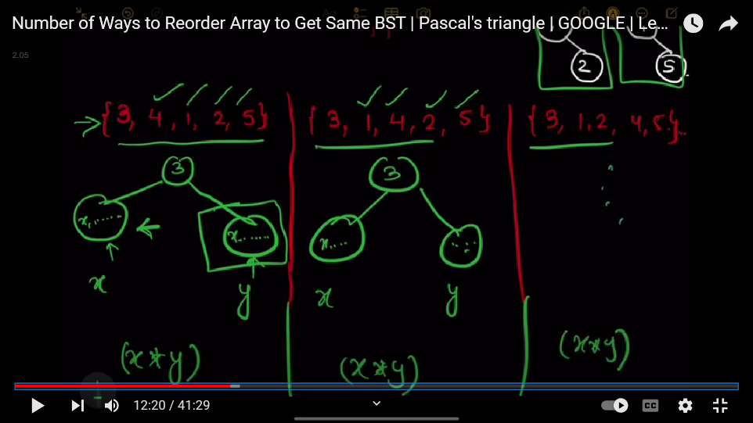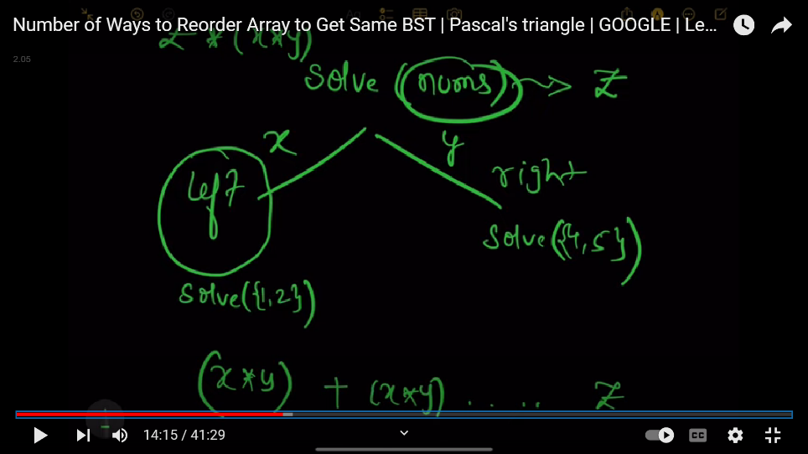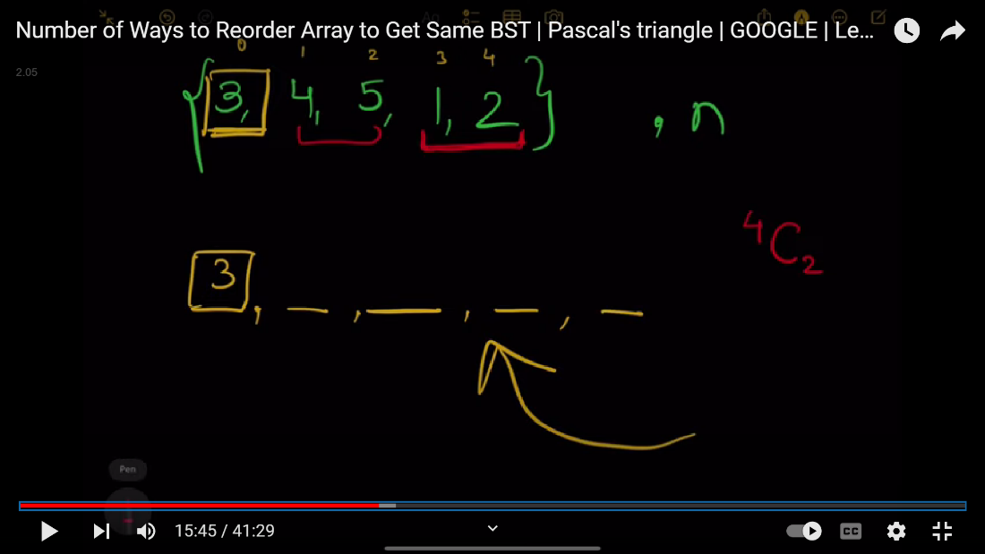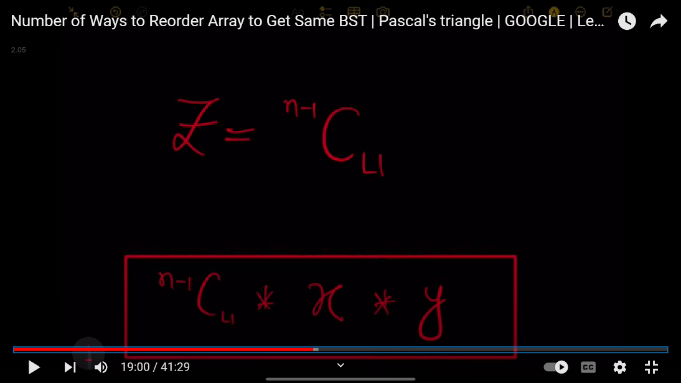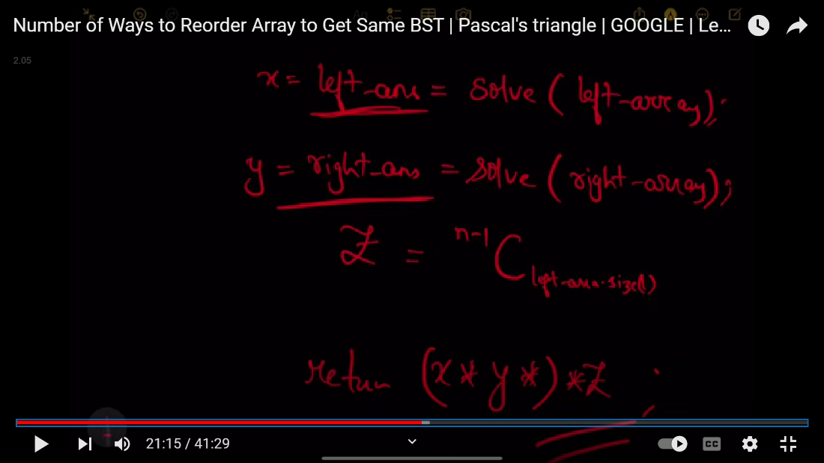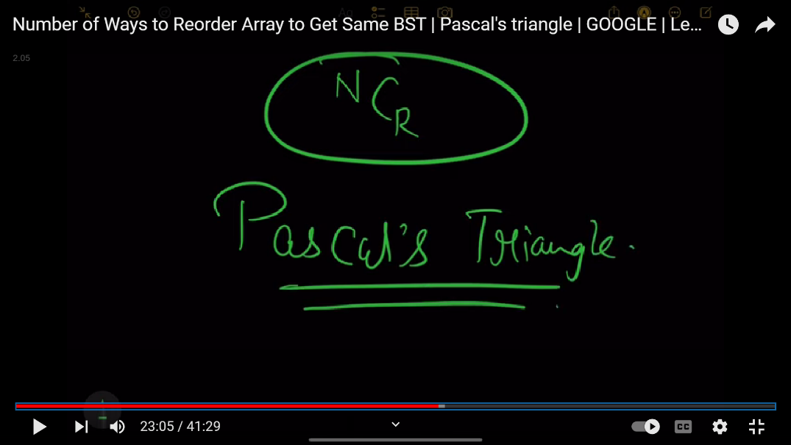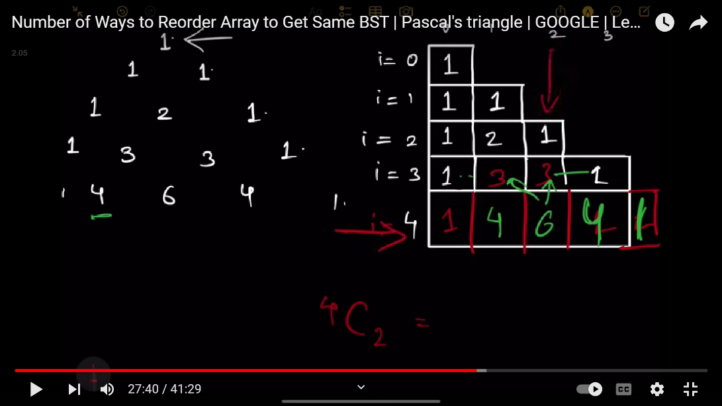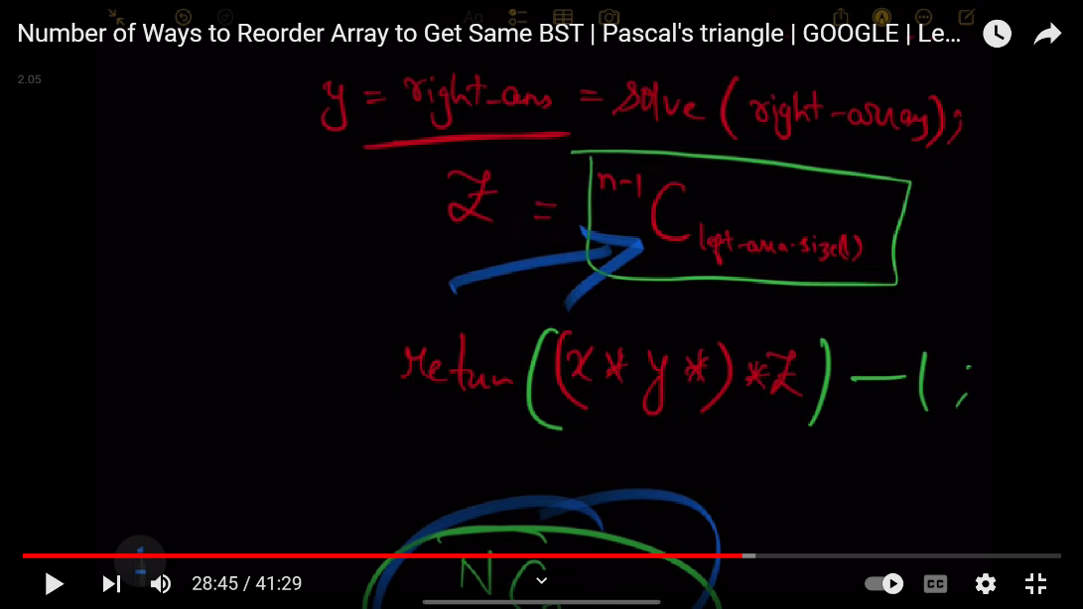

class Solution {

public:

    typedef long long ll;

    ll MOD = 1e9 + 7;

    vector<vector<ll>> PT;

    int solve(vector<int>& nums) {

        int m = nums.size();

        if(m < 3)

            return 1;

        vector<int> left, right;

        int root = nums[0];

        for(int i = 1; i < m; i++) {

            if(nums[i] < root) {

                left.push_back(nums[i]);

            } else {

                right.push_back(nums[i]);

            }

        }

        ll leftways  = solve(left)  % MOD;

        ll rightways = solve(right) % MOD;

        int  ans= (((leftways * rightways)%MOD) * PT[m-1][left.size()]) % MOD;

        return ans;

    }

    int numOfWays(vector<int>& nums) {

        int n = nums.size();

        PT.resize(n+1);

        for(int i = 0; i <= n; i++) {

            PT[i] = vector<long long>(i+1, 1);

            for(int j = 1; j < i; j++) {

                PT[i][j] = (PT[i-1][j-1] + PT[i-1][j]) % MOD;

            }

        }

        return (solve(nums)-1) % MOD;

    }

};

**254: Number of increasing paths in a grid**

You are given an m x n integer matrix grid, where you can move from a cell to any adjacent cell in all 4 directions.

Return *the number of****strictly******increasing****paths in the grid such that you can start from****any****cell and end at****any****cell.*Since the answer may be very large, return it **modulo** 109 + 7.

Two paths are considered different if they do not have exactly the same sequence of visited cells.

**Example 1:**

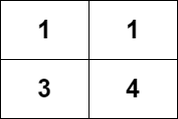

**Input:** grid = [[1,1],[3,4]]

**Output:** 8

**Explanation:** The strictly increasing paths are:

- Paths with length 1: [1], [1], [3], [4].

- Paths with length 2: [1 -> 3], [1 -> 4], [3 -> 4].

- Paths with length 3: [1 -> 3 -> 4].

The total number of paths is 4 + 3 + 1 = 8.

**Example 2:**

**Input:** grid = [[1],[2]]

**Output:** 3

**Explanation:** The strictly increasing paths are:

- Paths with length 1: [1], [2].

- Paths with length 2: [1 -> 2].

The total number of paths is 2 + 1 = 3.

**Constraints:**

* m == grid.length
* n == grid[i].length
* 1 <= m, n <= 1000
* 1 <= m * n <= 105
* 1 <= grid[i][j] <= 105
* class Solution {
* public:
* int m, n;
* vector<vector<int>> directions = {
* {-1,0},
* {0,-1},         {0,1},
* {1, 0}
* };
* int t[1001][1001];
* bool isSafe(int i, int j) {
* return (i < m && i >= 0 && j < n && j >= 0);
* }
* long long MOD = 1e9+7;
* int dfs(vector<vector<int>>& grid, int i, int j) {
* if(t[i][j] != -1)
* return t[i][j];
* int answer = 1;
* for(auto &dir : directions) {
* int i_ = i + dir[0];
* int j_ = j + dir[1];
* if(isSafe(i_, j_) && grid[i_][j_] > grid[i][j]) { //vaild paths ending at i,j
* answer = (answer + dfs(grid, i_, j_)) % MOD;
* }
* }
* return t[i][j] = answer;
* }
* int countPaths(vector<vector<int>>& grid) {
* m = grid.size();
* n = grid[0].size();
* memset(t, -1, sizeof(t));
* int result = 0;
* for(int i = 0; i < m; i++) {
* for(int j = 0; j < n; j++) {
* result = (result + dfs(grid, i, j)) % MOD;
* }
* }

* return result;
* }
* };

**255: Longest increasing path in a matrix**

Given an m x n integers matrix, return *the length of the longest increasing path in*matrix.

From each cell, you can either move in four directions: left, right, up, or down. You **may not** move **diagonally** or move **outside the boundary** (i.e., wrap-around is not allowed).

**Example 1:**

**Input:** matrix = [[9,9,4],[6,6,8],[2,1,1]]

**Output:** 4

**Explanation:** The longest increasing path is [1, 2, 6, 9].

**Example 2:**

**Input:** matrix = [[3,4,5],[3,2,6],[2,2,1]]

**Output:** 4

**Explanation:** The longest increasing path is [3, 4, 5, 6]. Moving diagonally is not allowed.

**Example 3:**

**Input:** matrix = [[1]]

**Output:** 1

**Constraints:**

* m == matrix.length
* n == matrix[i].length
* 1 <= m, n <= 200
* 0 <= matrix[i][j] <= 231 - 1

**This problem is very much similar to previous problem**

**Sol : using same concept i.e dfs+memorization , the code is very much similar to previous code only change in two places in result and ans storing parts**

class Solution {

public:

    int m, n;

    vector<vector<int>> directions = {

                {-1,0},

        {0,-1},         {0,1},

                {1, 0}

    };

    int t[1001][1001];

    bool isSafe(int i, int j) {

        return (i < m && i >= 0 && j < n && j >= 0);

    }

    long long MOD = 1e9+7;

    int dfs(vector<vector<int>>& grid, int i, int j) {

        if(t[i][j] != -1)

            return t[i][j];

        int answer = 1;

        for(auto &dir : directions) {

            int i_ = i + dir[0];

            int j_ = j + dir[1];

            if(isSafe(i_, j_) && grid[i_][j_] > grid[i][j]) {

                answer = max(answer , dfs(grid, i_, j_)+1) % MOD;

            }//here we are increasing dfs to 1 because in this question we have to get how many times dfs call made implies our longestpath, we are taking max ans and dfs()+1;

            // when the answer will be passed to result it will store the max ans

        }

        return t[i][j] = answer;

    }

    int longestIncreasingPath(vector<vector<int>>& grid) {

        m = grid.size();

        n = grid[0].size();

        memset(t, -1, sizeof(t));

        int result = 0;

        for(int i = 0; i < m; i++) {

            for(int j = 0; j < n; j++) {

                result = max(result ,dfs(grid, i, j)) % MOD;

            }

        }

        return result;

    }

};

**256: Snapshot Array**

Implement a SnapshotArray that supports the following interface:

* SnapshotArray(int length) initializes an array-like data structure with the given length. **Initially, each element equals 0**.
* void set(index, val) sets the element at the given index to be equal to val.
* int snap() takes a snapshot of the array and returns the snap_id: the total number of times we called snap() minus 1.
* int get(index, snap_id) returns the value at the given index, at the time we took the snapshot with the given snap_id

**Example 1:**

**Input:** ["SnapshotArray","set","snap","set","get"]

[[3],[0,5],[],[0,6],[0,0]]

**Output:** [null,null,0,null,5]

**Explanation:**

SnapshotArray snapshotArr = new SnapshotArray(3); // set the length to be 3

snapshotArr.set(0,5); // Set array[0] = 5

snapshotArr.snap(); // Take a snapshot, return snap_id = 0

snapshotArr.set(0,6);

snapshotArr.get(0,0); // Get the value of array[0] with snap_id = 0, return 5

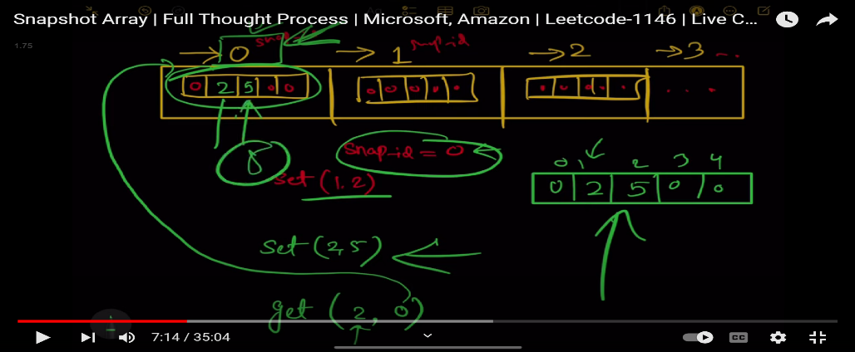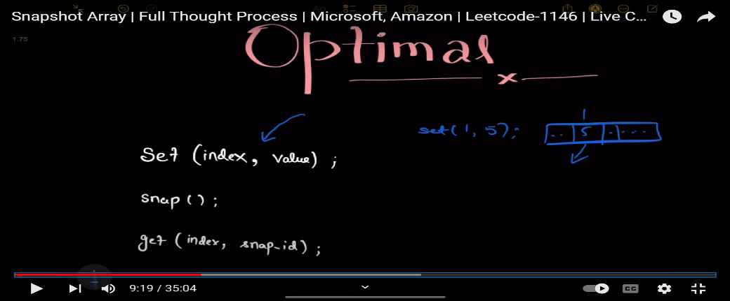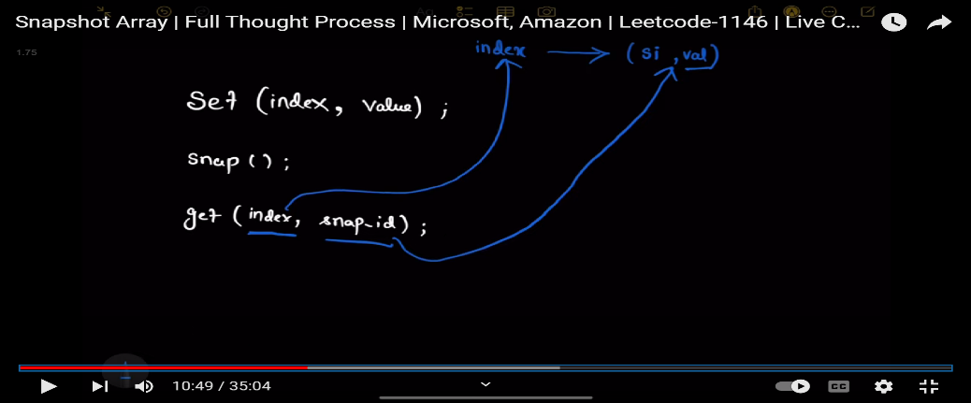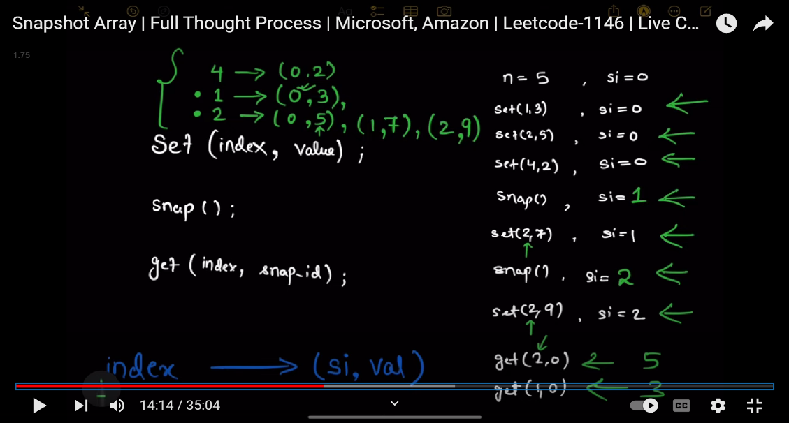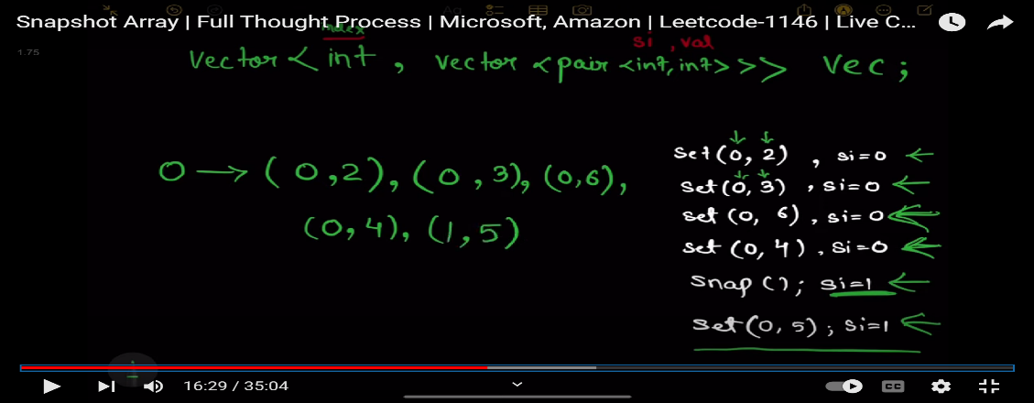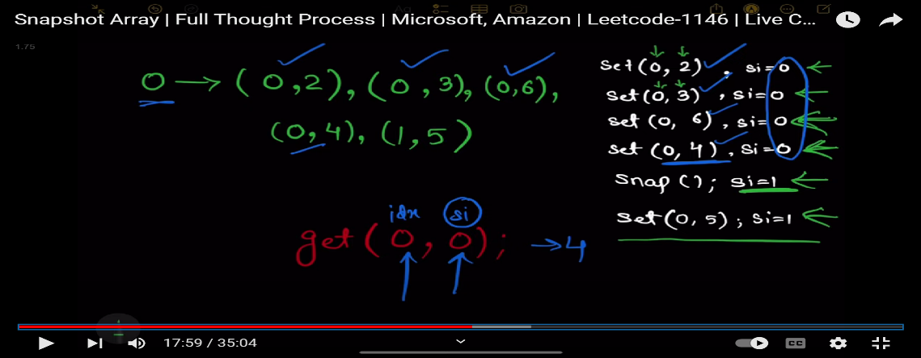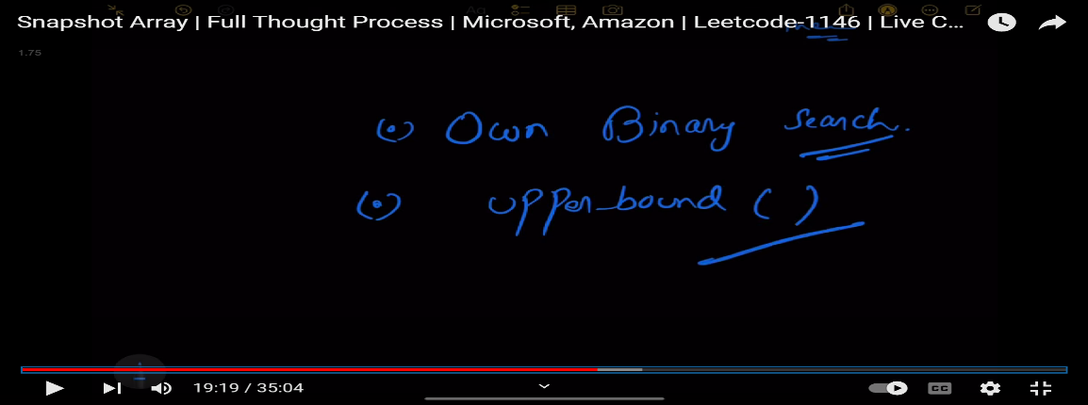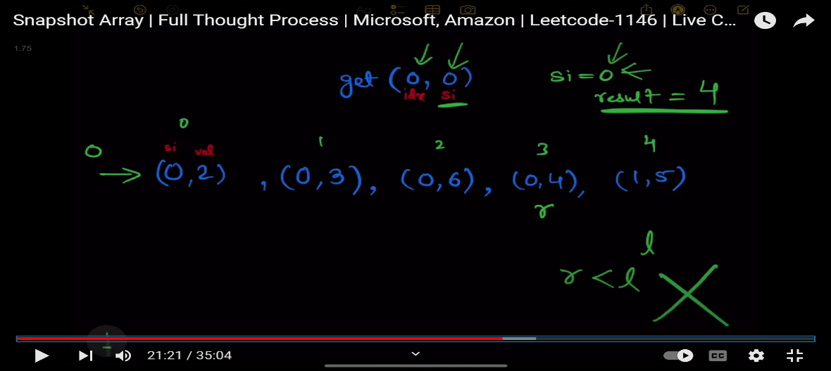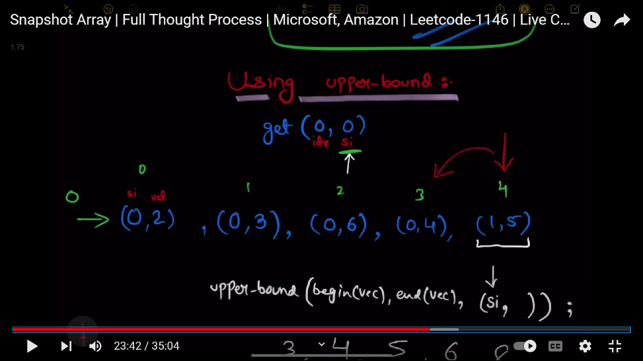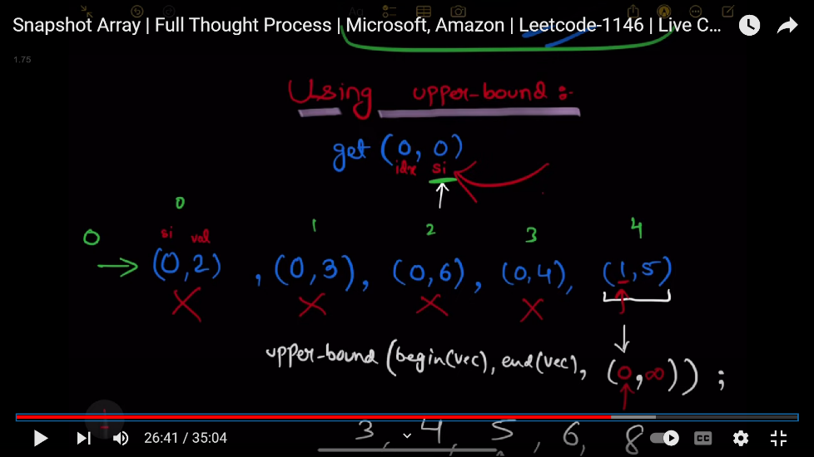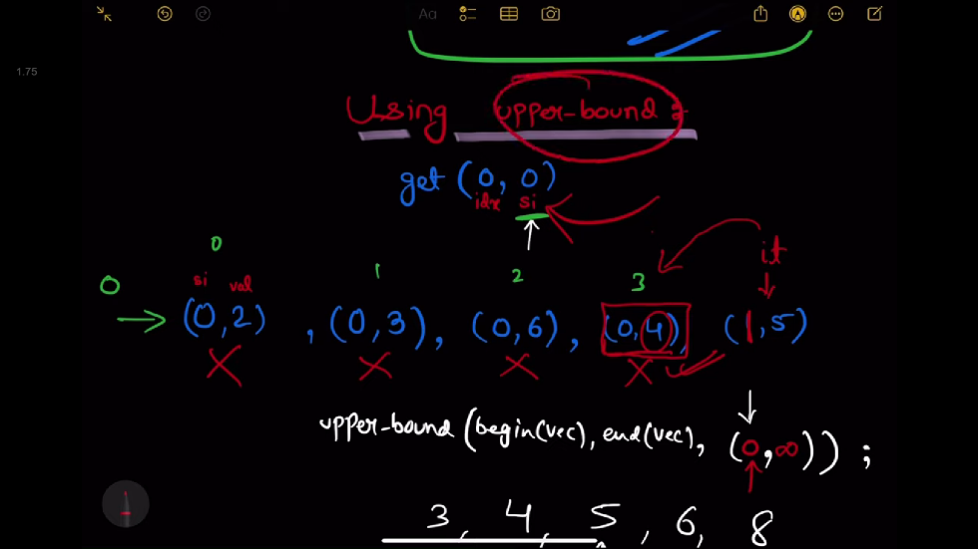

class SnapshotArray {

public:

    //unordered_map<int,vector<pair<int,int>>>mp

    vector<vector<pair<int,int>>>vec; //index->snap_id,val

    int snapid=0;

    SnapshotArray(int length) {

        vec.resize(length);

        for(int i=0;i<length;i++){

            vec[i].push_back({0,0});

        }

    }

    void set(int index, int val) {

        vec[index].push_back({snapid,val});

    }

    int snap() {

        return snapid++; //first will return snapid=0 and then increment

    }

    int get(int index, int snap_id) {

        //using binary search doing for snap_id

        int l=0,h=vec[index].size()-1;

        int result=0;

        while(l<=h){

            int mid=l+(h-l)/2;

            if(vec[index][mid].first<=snap_id){

                result=vec[index][mid].second;

                l=mid+1;

            }

            else{

                h=mid-1;

            }

        }

        return result;

        //using upper_bound

        // auto it=upper_bound(vec[index].begin(),vec[index].end(),make_pair(snap_id,INT_MAX));

        // //return prev(it)->second;

        // it--;

        // return it->second;

    }

};

**257: Make array strictly increasing**

Given two integer arrays arr1 and arr2, return the minimum number of operations (possibly zero) needed to make arr1 strictly increasing.

In one operation, you can choose two indices 0 <= i < arr1.length and 0 <= j < arr2.length and do the assignment arr1[i] = arr2[j].

If there is no way to make arr1 strictly increasing, return -1.

**Example 1:**

**Input:** arr1 = [1,5,3,6,7], arr2 = [1,3,2,4]

**Output:** 1

**Explanation:** Replace 5 with 2, then arr1 = [1, 2, 3, 6, 7].

**Example 2:**

**Input:** arr1 = [1,5,3,6,7], arr2 = [4,3,1]

**Output:** 2

**Explanation:** Replace 5 with 3 and then replace 3 with 4. arr1 = [1, 3, 4, 6, 7].

**Example 3:**

**Input:** arr1 = [1,5,3,6,7], arr2 = [1,6,3,3]

**Output:** -1

**Explanation:** You can't make arr1 strictly increasing.

// class Solution {    //tle

// public:

//     int solve(vector<int>& arr1, vector<int>& arr2,int ind,int prev){

//         if(ind>=arr1.size()){

//             return 0;

//         }

//         int result1=1e9+1;

//         if(arr1[ind]>prev){

//             result1=solve(arr1,arr2,ind+1,arr1[ind]); //when no operation

//         }

//         int result2=1e9+1;

//         auto it=upper_bound(arr2.begin(),arr2.end(),prev);

//         if(it!=arr2.end()){

//             int j=it-arr2.begin();

//             // arr1[ind]=arr2[j]; //doing this will change the arr1 and we not want when upper resursion will call foe some ele

//             // so we do

//             prev=arr2[j];

//             result2= 1 + solve(arr1,arr2,ind+1,prev);

//         }

//         return min(result1,result2);

//     }

//     int makeArrayIncreasing(vector<int>& arr1, vector<int>& arr2) {

//         sort(arr2.begin(),arr2.end());

//         int result=solve(arr1,arr2,0,INT_MIN);

//         if(result==1e9+1){

//             return -1;

//         }

//         return result;

//     }

// };

//Approach-1 (Using simple Recursion + Memoization) - O(n*n*log(n))

class Solution {

public:

    //we wre doing memoization with map because using dp vector prev can take 1e9+1 value which is very large

    map<pair<int, int>, int> mp;

    int solve(int idx, vector<int>& arr1, vector<int>& arr2, int prev) {

        if(idx == arr1.size())

            return 0;

        int result1 = 1e9+1;

        if(mp.find({idx, prev}) != mp.end())

            return mp[{idx, prev}];

        if(arr1[idx] > prev) {

            result1 = solve(idx+1, arr1, arr2, arr1[idx]);

        }

        int result2 = 1e9+1;

        auto it = upper_bound(begin(arr2), end(arr2), prev);

        if(it != end(arr2)) {

            int i = it - begin(arr2);

            result2 = 1 + solve(idx+1, arr1, arr2, arr2[i]);

        }

        return mp[{idx, prev}] = min(result1, result2);

    }

    int makeArrayIncreasing(vector<int>& arr1, vector<int>& arr2) {

        sort(begin(arr2), end(arr2));

        mp.clear();

        int result = solve(0, arr1, arr2, INT_MIN);

        if(result == 1e9+1)

            return -1;

        return result;

    }

};

**258: Minimum cost to make array equal (binary search)**

You are given two **0-indexed** arrays nums and cost consisting each of n **positive** integers.

You can do the following operation **any** number of times:

* Increase or decrease **any** element of the array nums by 1.

The cost of doing one operation on the ith element is cost[i].

Return *the****minimum****total cost such that all the elements of the array*nums*become****equal***.

**Example 1:**

**Input:** nums = [1,3,5,2], cost = [2,3,1,14]

**Output:** 8

**Explanation:** We can make all the elements equal to 2 in the following way:

- Increase the 0th element one time. The cost is 2.

- Decrease the 1st element one time. The cost is 3.

- Decrease the 2nd element three times. The cost is 1 + 1 + 1 = 3.

The total cost is 2 + 3 + 3 = 8.

It can be shown that we cannot make the array equal with a smaller cost.

**Example 2:**

**Input:** nums = [2,2,2,2,2], cost = [4,2,8,1,3]

**Output:** 0

**Explanation:** All the elements are already equal, so no operations are needed.

class Solution {

public:

    typedef long long ll;

    ll func(vector<int>& nums, vector<int>& cost,int target){

        ll result=0;

        for(int i=0;i<nums.size();i++){

            result+=(ll)abs(target-nums[i])*cost[i];

        }

        return result;

    }

    long long minCost(vector<int>& nums, vector<int>& cost) {

        ll ans=INT_MAX;

        ll left=*min_element(nums.begin(),nums.end());

        ll right=*max_element(nums.begin(),nums.end());

        while(left<=right){

            ll mid=left+(right-left)/2;

            ll cost1=func(nums,cost,mid);

            ll cost2=func(nums,cost,mid+1);

            ans=min(cost1,cost2);

            if(cost1<cost2){

                right=mid-1;

            }

            else{

                left=mid+1;

            }

        }

        return ans==INT_MAX?0:ans;

    }

};

**259: Rotate list**

Given the head of a linked list, rotate the list to the right by k places.

**Example 1:**

**Input:** head = [1,2,3,4,5], k = 2

**Output:** [4,5,1,2,3]

**Example 2:**

**Input:** head = [0,1,2], k = 4

**Output:** [2,0,1]

**Constraints:**

* The number of nodes in the list is in the range [0, 500].
* -100 <= Node.val <= 100
* 0 <= k <= 2 * 109
* class Solution {
* public:
* ListNode* rotateRight(ListNode* head, int k) {
* if(!head) return head;
* int len=1; // number of nodes
* ListNode *newH, *tail;
* newH=tail=head;
* while(tail->next)  // get the number of nodes in the list
* {
* tail = tail->next;
* len++;
* }
* tail->next = head; // circle the link
* if(k %= len)
* {
* for(auto i=0; i<len-k; i++) tail = tail->next; // the tail node is the (len-k)-th node (1st node is head)
* }
* newH = tail->next;
* tail->next = NULL;
* return newH;
* }
* };

**260: Trapping Rainwater**

Given n non-negative integers representing an elevation map where the width of each bar is 1, compute how much water it can trap after raining.

**Example 1:**

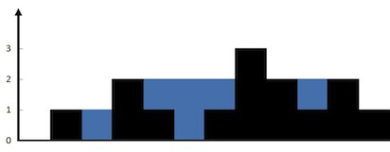

**Input:** height = [0,1,0,2,1,0,1,3,2,1,2,1]

**Output:** 6

**Explanation:** The above elevation map (black section) is represented by array [0,1,0,2,1,0,1,3,2,1,2,1]. In this case, 6 units of rain water (blue section) are being trapped.

**Example 2:**

**Input:** height = [4,2,0,3,2,5]

**Output:** 9

**Solution 1: Brute force, TLE (approach is very similar to largest area in histogram)**

**Approach**: For each index, we have to find the amount of water that can be stored and we have to sum it up.If we observe carefully the amount the water stored at a particular index is the minimum of maximum elevation to the left and right of the index minus the elevation at that index.

**Code:**

* C++ Code
* Java Code
* Python Code

#include<bits/stdc++.h>

using namespace std;

int trap(vector < int > & arr) {

int n = arr.size();

int waterTrapped = 0;

for (int i = 0; i < n; i++) {

int j = i;

int leftMax = 0, rightMax = 0;

while (j >= 0) {

leftMax = max(leftMax, arr[j]);

j--;

}

j = i;

while (j < n) {

rightMax = max(rightMax, arr[j]);

j++;

}

waterTrapped += min(leftMax, rightMax) - arr[i];

}

return waterTrapped;

}

int main() {

vector < int > arr;

arr = {0,1,0,2,1,0,1,3,2,1,2,1};

cout << "The water that can be trapped is " << trap(arr) << endl;

}

**Output:** The water that can be trapped is 6

**Time Complexity:** O(N*N) as for each index we are calculating leftMax and rightMax so it is a nested loop.

**Space Complexity:** O(1).

**Solution 2:Better solution (approach is very similar to largest area in histogram)**

**Intuition:**We are taking O(N) for computing leftMax and rightMax at each index. The complexity can be boiled down to O(1) if we precompute the leftMax and rightMax at each index.

**Approach:**Take 2 array prefix and suffix array and precompute the leftMax and rightMax for each index beforehand. Then use the formula min(prefix[I], suffix[i])-arr[i] to compute water trapped at each index.

**Code:**

* C++ Code
* Java Code
* Python Code

#include<bits/stdc++.h>

using namespace std;

int trap(vector < int > & arr) {

int n = arr.size();

int prefix[n], suffix[n];

prefix[0] = arr[0];

for (int i = 1; i < n; i++) {

prefix[i] = max(prefix[i - 1], arr[i]);

}

suffix[n - 1] = arr[n - 1];

for (int i = n - 2; i >= 0; i--) {

suffix[i] = max(suffix[i + 1], arr[i]);

}

int waterTrapped = 0;

for (int i = 0; i < n; i++) {

waterTrapped += min(prefix[i], suffix[i]) - arr[i];

}

return waterTrapped;

}

int main() {

vector < int > arr;

arr = {0,1,0,2,1,0,1,3,2,1,2,1};

cout << "The water that can be trapped is " << trap(arr) << endl;

}

**Output:** The water that can be trapped is 6

**Time Complexity:**O(3*N) as we are traversing through the array only once. And O(2*N) for computing prefix and suffix array.

**Space Complexity:**O(N)+O(N) for prefix and suffix arrays.

**Solution 3:Optimal Solution(**[**Two pointer approach**](https://takeuforward.org/data-structure/what-is-two-pointer-approach/)**)**

**Approach:** Take 2 pointers l(left pointer) and r(right pointer) pointing to 0th and (n-1)th index respectively. Take two variables leftMax and rightMax and initialize them to 0. If height[l] is less than or equal to height[r] then if leftMax is less than height[l] update leftMax to height[l] else add leftMax-height[l] to your final answer and move the l pointer to the right i.e l++. If height[r] is less than height[l], then now we are dealing with the right block. If height[r] is greater than rightMax, then update rightMax to height[r] else add rightMax-height[r] to the final answer. Now move r to the left. Repeat these steps till l and r crosses each other.

**Intuition:** We need a minimum of leftMax and rightMax.So if we take the case when height[l]<=height[r] we increase l++, so we can surely say that there is a block with a height more than height[l] to the right of l. And for the same reason when height[r]<=height[l] we can surely say that there is a block to the left of r which is at least of height[r]. So by traversing these cases and using two pointers approach the time complexity can be decreased without using extra space.

**Code:**

* C++ Code
* Java Code
* Python Code

#include<bits/stdc++.h>

using namespace std;

int trap(vector < int > & height) {

int n = height.size();

int left = 0, right = n - 1;

int res = 0;

int maxLeft = 0, maxRight = 0;

while (left <= right) {

if (height[left] <= height[right]) {

if (height[left] >= maxLeft) {

maxLeft = height[left];

} else {

res += maxLeft - height[left];

}

left++;

} else {

if (height[right] >= maxRight) {

maxRight = height[right];

} else {

res += maxRight - height[right];

}

right--;

}

}

return res;

}

int main() {

vector < int > arr;

arr = {0,1,0,2,1,0,1,3,2,1,2,1};

cout << "The water that can be trapped is " << trap(arr) << endl;

}

**Output:** The water that can be trapped is 6

**Time Complexity:** O(N) because we are using 2 pointer approach.

**Space Complexity:** O(1) because we are not using anything extra.

Special than

**261: Count all possible routes**

You are given an array of **distinct** positive integers locations where locations[i] represents the position of city i. You are also given integers start, finish and fuel representing the starting city, ending city, and the initial amount of fuel you have, respectively.

At each step, if you are at city i, you can pick any city j such that j != i and 0 <= j < locations.length and move to city j. Moving from city i to city j reduces the amount of fuel you have by |locations[i] - locations[j]|. Please notice that |x| denotes the absolute value of x.

Notice that fuel **cannot** become negative at any point in time, and that you are **allowed** to visit any city more than once (including start and finish).

Return *the count of all possible routes from*start *to* finish. Since the answer may be too large, return it modulo 109 + 7.

**Example 1:**

**Input:** locations = [2,3,6,8,4], start = 1, finish = 3, fuel = 5

**Output:** 4

**Explanation:** The following are all possible routes, each uses 5 units of fuel:

1 -> 3

1 -> 2 -> 3

1 -> 4 -> 3

1 -> 4 -> 2 -> 3

**Example 2:**

**Input:** locations = [4,3,1], start = 1, finish = 0, fuel = 6

**Output:** 5

**Explanation:** The following are all possible routes:

1 -> 0, used fuel = 1

1 -> 2 -> 0, used fuel = 5

1 -> 2 -> 1 -> 0, used fuel = 5

1 -> 0 -> 1 -> 0, used fuel = 3

1 -> 0 -> 1 -> 0 -> 1 -> 0, used fuel = 5

**Example 3:**

**Input:** locations = [5,2,1], start = 0, finish = 2, fuel = 3

**Output:** 0

**Explanation:** It is impossible to get from 0 to 2 using only 3 units of fuel since the shortest route needs 4 units of fuel.

**Constraints:**

* 2 <= locations.length <= 100
* 1 <= locations[i] <= 109
* All integers in locations are **distinct**.
* 0 <= start, finish < locations.length
* 1 <= fuel <= 200

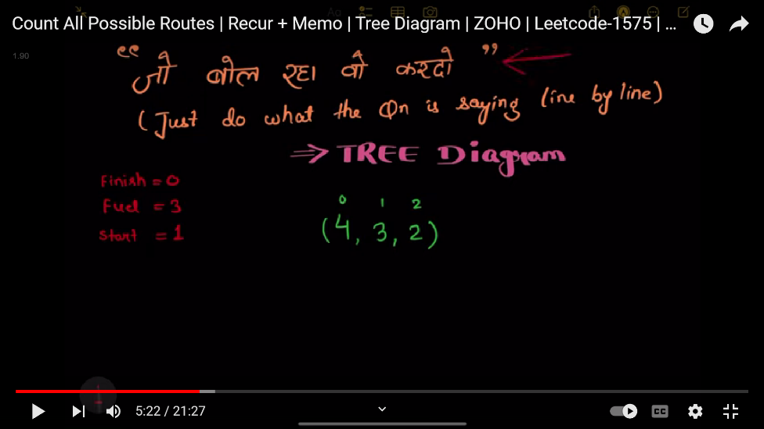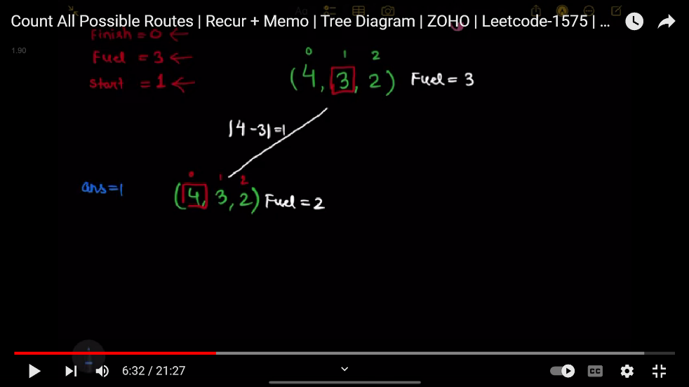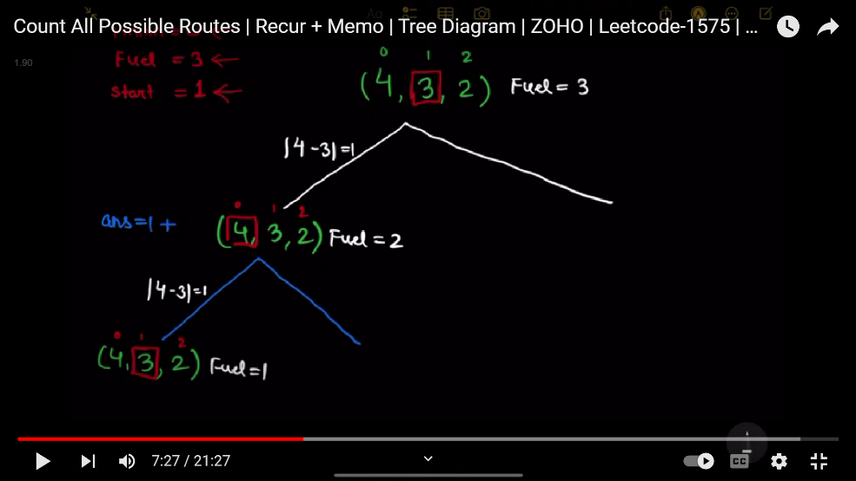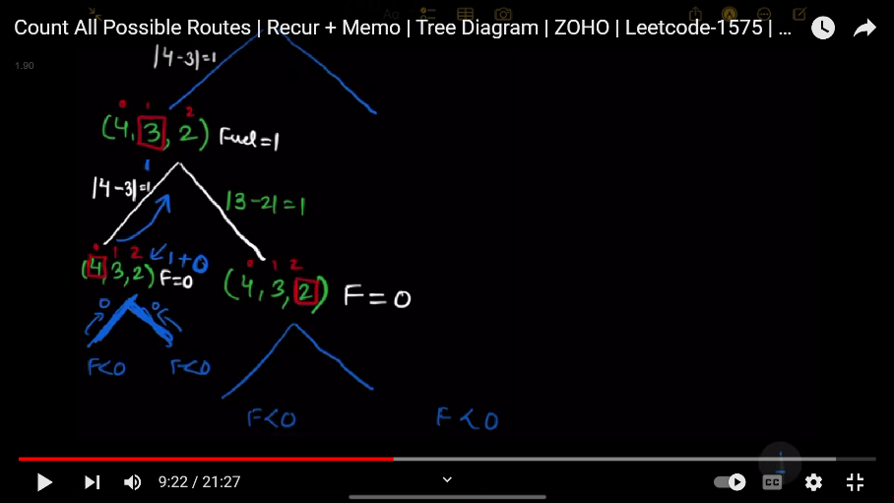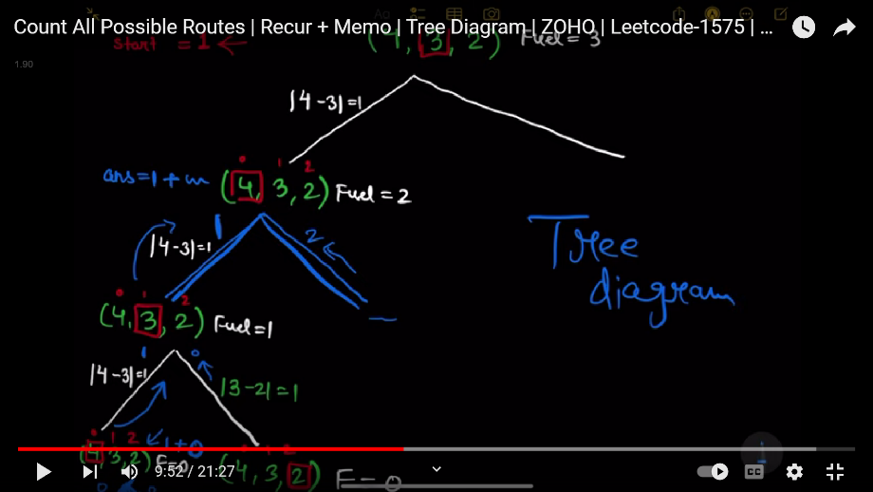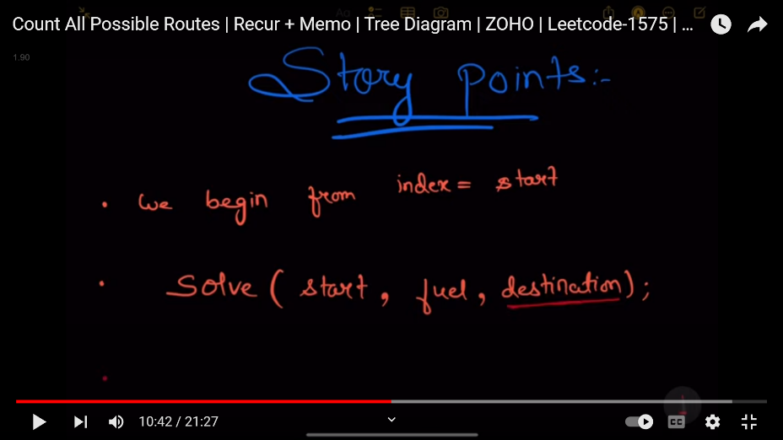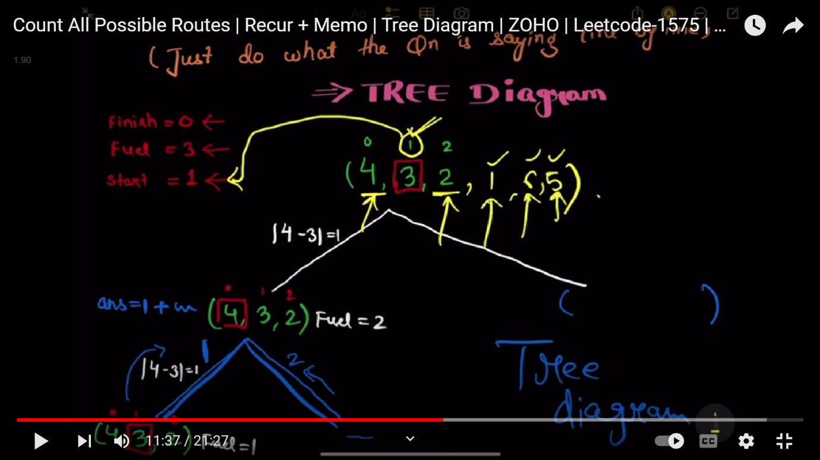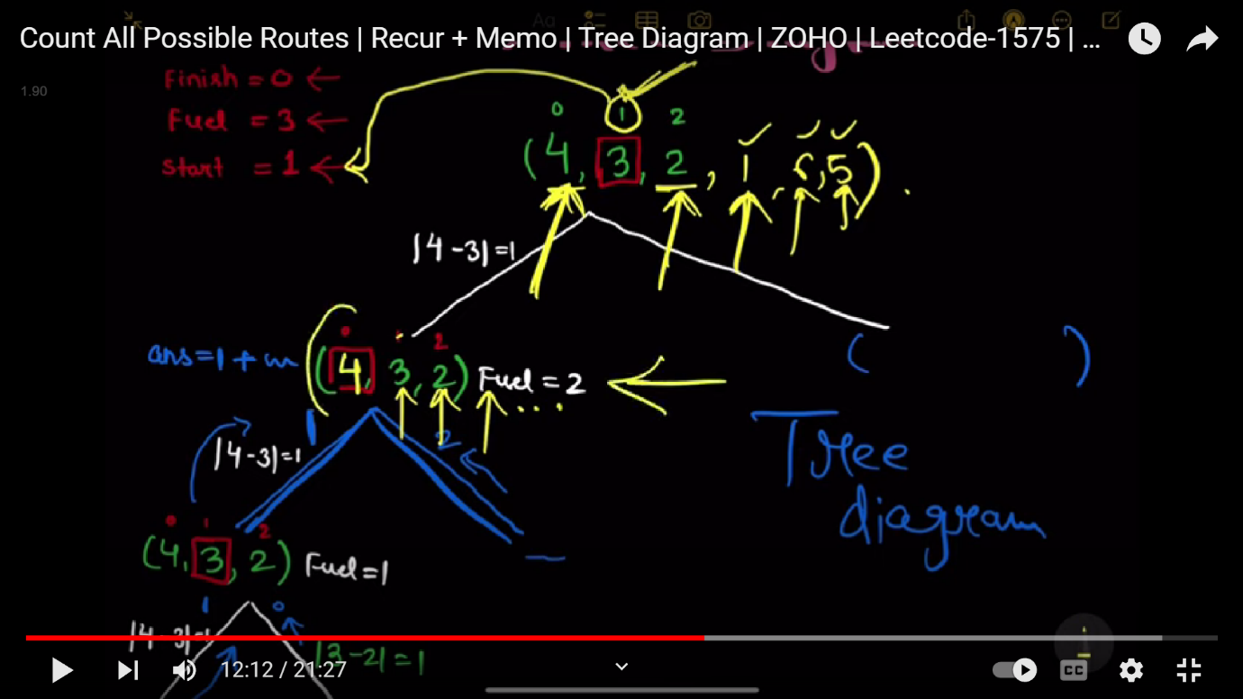

class Solution {

public:

    int n;

    int mod=1000000007;

    int dp[101][201];

    int solve(vector<int>& locations, int i, int finish, int fuel){

        if(fuel<0){

            return 0;

        }

        if(dp[i][fuel]!=-1){

            return dp[i][fuel];

        }



        int ans=0;

        if(i==finish){

            ans+=1 ;

        }

        for(int j=0;j<n;j++){

            if(i!=j){

                int remain = fuel- abs(locations[i]-locations[j]);

                ans=(ans+solve(locations,j,finish,remain))%mod;

            }

        }

        return dp[i][fuel]=ans%mod;

    }

    int countRoutes(vector<int>& locations, int start, int finish, int fuel) {

        memset(dp,-1,sizeof(dp));

        n=locations.size();

        return solve(locations,start,finish,fuel);

    }

};

**262: Tallest BillBoard**

You are installing a billboard and want it to have the largest height. The billboard will have two steel supports, one on each side. Each steel support must be an equal height.

You are given a collection of rods that can be welded together. For example, if you have rods of lengths 1, 2, and 3, you can weld them together to make a support of length 6.

Return *the largest possible height of your billboard installation*. If you cannot support the billboard, return 0.

**Example 1:**

**Input:** rods = [1,2,3,6]

**Output:** 6

**Explanation:** We have two disjoint subsets {1,2,3} and {6}, which have the same sum = 6.

**Example 2:**

**Input:** rods = [1,2,3,4,5,6]

**Output:** 10

**Explanation:** We have two disjoint subsets {2,3,5} and {4,6}, which have the same sum = 10.

**Example 3:**

**Input:** rods = [1,2]

**Output:** 0

**Explanation:** The billboard cannot be supported, so we return 0.

**Constraints:**

* 1 <= rods.length <= 20
* 1 <= rods[i] <= 1000
* sum(rods[i]) <= 5000

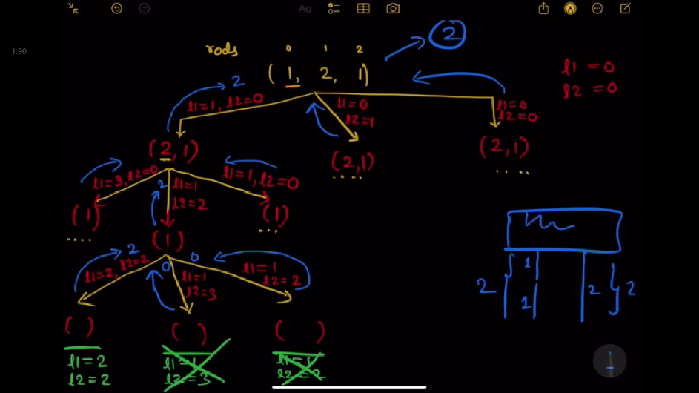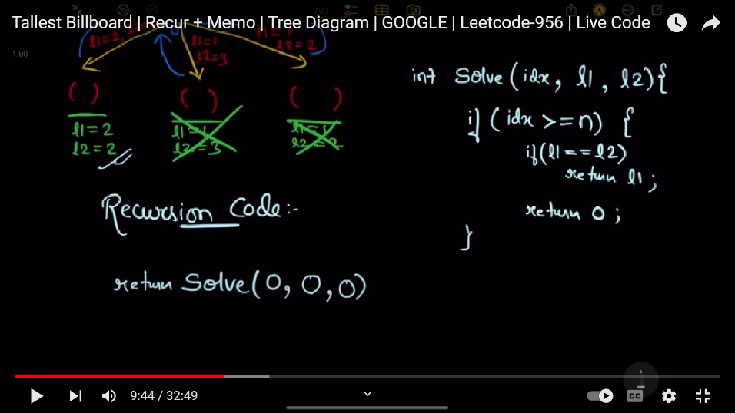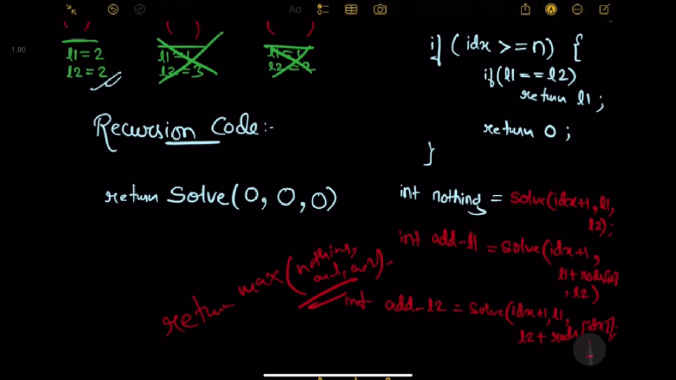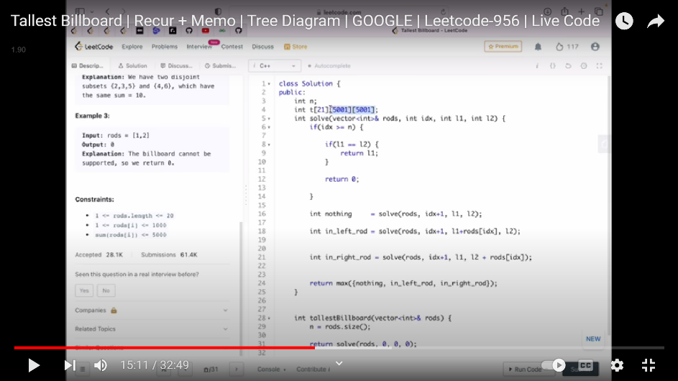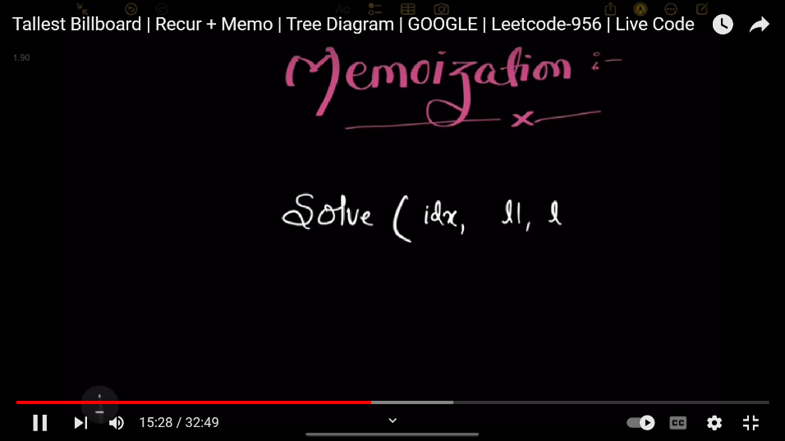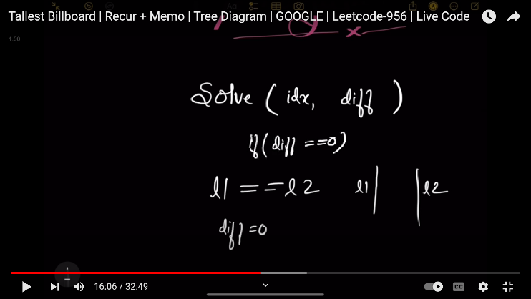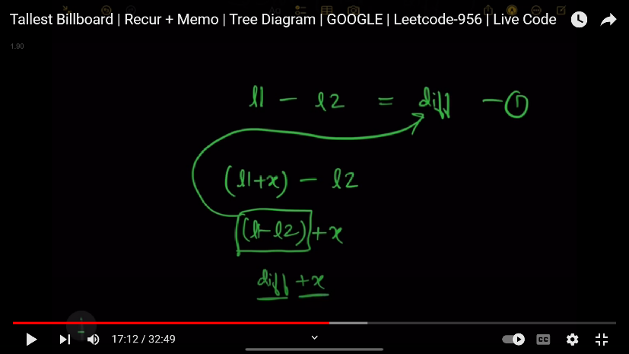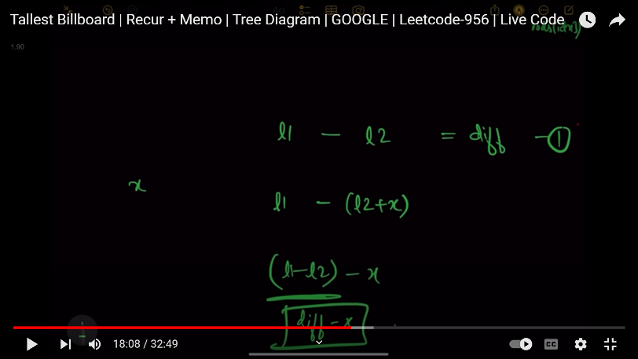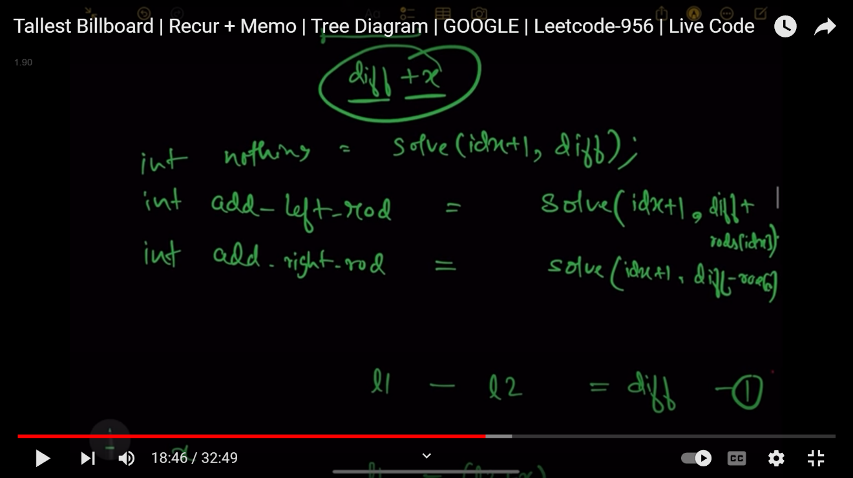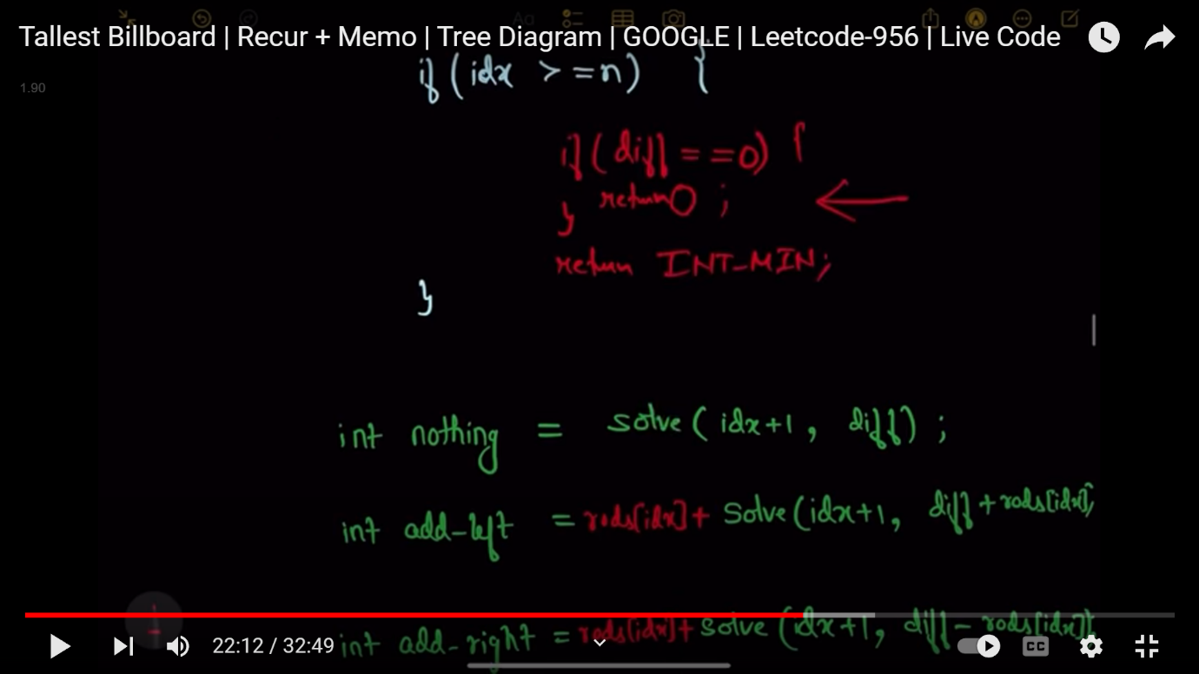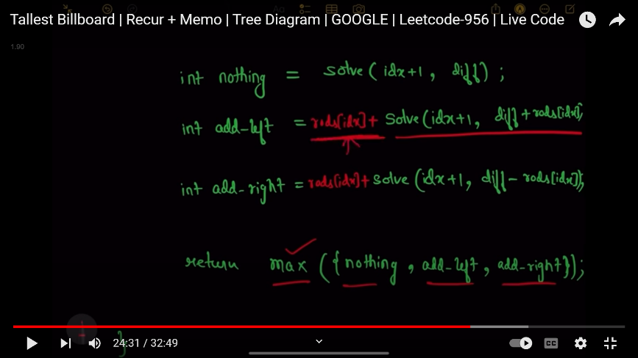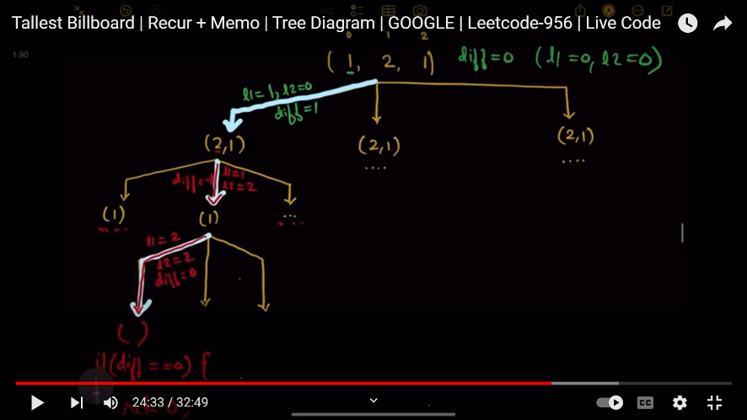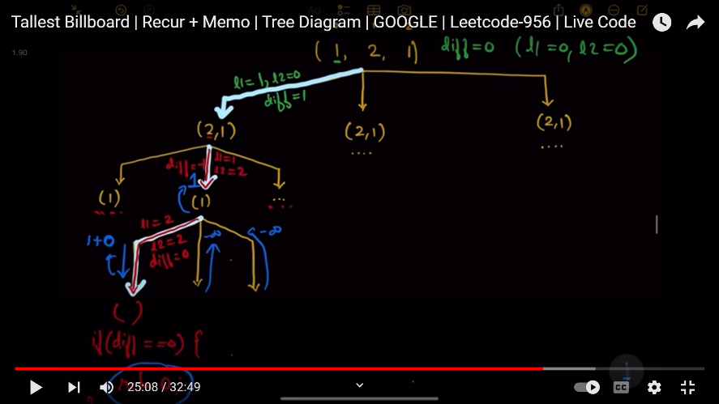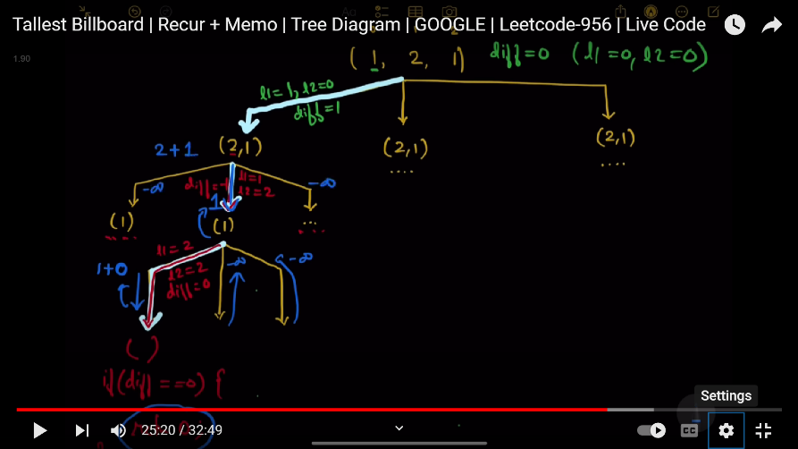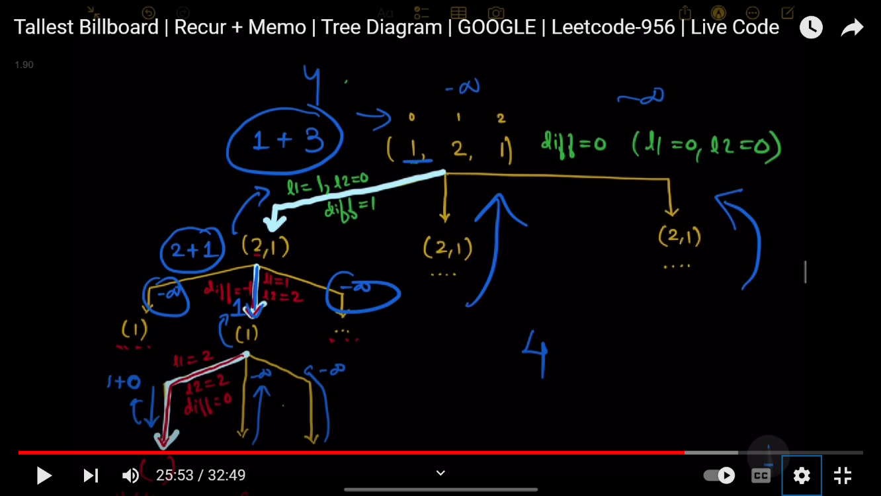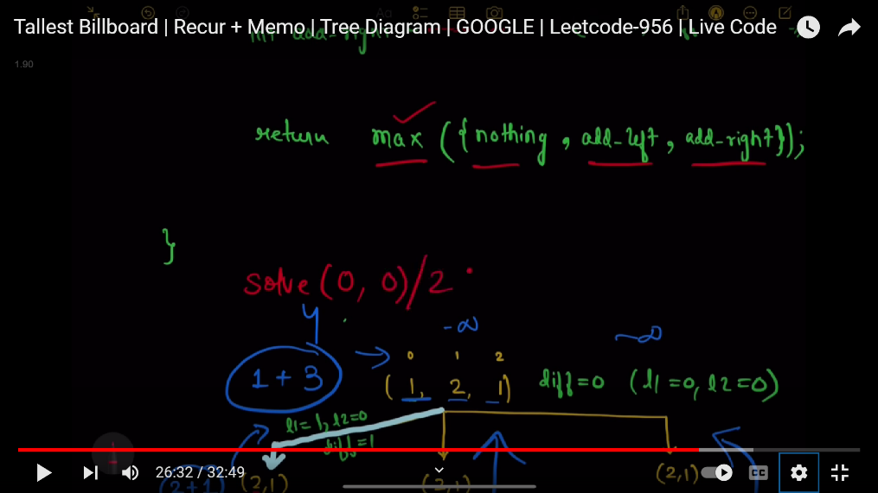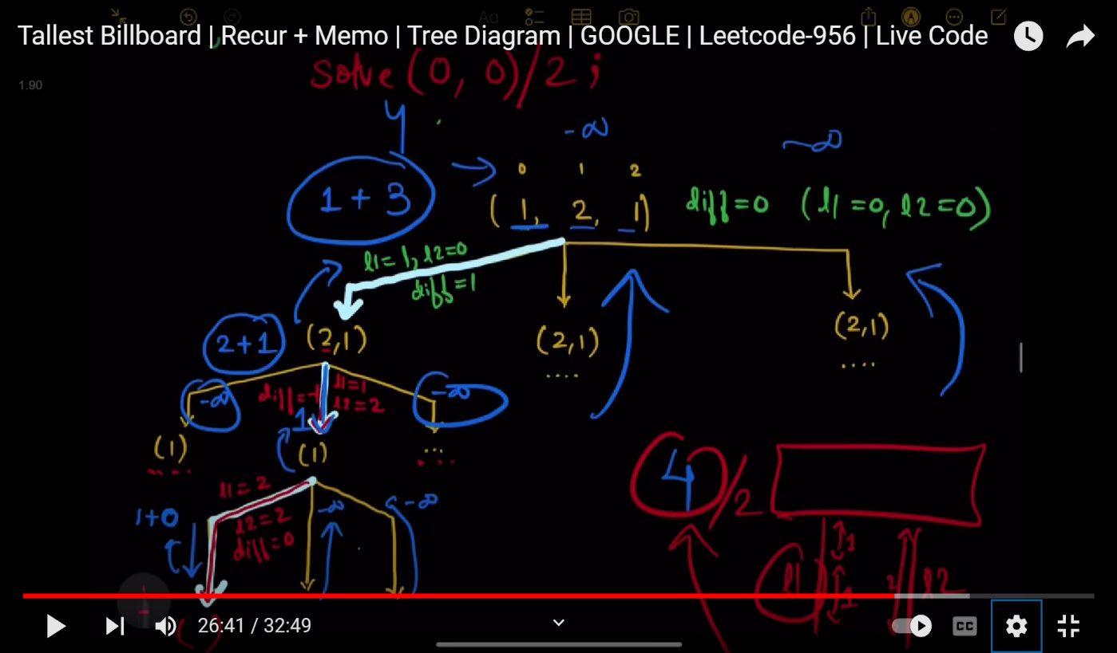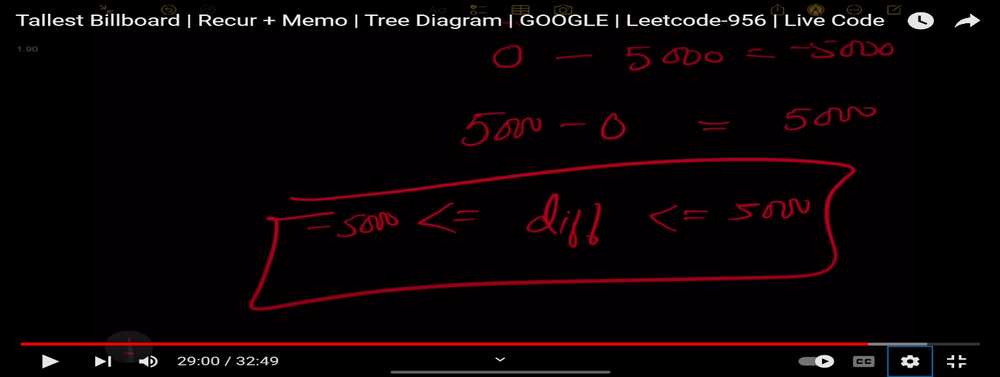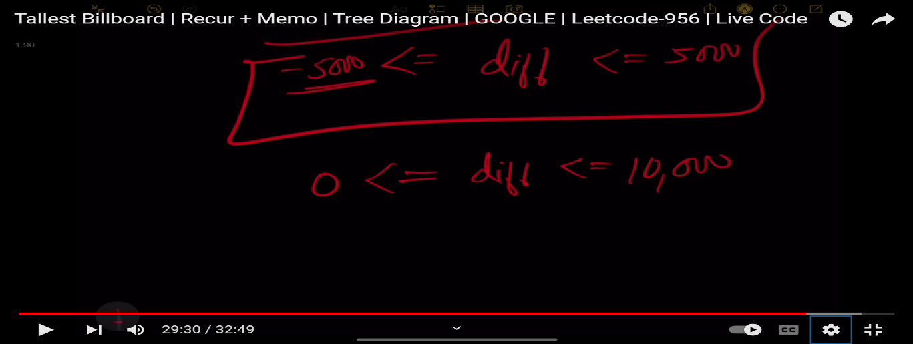

//using recursion -->>tle

class Solution {

public:

    int n;

    int solve(vector<int>&rods,int i,int l1,int l2){

        if(i==n){

            if(l1==l2){

                return l1;

            }

            return 0;

        }

        int nothing=solve(rods,i+1,l1,l2);

        int add_leftrod=solve(rods,i+1,l1+rods[i],l2);

        int add_rightrod=solve(rods,i+1,l1,l2+rods[i]);

        return max(nothing,max(add_leftrod,add_rightrod));

    }

    int tallestBillboard(vector<int>& rods) {

        n=rods.size();

        return solve(rods,0,0,0);

    }

};

**using memorization**

class Solution {

public:

    int dp[21][10001];

    int n;

    int solve(vector<int>&rods,int i,int diff){

        if(i>=n){

            if(diff==0){

                return 0;

            }

            return INT_MIN;

        }

        if(dp[i][diff+5000]!=-1){

            return dp[i][diff+5000];

        }

        int nothing=solve(rods,i+1,diff);

        int add_leftrod=rods[i]+solve(rods,i+1,diff+rods[i]);

        int add_rightrod=rods[i]+solve(rods,i+1,diff-rods[i]);

        return dp[i][diff+5000]=max(nothing,max(add_leftrod,add_rightrod));

    }

    int tallestBillboard(vector<int>& rods) {

        memset(dp,-1,sizeof(dp));

        n=rods.size();

        return (solve(rods,0,0)/2);

    }

};

**263: Best time to buy and sell stock I**

You are given an array prices where prices[i] is the price of a given stock on the ith day.

You want to maximize your profit by choosing a **single day** to buy one stock and choosing a **different day in the future** to sell that stock.

Return *the maximum profit you can achieve from this transaction*. If you cannot achieve any profit, return 0.

**Example 1:**

**Input:** prices = [7,1,5,3,6,4]

**Output:** 5

**Explanation:** Buy on day 2 (price = 1) and sell on day 5 (price = 6), profit = 6-1 = 5.

Note that buying on day 2 and selling on day 1 is not allowed because you must buy before you sell.

**Example 2:**

**Input:** prices = [7,6,4,3,1]

**Output:** 0

**Explanation:** In this case, no transactions are done and the max profit = 0.

**Constraints:**

* 1 <= prices.length <= 105
* 0 <= prices[i] <= 104
* /*class Solution {
* public:
* int maxProfit(vector<int>& prices) {
* int profit=0,minprice=INT_MAX,maxprofit=0;
* for(int i=0;i<prices.size();i++)
* {
* minprice=min(prices[i],minprice);
* maxprofit=max(maxprofit,prices[i]-minprice);
* }
* return maxprofit;
* }
* };*/
* //1->buy , 0->not buy
* // recursion & memoization
* class Solution {
* public:
* int dp[300001][3][2];
* int n;
* int solve(vector<int>& prices,int i,int buy,int tra){
* if(i>=n){
* return 0;
* }
* if(dp[i][buy][tra]!=-1){
* return dp[i][buy][tra];
* }
* int profit=0;
* if(buy==1 && tra<1){
* profit = max(-prices[i]+solve(prices,i+1,0,tra),solve(prices,i+1,1,tra));                                  //buy                  // not buy
* }
* else if(buy==0 && tra<1){
* profit = max(prices[i]+solve(prices,i+1,1,tra+1),solve(prices,i+1,0,tra));                                  //sale                 // not sale
* }
* return dp[i][buy][tra] =profit;
* }
* int maxProfit(vector<int>& prices) {
* n=prices.size();
* memset(dp,-1,sizeof(dp));
* return solve(prices,0,1,0);
* }
* };

**264: Best time to buy and sell stock ||**

You are given an integer array prices where prices[i] is the price of a given stock on the ith day.

On each day, you may decide to buy and/or sell the stock. You can only hold **at most one** share of the stock at any time. However, you can buy it then immediately sell it on the **same day**.

Find and return *the****maximum****profit you can achieve*.

**Example 1:**

**Input:** prices = [7,1,5,3,6,4]

**Output:** 7

**Explanation:** Buy on day 2 (price = 1) and sell on day 3 (price = 5), profit = 5-1 = 4.

Then buy on day 4 (price = 3) and sell on day 5 (price = 6), profit = 6-3 = 3.

Total profit is 4 + 3 = 7.

**Example 2:**

**Input:** prices = [1,2,3,4,5]

**Output:** 4

**Explanation:** Buy on day 1 (price = 1) and sell on day 5 (price = 5), profit = 5-1 = 4.

Total profit is 4.

**Example 3:**

**Input:** prices = [7,6,4,3,1]

**Output:** 0

**Explanation:** There is no way to make a positive profit, so we never buy the stock to achieve the maximum profit of 0.

//1->buy , 0->not buy

// recursion & memoization

class Solution {

public:

    int dp[300001][3];

    int n;

    int solve(vector<int>& prices,int i,int buy){

        if(i>=n){

            return 0;

        }

        if(dp[i][buy]!=-1){

            return dp[i][buy];

        }

        int profit=0;

        if(buy==1){

            profit = max(-prices[i]+solve(prices,i+1,0),solve(prices,i+1,1));                                  //buy                  // not buy

        }

        else{

           profit = max(prices[i]+solve(prices,i+1,1),solve(prices,i+1,0));                                  //sale                 // not sale

        }

        return dp[i][buy] =profit;

    }

    int maxProfit(vector<int>& prices) {

        n=prices.size();

        memset(dp,-1,sizeof(dp));

        return solve(prices,0,1);

    }

};

//tabulation

class Solution {

public:

    int maxProfit(vector<int>& prices) {

        int n=prices.size();

        vector<vector<int>>dp(n+1,vector<int>(2,0));

        for(int i=n-1;i>=0;i--){

            for(int buy=0;buy<=1;buy++){

                int profit=0;

                if(buy==1){

                    profit=max(-prices[i]+dp[i+1][0],dp[i+1][1]);

                }

                else{

                    profit=max(prices[i]+dp[i+1][1],dp[i+1][0]);

                }

                dp[i][buy]=profit;

            }

        }

        return dp[0][1];

    }

};

**265: Best time to buy and sell stock |||**

You are given an array prices where prices[i] is the price of a given stock on the ith day.

Find the maximum profit you can achieve. You may complete **at most two transactions**.

**Note:** You may not engage in multiple transactions simultaneously (i.e., you must sell the stock before you buy again).

**Example 1:**

**Input:** prices = [3,3,5,0,0,3,1,4]

**Output:** 6

**Explanation:** Buy on day 4 (price = 0) and sell on day 6 (price = 3), profit = 3-0 = 3.

Then buy on day 7 (price = 1) and sell on day 8 (price = 4), profit = 4-1 = 3.

**Example 2:**

**Input:** prices = [1,2,3,4,5]

**Output:** 4

**Explanation:** Buy on day 1 (price = 1) and sell on day 5 (price = 5), profit = 5-1 = 4.

Note that you cannot buy on day 1, buy on day 2 and sell them later, as you are engaging multiple transactions at the same time. You must sell before buying again.

**Example 3:**

**Input:** prices = [7,6,4,3,1]

**Output:** 0

**Explanation:** In this case, no transaction is done, i.e. max profit = 0.

**Constraints:**

* 1 <= prices.length <= 105
* 0 <= prices[i] <= 105
* //1->buy , 0->not buy
* // recursion & memoization
* class Solution {
* public:
* int dp[300001][3][3];
* int n;
* int solve(vector<int>& prices,int i,int buy,int tra){
* if(i>=n){
* return 0;
* }
* if(dp[i][buy][tra]!=-1){
* return dp[i][buy][tra];
* }
* int profit=0;
* if(buy==1 && tra<2){
* profit = max(-prices[i]+solve(prices,i+1,0,tra),solve(prices,i+1,1,tra));                                  //buy                  // not buy
* }
* else if(buy==0 && tra<2){
* profit = max(prices[i]+solve(prices,i+1,1,tra+1),solve(prices,i+1,0,tra));                                  //sale                 // not sale
* }
* return dp[i][buy][tra] =profit;
* }
* int maxProfit(vector<int>& prices) {
* n=prices.size();
* memset(dp,-1,sizeof(dp));
* return solve(prices,0,1,0);
* }
* };

**266: Best time to buy and sell stock IV**

You are given an integer array prices where prices[i] is the price of a given stock on the ith day, and an integer k.

Find the maximum profit you can achieve. You may complete at most k transactions: i.e. you may buy at most k times and sell at most k times.

**Note:** You may not engage in multiple transactions simultaneously (i.e., you must sell the stock before you buy again).

**Example 1:**

**Input:** k = 2, prices = [2,4,1]

**Output:** 2

**Explanation:** Buy on day 1 (price = 2) and sell on day 2 (price = 4), profit = 4-2 = 2.

**Example 2:**

**Input:** k = 2, prices = [3,2,6,5,0,3]

**Output:** 7

**Explanation:** Buy on day 2 (price = 2) and sell on day 3 (price = 6), profit = 6-2 = 4. Then buy on day 5 (price = 0) and sell on day 6 (price = 3), profit = 3-0 = 3.

**Constraints:**

* 1 <= k <= 100
* 1 <= prices.length <= 1000
* 0 <= prices[i] <= 1000
* //1->buy , 0->not buy
* // recursion & memoization
* class Solution {
* public:
* int n;
* int dp[1001][3][1001];
* int solve(vector<int>& prices,int i,int buy,int tra,int k){
* if(i>=n){
* return 0;
* }
* if(dp[i][buy][tra]!=-1){
* return dp[i][buy][tra];
* }
* int profit=0;
* if(buy==1 && tra<k){
* profit = max(-prices[i]+solve(prices,i+1,0,tra,k),solve(prices,i+1,1,tra,k));                                  //buy                  // not buy
* }
* else if(buy==0 && tra<k){
* profit = max(prices[i]+solve(prices,i+1,1,tra+1,k),solve(prices,i+1,0,tra,k));                                  //sale                 // not sale
* }
* return dp[i][buy][tra] =profit;
* }
* int maxProfit(int k, vector<int> &prices) {
* n=prices.size();
* memset(dp,-1,sizeof(dp));
* return solve(prices,0,1,0,k);
* }
* };

**267: Best time to buy and sell stock with cooldown**

You are given an array prices where prices[i] is the price of a given stock on the ith day.

Find the maximum profit you can achieve. You may complete as many transactions as you like (i.e., buy one and sell one share of the stock multiple times) with the following restrictions:

* After you sell your stock, you cannot buy stock on the next day (i.e., cooldown one day).

**Note:** You may not engage in multiple transactions simultaneously (i.e., you must sell the stock before you buy again).

**Example 1:**

**Input:** prices = [1,2,3,0,2]

**Output:** 3

**Explanation:** transactions = [buy, sell, cooldown, buy, sell]

**Example 2:**

**Input:** prices = [1]

**Output:** 0

**Constraints:**

* 1 <= prices.length <= 5000
* 0 <= prices[i] <= 1000
* //1->buy , 0->not buy
* // recursion & memoization
* class Solution {
* public:
* int dp[300001][3];
* int n;
* int solve(vector<int>& prices,int i,int buy){
* if(i>=n){
* return 0;
* }
* if(dp[i][buy]!=-1){
* return dp[i][buy];
* }
* int profit=0;
* if(buy==1){
* profit = max(-prices[i]+solve(prices,i+1,0),solve(prices,i+1,1));                                  //buy                  // not buy
* }
* else{
* profit = max(prices[i]+solve(prices,i+2,1),solve(prices,i+1,0));                                  //sale (i+2 for cooldown)              // not sale
* }
* return dp[i][buy] =profit;
* }
* int maxProfit(vector<int>& prices) {
* n=prices.size();
* memset(dp,-1,sizeof(dp));
* return solve(prices,0,1);
* }
* };

**268: Best time to buy and sell stock with transaction fee**

You are given an array prices where prices[i] is the price of a given stock on the ith day, and an integer fee representing a transaction fee.

Find the maximum profit you can achieve. You may complete as many transactions as you like, but you need to pay the transaction fee for each transaction.

**Note:**

* You may not engage in multiple transactions simultaneously (i.e., you must sell the stock before you buy again).
* The transaction fee is only charged once for each stock purchase and sale.

**Example 1:**

**Input:** prices = [1,3,2,8,4,9], fee = 2

**Output:** 8

**Explanation:** The maximum profit can be achieved by:

- Buying at prices[0] = 1

- Selling at prices[3] = 8

- Buying at prices[4] = 4

- Selling at prices[5] = 9

The total profit is ((8 - 1) - 2) + ((9 - 4) - 2) = 8.

**Example 2:**

**Input:** prices = [1,3,7,5,10,3], fee = 3

**Output:** 6

**Constraints:**

* 1 <= prices.length <= 5 * 104
* 1 <= prices[i] < 5 * 104
* 0 <= fee < 5 * 104
* //1->buy , 0->not buy
* // recursion & memoization
* class Solution {
* public:
* int dp[300001][3];
* int n;
* int f;
* int solve(vector<int>& prices,int i,int buy){
* if(i>=n){
* return 0;
* }
* if(dp[i][buy]!=-1){
* return dp[i][buy];
* }
* int profit=0;
* if(buy==1){
* profit = max(-prices[i]+solve(prices,i+1,0),solve(prices,i+1,1));                                  //buy                  // not buy
* }
* else{
* profit = max(prices[i]-f+solve(prices,i+1,1),solve(prices,i+1,0));                                  //sale              // not sale
* }
* return dp[i][buy] =profit;
* }
* int maxProfit(vector<int>& prices, int fee) {
* n=prices.size();
* f=fee;
* memset(dp,-1,sizeof(dp));
* return solve(prices,0,1);
* }
* };

**269: Minimum no of platforms**

Given arrival and departure times of all trains that reach a railway station. Find the minimum number of platforms required for the railway station so that no train is kept waiting.  
Consider that all the trains arrive on the same day and leave on the same day. Arrival and departure time can never be the same for a train but we can have arrival time of one train equal to departure time of the other. At any given instance of time, same platform can not be used for both departure of a train and arrival of another train. In such cases, we need different platforms**.**

**Example 1:**

**Input**: n = 6

arr[] = {0900, 0940, 0950, 1100, 1500, 1800}

dep[] = {0910, 1200, 1120, 1130, 1900, 2000}

**Output**: 3

**Explanation**:

Minimum 3 platforms are required to

safely arrive and depart all trains.

**Example 2:**

**Input**: n = 3

arr[] = {0900, 1100, 1235}

dep[] = {1000, 1200, 1240}

**Output**: 1

**Explanation**: Only 1 platform is required to

safely manage the arrival and departure

of all trains.

int countPlatforms(int n,int arr[],int dep[])

 {

    sort(arr,arr+n);

    sort(dep,dep+n);

    int ans=1;

    int count=1;

    int i=1,j=0;

    while(i<n && j<n)

    {

        if(arr[i]<=dep[j]) //one more platform needed

        {

            count++;

            i++;

        }

        else //one platform can be reduced

        {

            count--;

            j++;

        }

        ans=max(ans,count); //updating the value with the current maximum

    }

    return ans;

 }

bool cmp(pair<int,int>&a,pair<int,int>&b){

    if(a.first!=b.first){

        return a.first<b.first;

    }

    return a.second<b.second;

}

int calculateMinPatforms(int at[], int dt[], int n) {

    // Write your code here.

    vector<pair<int,int>>vec;

    for(int i=0;i<n;i++){

        vec.push_back({at[i],dt[i]});

    }

    sort(vec.begin(),vec.end(),cmp);

    priority_queue<int,vector<int>,greater<int>>pq;//it is made to compare from

    // the previous min departure

    pq.push(vec[0].second);

    int cnt=1;

    for(int i=1;i<vec.size();i++){

        if(vec[i].first>pq.top()){

            pq.pop();

        }

        else{

            cnt++;

        }

        pq.push(vec[i].second);

    }

    return cnt;

**270: Job sequencing Problem**

Given a set of **N** jobs where each **jobi** has a deadline and profit associated with it.

Each job takes ***1*** unit of time to complete and only one job can be scheduled at a time. We earn the profit associated with job if and only if the job is completed by its deadline.

Find the number of jobs done and the **maximum profit**.

**Note:**Jobs will be given in the form (Jobid, Deadline, Profit) associated with that Job.

**Example 1:**

**Sample Input 1:**

2 //no of test case

4 //no of elements

2 2 1 1 //deadline

30 40 10 10 //profit

5 //no of elements

2 4 1 3 5

25 40 5 50 60

##### Sample Output 1 :

70

180

##### Explanation For Sample Input 1 :

For the first test case, the first and second jobs can be completed within the deadlines, and we earn a profit of 70 by doing so.

For the second test case, all the jobs have different deadlines. So we complete all the jobs.

##### Sample Input 2 :

2

1

2

50

3

1 1 1

40 60 50

##### Sample Output 2 :

50

60

#include <bits/stdc++.h>

int jobScheduling(vector<vector<int>> &jobs)

{

    unordered_map<int,vector<int>>mp;

    int maxi_deadline=0;

    for(int i=0;i<jobs.size();i++){

        mp[jobs[i][0]].push_back(jobs[i][1]);

        maxi_deadline=max(maxi_deadline,jobs[i][0]);

    }

    int ans=0;

    priority_queue<int>pq; //made to give the maxprofit

    for(int i=maxi_deadline;i>0;i--){

        for(auto &v: mp[i]){

            pq.push(v);

        }

        if(pq.size()==0){

            continue;

        }

        ans+=pq.top();

        pq.pop();

    }

    return ans;

}

**271: Find K pairs with smallest sums**

You are given two integer arrays nums1 and nums2 sorted in **ascending order** and an integer k.

Define a pair (u, v) which consists of one element from the first array and one element from the second array.

Return *the* k *pairs* (u1, v1), (u2, v2), ..., (uk, vk) *with the smallest sums*.

**Example 1:**

**Input:** nums1 = [1,7,11], nums2 = [2,4,6], k = 3

**Output:** [[1,2],[1,4],[1,6]]

**Explanation:** The first 3 pairs are returned from the sequence: [1,2],[1,4],[1,6],[7,2],[7,4],[11,2],[7,6],[11,4],[11,6]

**Example 2:**

**Input:** nums1 = [1,1,2], nums2 = [1,2,3], k = 2

**Output:** [[1,1],[1,1]]

**Explanation:** The first 2 pairs are returned from the sequence: [1,1],[1,1],[1,2],[2,1],[1,2],[2,2],[1,3],[1,3],[2,3]

**Example 3:**

**Input:** nums1 = [1,2], nums2 = [3], k = 3

**Output:** [[1,3],[2,3]]

**Explanation:** All possible pairs are returned from the sequence: [1,3],[2,3]

**Constraints:**

* 1 <= nums1.length, nums2.length <= 105
* -109 <= nums1[i], nums2[i] <= 109
* nums1 and nums2 both are sorted in **ascending order**.
* 1 <= k <= 104
* //standard question of heap priority_queue
* //optimized brute force solution
* class Solution {
* public:
* vector<vector<int>> kSmallestPairs(vector<int>& nums1, vector<int>& nums2, int k) {
* priority_queue<pair<int,pair<int,int>>>pq;
* for(int i=0;i<nums1.size();i++){
* for(int j=0;j<nums2.size();j++){
* int sum=nums1[i]+nums2[j];
* if(pq.size()<k){
* pq.push({sum,{i,j}});
* }
* else if(sum<pq.top().first){
* pq.pop();
* pq.push({sum,{i,j}});
* }
* else{
* break;
* }
* }
* }
* vector<vector<int>>ans;
* while(!pq.empty()){
* int i=pq.top().second.first;
* int j=pq.top().second.second;
* ans.push_back({nums1[i],nums2[j]});
* pq.pop();
* }
* return ans;
* }
* };

**272: Subset Sums(striver sde sheet)**

**Problem Statement:** Given an array print all the sum of the subset generated from it, in the increasing order.

**Examples:**

**Example 1:**

**Input:** N = 3, arr[] = {5,2,1}

**Output:** 0,1,2,3,5,6,7,8

**Explanation:** We have to find all the subset’s sum and print them.in this case the generated subsets are [ [], [1], [2], [2,1], [5], [5,1], [5,2]. [5,2,1],so the sums we get will be 0,1,2,3,5,6,7,8

**Input:** N=3,arr[]= {3,1,2}

**Output:** 0,1,2,3,3,4,5,6

**Explanation:** We have to find all the subset’s sum and print them.in this case the generated subsets are [ [], [1], [2], [2,1], [3], [3,1], [3,2]. [3,2,1],so the sums we get will be 0,1,2,3,3,4,5,6

### **Solution**

**Disclaimer**: Don’t jump directly to the solution, try it out yourself first.

**Solution 1: Using recursion**

**Intuition**: The main idea is that on every index you have two options either to select the element to add it to your subset(pick) or not select the element at that index and move to the next index(non-pick).

**Approach:**Traverse through the array and for each index solve for two arrays, one where you pick the element,i.e add the element to the sum or don’t pick and move to the next element, recursively, until the base condition. Here when you reach the end of the array is the base condition.

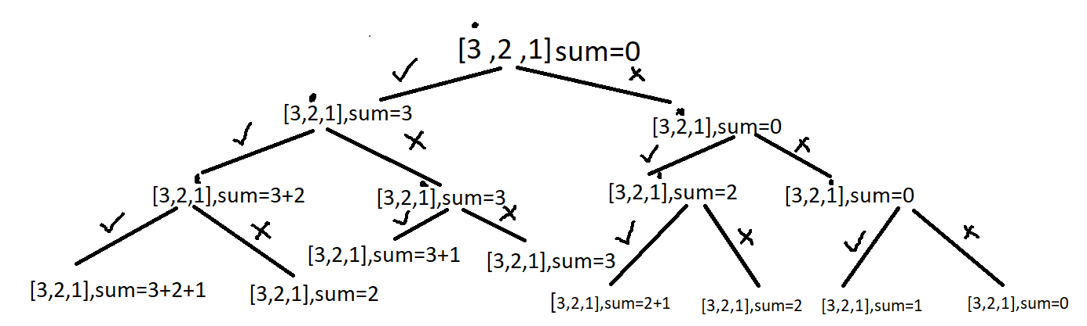

**Code:**

* C++ Code
* Java Code
* Python Code

#include<bits/stdc++.h>

using namespace std;

class Solution {

public:

void subsetSumsHelper(int ind, vector < int > & arr, int n, vector < int > & ans, int sum) {

if (ind == n) {

ans.push_back(sum);

return;

}

//element is picked

subsetSumsHelper(ind + 1, arr, n, ans, sum + arr[ind]);

//element is not picked

subsetSumsHelper(ind + 1, arr, n, ans, sum);

}

vector < int > subsetSums(vector < int > arr, int n) {

vector < int > ans;

subsetSumsHelper(0, arr, n, ans, 0);

sort(ans.begin(), ans.end());

return ans;

}

};

int main() {

vector < int > arr{3,1,2};

Solution ob;

vector < int > ans = ob.subsetSums(arr, arr.size());

sort(ans.begin(), ans.end());

cout<<"The sum of each subset is "<<endl;

for (auto sum: ans) {

cout << sum << " ";

}

cout << endl;

return 0;

}

**Output:**

The sum of each subset is  
0 1 2 3 3 4 5 6

**Time Complexity**: O(2^n)+O(2^n log(2^n)). Each index has two ways. You can either pick it up or not pick it. So for n index time complexity for O(2^n) and for sorting it will take (2^n log(2^n)).

**Space Complexity:**O(2^n) for storing subset sums, since 2^n subsets can be generated for an array of size n.

**273: Subset ||**

**Problem Statement:** Given an array of integers that **may contain duplicates** the task is to return all possible subsets. Return only **unique subsets**and they can be in any order.

**Examples:**

**Example 1:**

**Input:** array[] = [1,2,2]

**Output:** [ [ ],[1],[1,2],[1,2,2],[2],[2,2] ]

**Explanation:** We can have subsets ranging from length 0 to 3. which are listed above. Also the subset [1,2] appears twice but is printed only once as we require only unique subsets.

**Input:** array[] = [1]

**Output:** [ [ ], [1] ]

**Explanation:** Only two unique subsets are available

### **Solution**

**Disclaimer**: Don’t jump directly to the solution, try it out yourself first.

**Solution 1: Brute Force**

**Approach**:  
At every index, we make a decision whether to pick or not pick the element at that index. This will help us in generating all possible combinations but does not take care of the duplicates. Hence we will use a set to store all the combinations that will discard the duplicates.

**Code:**

* C++ Code
* Java Code
* Python Code

#include <bits/stdc++.h>

using namespace std;

void printAns(vector < vector < int >> & ans) {

cout << "The unique subsets are " << endl;

cout << "[ ";

for (int i = 0; i < ans.size(); i++) {

cout << "[ ";

for (int j = 0; j < ans[i].size(); j++)

cout << ans[i][j] << " ";

cout << "]";

}

cout << " ]";

}

class Solution {

public:

void fun(vector < int > & nums, int index, vector < int > ds, set < vector < int >> & res) {

if (index == nums.size()) {

sort(ds.begin(), ds.end());

res.insert(ds);

return;

}

ds.push_back(nums[index]);

fun(nums, index + 1, ds, res);

ds.pop_back();

fun(nums, index + 1, ds, res);

}

vector < vector < int >> subsetsWithDup(vector < int > & nums) {

vector < vector < int >> ans;

set < vector < int >> res;

vector < int > ds;

fun(nums, 0, ds, res);

for (auto it = res.begin(); it != res.end(); it++) {

ans.push_back( * it);

}

return ans;

}

};

int main() {

Solution obj;

vector < int > nums = {1, 2, 2};

vector < vector < int >> ans = obj.subsetsWithDup(nums);

printAns(ans);

return 0;

}

**Output:**

The unique subsets are  
[ [ ][ 1 ][ 1 2 ][ 1 2 2 ][ 2 ][ 2 2 ] ]

**Time Complexity: O( 2^n *(k log (x) )). 2^n**for generating every subset and **k\*** **log( x)**  to insert every combination of average length k in a set of size x. After this, we have to convert the set of combinations back into a list of list /vector of vectors which takes more time.

**Space Complexity:  O(2^n * k)**to store every subset of average length k. Since we are initially using a set to store the answer another **O(2^n *k)** is also used.

**Solution 2: Optimal**

**Approach**:

In the previous method, we were taking extra time to store the unique combination with the help of a set.  To make the solution efficient we will have to decide on a method that will consider only the unique combinations without the help of additional data structure.

Lets  understand  with an example where arr = [1,2,2 ].

Initially start with an empty data structure. In the first recursion, call make a subset of size one, in the next recursion call a subset of size 2, and so on. But first, in order to make a subset of size one what options do we have?

We can pick up elements from either the first index or the second index or the third index. However, if we have already picked up two from the second index, picking up two from the third index will make another duplicate subset of size one. Since we are trying to avoid duplicate subsets we can avoid picking up from the third index. This should give us an intuition that whenever there are duplicate elements in the array we pick up only the first occurrence.

The next recursion calls will continue from the point the previous one ended.

Let’s summarize:-

* Sort the input array.Make a recursive function that takes the input array ,the current subset,the current index and  a list of list/ vector of vectors to contain the answer.
* Try to make a subset of size n during the nth recursion call and consider elements from every index while generating the combinations. Only pick up elements that are appearing for the first time during a recursion call to avoid duplicates.
* Once an element is picked up, move to the next index.The recursion will terminate when the end of array is reached.While returning backtrack by removing the last element that was inserted.

**Code:**

* C++ Code
* Java Code
* Python Code

#include <bits/stdc++.h>

using namespace std;

void printAns(vector < vector < int >> & ans) {

cout<<"The unique subsets are "<<endl;

cout << "[ ";

for (int i = 0; i < ans.size(); i++) {

cout << "[ ";

for (int j = 0; j < ans[i].size(); j++

)

cout << ans[i][j] << " ";

cout << "]";

}

cout << " ]";

}

class Solution {

private:

void findSubsets(int ind, vector < int > & nums, vector < int > & ds, vector < vector < int >> & ans) {

ans.push_back(ds);

for (int i = ind; i < nums.size(); i++) {

if (i != ind && nums[i] == nums[i - 1]) continue;

ds.push_back(nums[i]);

findSubsets(i + 1, nums, ds, ans);

ds.pop_back();

}

}

public:

vector < vector < int >> subsetsWithDup(vector < int > & nums) {

vector < vector < int >> ans;

vector < int > ds;

sort(nums.begin(), nums.end());

findSubsets(0, nums, ds, ans);

return ans;

}

};

int main() {

Solution obj;

vector < int > nums = {1,2,2 };

vector < vector < int >> ans = obj.subsetsWithDup(nums);

printAns(ans);

return 0;

}

**Output:**

The unique subsets are  
[ [ ][ 1 ][ 1 2 ][ 1 2 2 ][ 2 ][ 2 2 ] ]

**Time Complexity: O(2^n)**for generating every subset and**O(k)**to insert every subset in another data structure if the average length of every subset is**k.** Overall **O(k * 2^n).**

**Space Complexity: O(2^n * k)**to store every subset of average length k. Auxiliary space is **O(n)** if n is the depth of the recursion tree.

**274: Combination Sum ||**

Given a collection of candidate numbers (candidates) and a target number (target), find all unique combinations in candidates where the candidate numbers sum to target.

Each number in candidates may only be used **once** in the combination.

**Note:** The solution set must not contain duplicate combinations.

**Example 1:**

**Input:** candidates = [10,1,2,7,6,1,5], target = 8

**Output:**

[

[1,1,6],

[1,2,5],

[1,7],

[2,6]

]

**Example 2:**

**Input:** candidates = [2,5,2,1,2], target = 5

**Output:**

[

[1,2,2],

[5]

]

**Constraints:**

* 1 <= candidates.length <= 100
* 1 <= candidates[i] <= 50
* 1 <= target <= 30
* //brute force tle
* class Solution {
* public:
* int n;
* void solve(vector<int>& candidates, int target, int i, set<vector<int>>& st, vector<int>& ds) {
* if (i == n) {
* if (target == 0) {
* st.insert(ds);
* }
* return;
* }
* // Include the current element
* if (target - candidates[i] >= 0) {
* ds.push_back(candidates[i]);
* solve(candidates, target - candidates[i], i + 1, st, ds);
* ds.pop_back(); // Backtrack by removing the last element
* }
* // Exclude the current element
* solve(candidates, target, i + 1, st, ds);
* }
* vector<vector<int>> combinationSum2(vector<int>& candidates, int target) {
* n = candidates.size();
* vector<vector<int>> ans;
* vector<int> ds;
* set<vector<int>> st;
* sort(candidates.begin(),candidates.end());
* solve(candidates, target, 0, st, ds);
* for (auto& it : st) {
* ans.push_back(it);
* }
* return ans;
* }
* };

To optimize the code and avoid Time Limit Exceeded (TLE) errors, you can utilize a more efficient approach such as backtracking with pruning. This approach involves avoiding unnecessary recursive calls by skipping elements that would lead to invalid or duplicate subsets.

In this optimized code, we sort the **candidates** vector in the beginning to handle duplicates efficiently. During the backtracking process, we use a for loop starting from **i** index and skip duplicates by checking if the current element is the same as the previous one (**candidates[i] == candidates[i - 1]**). This helps avoid unnecessary recursive calls and eliminates duplicate subsets.

Additionally, we check if **candidates[i]** is less than or equal to **target** before making a recursive call. This pruning step ensures that we only consider elements that can potentially contribute to a valid combination.

//optimal

class Solution {

public:

    int n;

    void solve(vector<int>& candidates, int target, int ind, vector<vector<int>>&ans, vector<int>& ds) {

        if (target == 0) {

            ans.push_back(ds);

            return ;

        }

        for(int i=ind; i<n && candidates[i]<=target;i++){

            if(i!=ind && candidates[i]==candidates[i-1]){

                continue; //skipping duplicates

            }

            ds.push_back(candidates[i]);// Include the current element

            solve(candidates,target-candidates[i],i+1,ans,ds);// Explore further combinationsz

            ds.pop_back(); // Backtrack by removing the last element

        }

    }

    vector<vector<int>> combinationSum2(vector<int>& candidates, int target) {

        n = candidates.size();

        vector<vector<int>> ans;

        vector<int> ds;

        sort(candidates.begin(),candidates.end());

        solve(candidates, target, 0, ans, ds);

        return ans;

    }

};

**274: Kth Permutation Sequence**

The set [1, 2, 3, ..., n] contains a total of n! unique permutations.

By listing and labeling all of the permutations in order, we get the following sequence for n = 3:

1. "123"
2. "132"
3. "213"
4. "231"
5. "312"
6. "321"

Given n and k, return the kth permutation sequence.

**Example 1:**

**Input:** n = 3, k = 3

**Output:** "213"

**Example 2:**

**Input:** n = 4, k = 9

**Output:** "2314"

**Example 3:**

**Input:** n = 3, k = 1

**Output:** "123"

**Constraints:**

* 1 <= n <= 9
* 1 <= k <= n!
* **Sol1: Brute force**
* **Time complexity**: **O(N! * N) +O(N! Log N!)**
* *Reason:  The recursion takes O(N!)  time because we generate every*possible permutation and another O(N)  time is required to make a deep copy and store every sequence in the data structure. Also,*O(N! Log N!)  time required to sort the data structure*
* **Space complexity: O(N)**
* *Reason*: Result stored in a vector*, we are auxiliary space taken by recursion*
* class Solution {
* public:
* //function to generate all possible permutations of a string
* void permutationHelper(string & s, int index, vector < string > & res) {
* if (index == s.size()) {
* res.push_back(s);
* return;
* }
* for (int i = index; i < s.size(); i++) {
* swap(s[i], s[index]);
* permutationHelper(s, index + 1, res);
* swap(s[i], s[index]);
* }
* }
* string getPermutation(int n, int k) {
* string s;
* vector < string > res;
* //create string
* for (int i = 1; i <= n; i++) {
* s.push_back(i + '0');
* }
* permutationHelper(s, 0, res);
* //sort the generated permutations
* sort(res.begin(), res.end());
* //make k 0-based indexed to point to kth sequence
* auto it = res.begin() + (k - 1);
* return *it;
* }
* };

**Sol2: optimal**

**Time Complexity: O(N) * O(N) = O(N^2)**

*Reason*: We are placing N numbers in N positions. This will take O(N) time. For every number,*we are reducing the search space by removing the element already placed in the previous step. This takes another O(N) time.*

Space Complexity: O(N)

*Reason: We are storing  the numbers in a data structure(here vector)*

class Solution {

  public:

    string getPermutation(int n, int k) {

        vector<int>num;

        int fact=1;

        for(int i=1;i<n;i++){

            fact=fact*i;          //calculating factorial for (n-1)

            num.push_back(i);

        }

        num.push_back(n);

        string ans="";

        k=k-1;

        while(true){

            ans=ans+to_string(num[k/fact]);//getting element's index from k/fact and get element

            num.erase(num.begin()+(k/fact)); //erasing that element from num

            if(num.size()==0){

                break;

            }

            k=k%fact;

            fact=fact/(num.size());

        }

        return ans;

    }

};

**275: Fair distribution of cookies**

You are given an integer array cookies, where cookies[i] denotes the number of cookies in the ith bag. You are also given an integer k that denotes the number of children to distribute **all** the bags of cookies to. All the cookies in the same bag must go to the same child and cannot be split up.

The **unfairness** of a distribution is defined as the **maximum** **total** cookies obtained by a single child in the distribution.

Return *the****minimum****unfairness of all distributions*.

**Example 1:**

**Input:** cookies = [8,15,10,20,8], k = 2

**Output:** 31

**Explanation:** One optimal distribution is [8,15,8] and [10,20]

- The 1st child receives [8,15,8] which has a total of 8 + 15 + 8 = 31 cookies.

- The 2nd child receives [10,20] which has a total of 10 + 20 = 30 cookies.

The unfairness of the distribution is max(31,30) = 31.

It can be shown that there is no distribution with an unfairness less than 31.

**Example 2:**

**Input:** cookies = [6,1,3,2,2,4,1,2], k = 3

**Output:** 7

**Explanation:** One optimal distribution is [6,1], [3,2,2], and [4,1,2]

- The 1st child receives [6,1] which has a total of 6 + 1 = 7 cookies.

- The 2nd child receives [3,2,2] which has a total of 3 + 2 + 2 = 7 cookies.

- The 3rd child receives [4,1,2] which has a total of 4 + 1 + 2 = 7 cookies.

The unfairness of the distribution is max(7,7,7) = 7.

It can be shown that there is no distribution with an unfairness less than 7.

**Constraints:**

* 2 <= cookies.length <= 8
* 1 <= cookies[i] <= 105
* 2 <= k <= cookie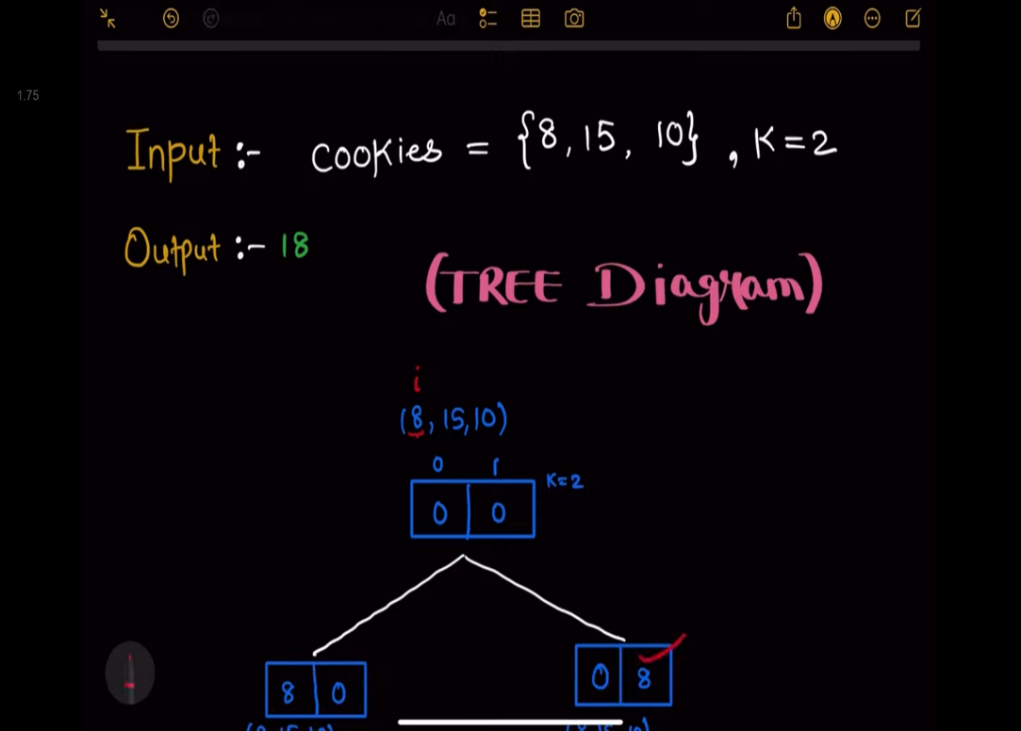s.length

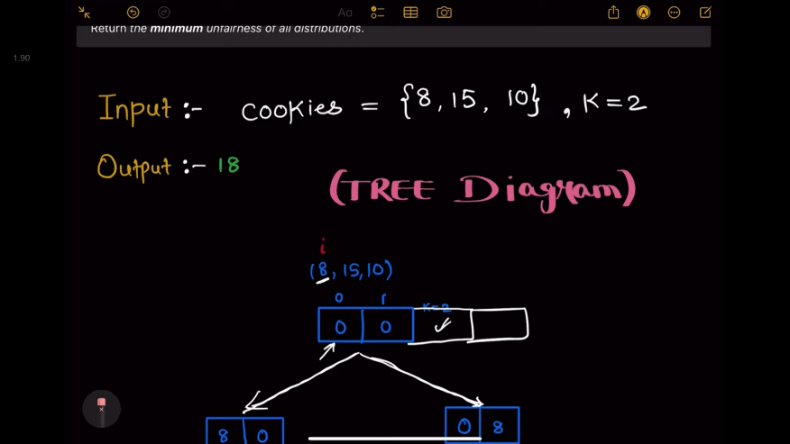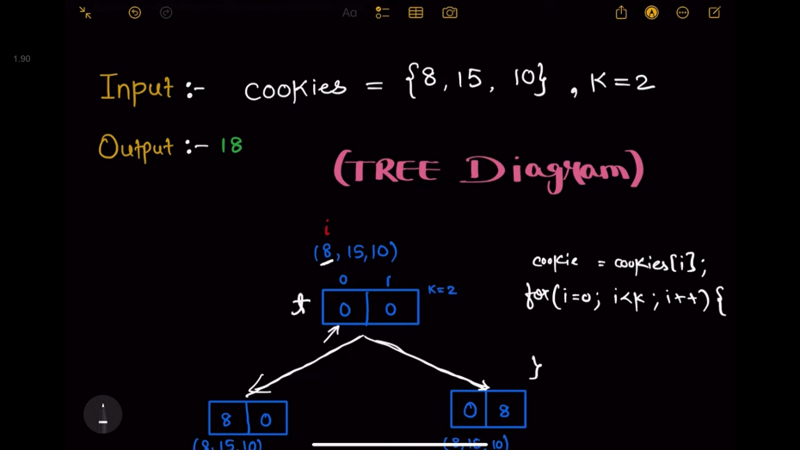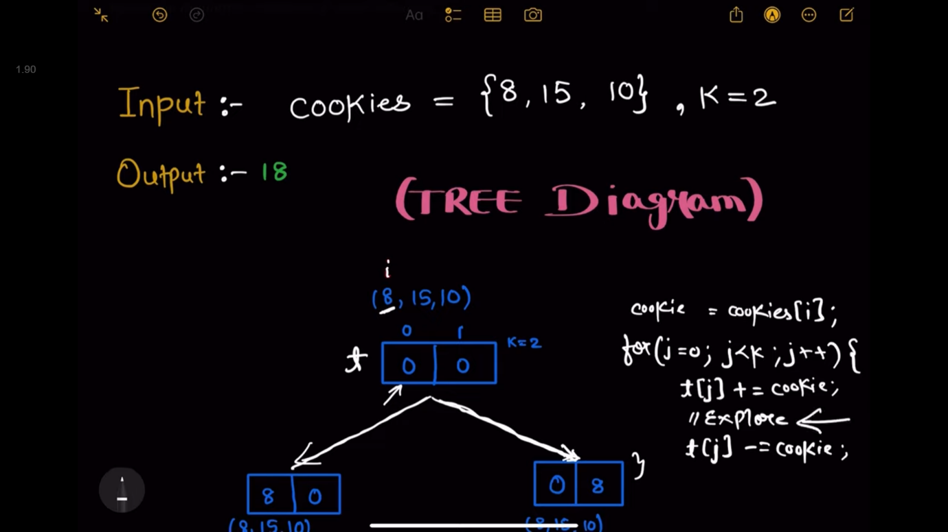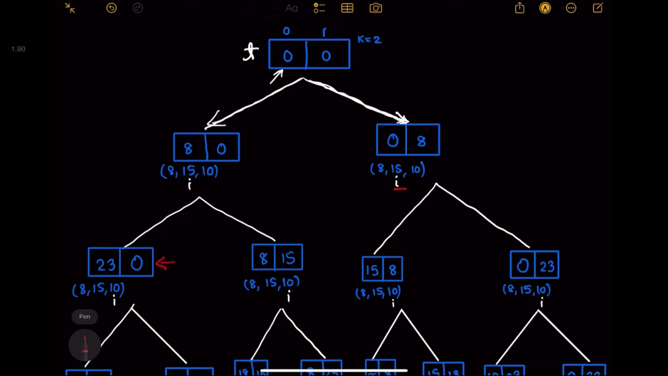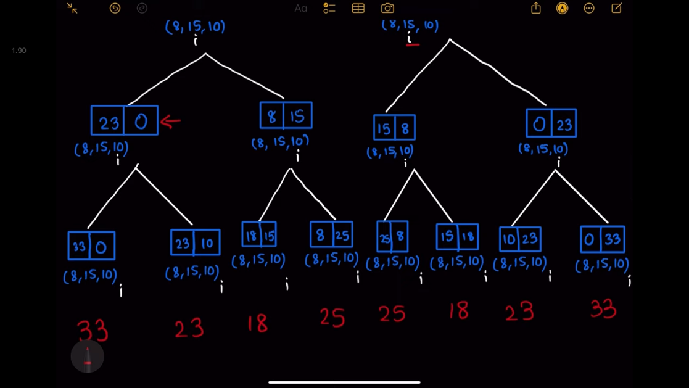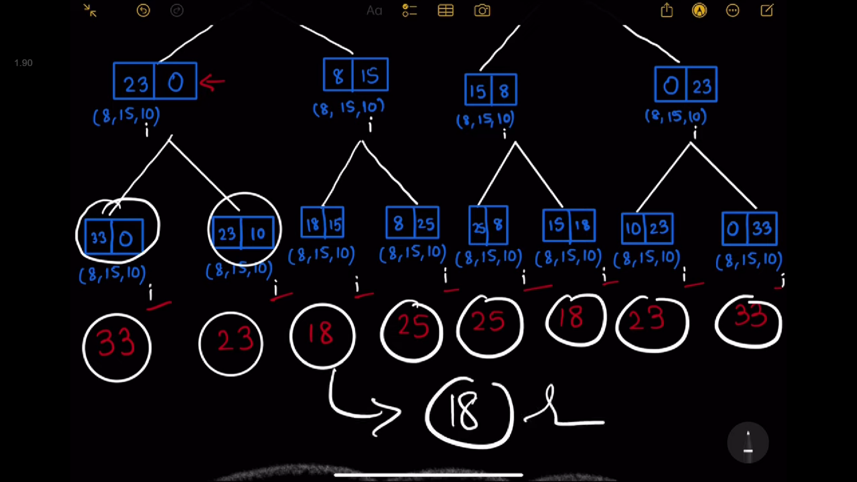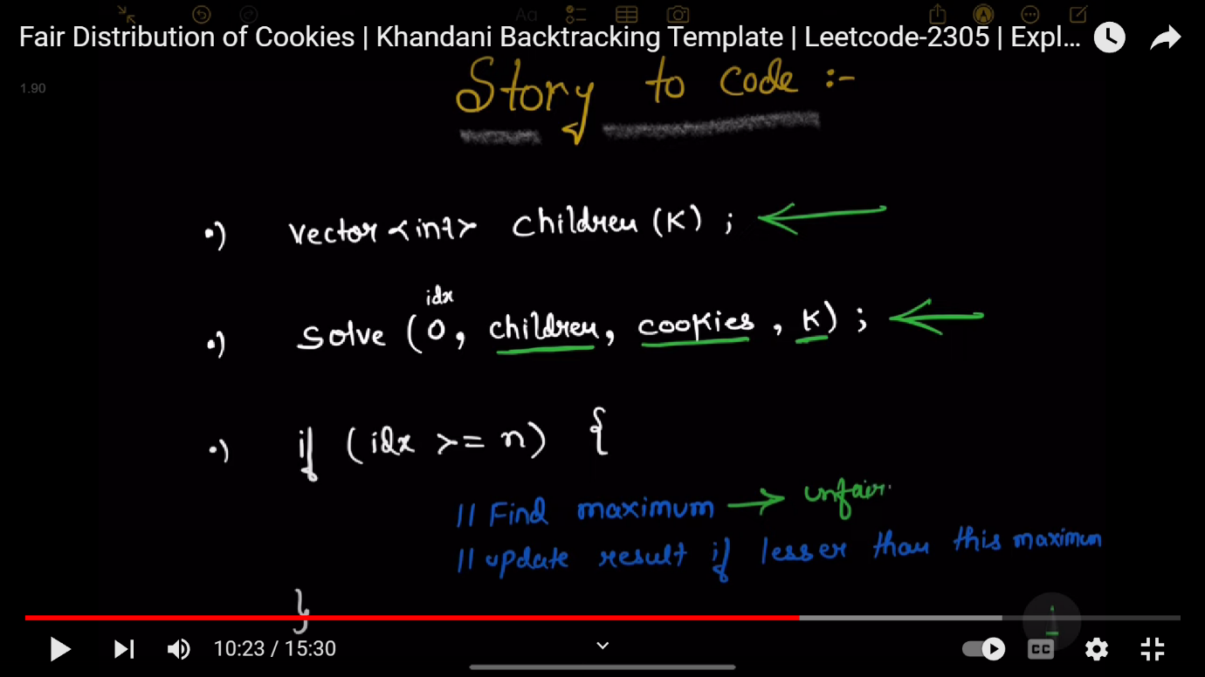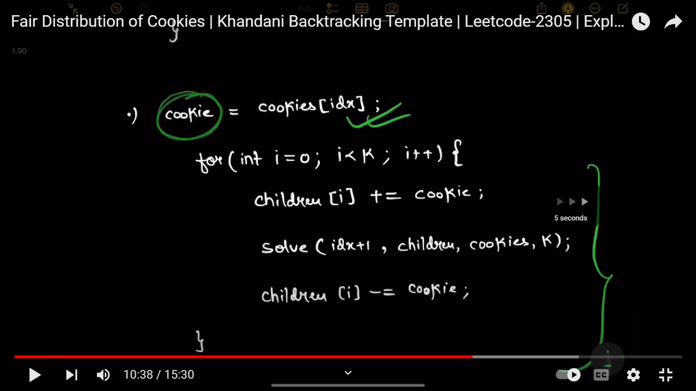

// class Solution {

// public:

//     void solve(vector<int>& cookies,int k,int i,vector<int>&children,vector<int>&ans){

//         if(i>=cookies.size()){

//             int d=*max_element(children.begin(),children.end());

//             ans.push_back(d);

//             return;

//         }

//         for(int j=0;j<k;j++){

//             children[j]+=cookies[i];

//             solve(cookies,k,i+1,children,ans);

//             children[j]-=cookies[i];

//         }

//     }

//     int distributeCookies(vector<int>& cookies, int k) {

//         vector<int>ans;

//         vector<int>children(k,0);

//         solve(cookies,k,0,children,ans);

//         int d= *min_element(ans.begin(),ans.end());

//         return d;

//     }

// };

//little space optimized tc: o(k^n)

class Solution {

public:

    int result=INT_MAX;

    void solve(vector<int>& cookies,int k,int i,vector<int>&children){

        if(i>=cookies.size()){

          int unfairness=*max_element(children.begin(),children.end());

            result=min(result,unfairness);

            return;

        }

        for(int j=0;j<k;j++){

            children[j]+=cookies[i];

            solve(cookies,k,i+1,children);

            children[j]-=cookies[i];

        }

    }

    int distributeCookies(vector<int>& cookies, int k) {

        vector<int>ans;

        vector<int>children(k,0);

        solve(cookies,k,0,children);

        return result;

    }

};

**276: Prime Pairs With target Sum**

You are given an integer n. We say that two integers x and y form a prime number pair if:

* 1 <= x <= y <= n
* x + y == n
* x and y are prime numbers

Return *the 2D sorted list of prime number pairs* [xi, yi]. The list should be sorted in **increasing** order of xi. If there are no prime number pairs at all, return *an empty array*.

**Note:** A prime number is a natural number greater than 1 with only two factors, itself and 1.

**Example 1:**

**Input:** n = 10

**Output:** [[3,7],[5,5]]

**Explanation:** In this example, there are two prime pairs that satisfy the criteria.

These pairs are [3,7] and [5,5], and we return them in the sorted order as described in the problem statement.

**Example 2:**

**Input:** n = 2

**Output:** []

**Explanation:** We can show that there is no prime number pair that gives a sum of 2, so we return an empty array.

**Constraints:**

* 1 <= n <= 106
* // class Solution {
* // public:
* //     bool isPrime(int num) {
* //         if (num <= 1)
* //             return false;
* //         for (int i = 2; i * i <= num; i++) {
* //             if (num % i == 0)
* //                 return false;
* //         }
* //         return true;
* //     }
* //     vector<vector<int>> findPrimePairs(int n) {
* //         vector<vector<int>> pairs;
* //         for (int x = 2; x <= n / 2; x++) {
* //             int y = n - x;
* //             if (isPrime(x) && isPrime(y)) {
* //                 pairs.push_back({x, y});
* //             }
* //         }
* //         return pairs;
* //     }
* // };
* class Solution {
* public:
* bool isPrime(int num) {
* if (num <= 1)
* return false;
* if (num == 2 || num == 3)
* return true;
* if (num % 2 == 0 || num % 3 == 0)
* return false;
* for (int i = 5; i * i <= num; i += 6) {
* if (num % i == 0 || num % (i + 2) == 0)
* return false;
* }
* return true;
* }
* std::vector<std::vector<int>> findPrimePairs(int n) {
* std::vector<std::vector<int>> pairs;
* for (int x = 2; x <= n / 2; x++) {
* int y = n - x;
* if (isPrime(x) && isPrime(y)) {
* pairs.push_back({x, y});
* }
* }
* return pairs;
* }
* };

**277: Longest Continuous Subarrays With absolute diff less than or equal to limit , we can also do this question using multiset as done in next question**

Given an array of integers nums and an integer limit, return the size of the longest **non-empty** subarray such that the absolute difference between any two elements of this subarray is less than or equal to limit*.*

**Example 1:**

**Input:** nums = [8,2,4,7], limit = 4

**Output:** 2

**Explanation:** All subarrays are:

[8] with maximum absolute diff |8-8| = 0 <= 4.

[8,2] with maximum absolute diff |8-2| = 6 > 4.

[8,2,4] with maximum absolute diff |8-2| = 6 > 4.

[8,2,4,7] with maximum absolute diff |8-2| = 6 > 4.

[2] with maximum absolute diff |2-2| = 0 <= 4.

[2,4] with maximum absolute diff |2-4| = 2 <= 4.

[2,4,7] with maximum absolute diff |2-7| = 5 > 4.

[4] with maximum absolute diff |4-4| = 0 <= 4.

[4,7] with maximum absolute diff |4-7| = 3 <= 4.

[7] with maximum absolute diff |7-7| = 0 <= 4.

Therefore, the size of the longest subarray is 2.

**Example 2:**

**Input:** nums = [10,1,2,4,7,2], limit = 5

**Output:** 4

**Explanation:** The subarray [2,4,7,2] is the longest since the maximum absolute diff is |2-7| = 5 <= 5.

**Example 3:**

**Input:** nums = [4,2,2,2,4,4,2,2], limit = 0

**Output:** 3

class Solution {

public:

    int longestSubarray(vector<int>& nums, int limit) {

        multiset<int>st;

        int ans=1,j=0;

        for(int i=0;i<nums.size();i++){

            st.insert(nums[i]);

            while(st.size()>1 && (*st.rbegin()-*st.begin()>limit)){

                st.erase(st.find(nums[j]));

                j++;

            }

            ans=max(ans,i-j+1);

        }

        return ans;

    }

};*/

class Solution {

public:

    int longestSubarray(vector<int>& nums, int limit) {

        int n = nums.size(),head=0,tail=0;

            int  ans = 1;

            deque<int> mxq; // keeps track of dreasing elements

            deque<int>mnq; //keeps track of increasing elements

    for (head=0; head < n; head++) {

        while (!mnq.empty() && mnq.back() > nums[head])    // if current element is less than back of mnq means

            mnq.pop_back();                                // pop back of mnq so that we can insert nums[head] means current element at correct place

        while (!mxq.empty() && mxq.back() < nums[head])         // if current element is greater than back of mxq means

            mxq.pop_back();                                   // we have to pop back of mxq so that we can insert nums[head] at correct place

// to maintain monotonicity of mxq and mnq we are doing above two operations

        mxq.push_back(nums[head]); // now you can insert it in mxq

        mnq.push_back(nums[head]); // now you can insert it in mnq

        while (mxq.front() - mnq.front() > limit) {

            if (mxq.front() == nums[tail])      // remove largest element from mxq i.e its front value if its equal to nums[tail]

                mxq.pop_front();

            if (mnq.front() == nums[tail])     // remove smallest element from mnq i.e its front value if its equal to nums[tail]

                mnq.pop_front();

            tail++;  // move window forward

        }

        ans =max(ans,head-tail+1);  // count subarrays

    }

    return ans;

    }

};

**278: Continuous Subarrays**

You are given a **0-indexed** integer array nums. A subarray of nums is called **continuous** if:

* Let i, i + 1, ..., jbe the indices in the subarray. Then, for each pair of indices i <= i1, i2 <= j, 0 <= |nums[i1] - nums[i2]| <= 2.

Return *the total number of****continuous****subarrays.*

A subarray is a contiguous **non-empty** sequence of elements within an array.

**Example 1:**

**Input:** nums = [5,4,2,4]

**Output:** 8

**Explanation:**

Continuous subarray of size 1: [5], [4], [2], [4].

Continuous subarray of size 2: [5,4], [4,2], [2,4].

Continuous subarray of size 3: [4,2,4].

Thereare no subarrys of size 4.

Total continuous subarrays = 4 + 3 + 1 = 8.

It can be shown that there are no more continuous subarrays.

**Example 2:**

**Input:** nums = [1,2,3]

**Output:** 6

**Explanation:**

Continuous subarray of size 1: [1], [2], [3].

Continuous subarray of size 2: [1,2], [2,3].

Continuous subarray of size 3: [1,2,3].

Total continuous subarrays = 3 + 2 + 1 = 6.

//sliding window and multiset technique

class Solution {

public:

    long long continuousSubarrays(vector<int>& nums) {

        int n=nums.size();

        long long ans=0;

        int j=0;

        multiset<int>st; //multiset(gives the min at the starting of it and max at the end of it)

        for(int i=0;i<n;i++){

            st.insert(nums[i]);

            while(st.size()>1 && (*st.rbegin()-*st.begin())>2){

                st.erase(st.find(nums[j]));

                j++;

            }

            ans+=i-j+1;

        }

        return ans;

    }

};

/*

- Time complexity:

The overall time complexity of the code is O(N * logN) since we are using multiset LogN comes into picture

*/

**Sol2 using monotonic Deque**

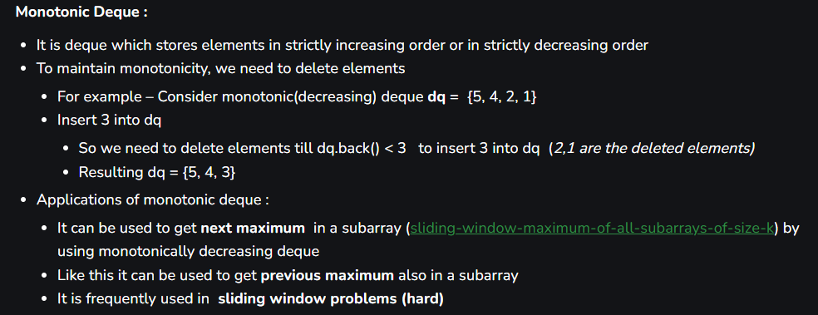

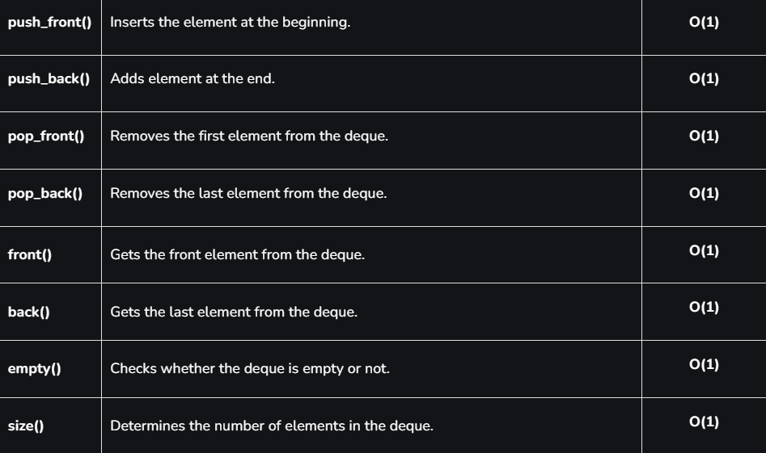

class Solution {

public:

    long long continuousSubarrays(vector<int>& nums) {

           int n = nums.size(),head=0,tail=0;

            long long  ans = 0;

            deque<int> mxq // keeps track of dreasing elements

            deque<int>mnq; //keeps track of increasing elements

    for (head=0; head < n; head++) {

        while (!mnq.empty() && mnq.back() > nums[head])    // if current element is less than back of mnq means

            mnq.pop_back();                                // pop back of mnq so that we can insert nums[head] means current element at correct place

        while (!mxq.empty() && mxq.back() < nums[head])         // if current element is greater than back of mxq means

            mxq.pop_back();                                   // we have to pop back of mxq so that we can insert nums[head] at correct place

// to maintain monotonicity of mxq and mnq we are doing above two operations

        mxq.push_back(nums[head]); // now you can insert it in mxq

        mnq.push_back(nums[head]); // now you can insert it in mnq

        while (mxq.front() - mnq.front() > 2) {

            if (mxq.front() == nums[tail])      // remove largest element from mxq i.e its front value if its equal to nums[tail]

                mxq.pop_front();

            if (mnq.front() == nums[tail])     // remove smallest element from mnq i.e its front value if its equal to nums[tail]

                mnq.pop_front();

            tail++;  // move window forward

        }

        ans += head - tail + 1;  // count subarrays

    }

    return ans;

    }

};

**Similar questions link**

<https://leetcode.com/problems/maximum-number-of-robots-within-budget/>  
<https://leetcode.com/problems/number-of-substrings-containing-all-three-characters/>  
<https://leetcode.com/problems/count-subarrays-with-fixed-bounds/>  
<https://leetcode.com/problems/count-number-of-nice-subarrays/>  
<https://leetcode.com/problems/longest-nice-subarray/>  
<https://leetcode.com/problems/count-the-number-of-good-subarrays/>  
<https://leetcode.com/problems/find-k-closest-elements/>  
<https://leetcode.com/problems/jump-game-vi/>

**279: Continuous Subarray sum**

Given an integer array nums and an integer k, return true *if*nums*has a****good subarray****or*false*otherwise*.

A **good subarray** is a subarray where:

* its length is **at least two**, and
* the sum of the elements of the subarray is a multiple of k.

**Note** that:

* A **subarray** is a contiguous part of the array.
* An integer x is a multiple of k if there exists an integer n such that x = n * k. 0 is **always** a multiple of k.

**Example 1:**

**Input:** nums = [23,2,4,6,7], k = 6

**Output:** true

**Explanation:** [2, 4] is a continuous subarray of size 2 whose elements sum up to 6.

**Example 2:**

**Input:** nums = [23,2,6,4,7], k = 6

**Output:** true

**Explanation:** [23, 2, 6, 4, 7] is an continuous subarray of size 5 whose elements sum up to 42.

42 is a multiple of 6 because 42 = 7 * 6 and 7 is an integer.

**Example 3:**

**Input:** nums = [23,2,6,4,7], k = 13

**Output:** false

//using hashmap;

//mp[sum]=ind , mp[sum+?]=ind when ? is multiple of 6(k)

class Solution {

public:

    bool checkSubarraySum(vector<int>& nums, int k) {

        unordered_map<int,int>mp;

        mp[0]=-1; //for discarding if nums[0]%6==0

        int running_sum=0;

        for(int i=0;i<nums.size();i++){

            running_sum+=nums[i];

            if(k!=0){

                running_sum=running_sum%k;

            }

            if(mp.find(running_sum)!=mp.end()){

                if(i-mp[running_sum]>1){

                    return true;

                }

            }

            else{

                mp[running_sum]=i;

            }

        }

        return false;

    }

};

**280: Longest Subarray With sum k**

Given an array containing **N** integers and an integer **K**., Your task is to find the length of the longest Sub-Array with the sum of the elements equal to the given value **K**.

**Example 1:**

**Input :**

A[] = {10, 5, 2, 7, 1, 9}

K = 15

**Output :** 4

**Explanation:**

The sub-array is **{5, 2, 7, 1}**.

**Example 2:**

**Input :**

A[] = {-1, 2, 3}

K = 6

**Output :** 0

**Explanation:**

There is no such sub-array with sum 6.

// #include <bits/stdc++.h>

// int getLongestSubarray(vector<int>& nums, int k){

//     // Write your code here

//     int maxlength=0;

//     int n=nums.size();

//     for(int i=0;i<n;i++){

//         int sum=0;

//         for(int j=i;j<n;j++){

//             sum+=nums[j];

//             if(sum==k){

//                 maxlength=max(maxlength,j-i+1);

//             }

//         }

//     }

//     return maxlength;

// }

#include <bits/stdc++.h>

int getLongestSubarray(vector<int> &nums, int k) {

        unordered_map<int,int>mp;

        int n=nums.size();

        int sum=0;

        int maxlength=0;

        for(int i=0;i<n;i++){

            sum+=nums[i];

            if(mp.find(sum)==mp.end()){

                mp[sum]=i;

            }

            if(sum==k){

                maxlength=i+1;

            }

            if(mp.find(sum-k)!=mp.end()){

                if(maxlength<i-mp[sum-k]){

                    maxlength=i-mp[sum-k];

                }

            }

        }

        return maxlength;

};

or

class Solution {



public:

    int lenOfLongSubarr(int nums[], int N, int k) {

        unordered_map<int, int> mp;

        mp[0] = -1;

        int sum = 0, maxi = 0;

        for (int i = 0; i < N; i++) {

            sum += nums[i];

            if (mp.find(sum - k) != mp.end()) {

                maxi = max(maxi, i - mp[sum - k]);

            }

            // Only update the map entry if it doesn't exist to keep the earliest occurrence of the sum

            if (mp.find(sum) == mp.end()) {

                mp[sum] = i;

            }

        }

        return maxi;

    }

};

**281: Longest subarray of 1’s after deleting one element**

Given a binary array nums, you should delete one element from it.

Return *the size of the longest non-empty subarray containing only*1*'s in the resulting array*. Return 0 if there is no such subarray.

**Example 1:**

**Input:** nums = [1,1,0,1]

**Output:** 3

**Explanation:** After deleting the number in position 2, [1,1,1] contains 3 numbers with value of 1's.

**Example 2:**

**Input:** nums = [0,1,1,1,0,1,1,0,1]

**Output:** 5

**Explanation:** After deleting the number in position 4, [0,1,1,1,1,1,0,1] longest subarray with value of 1's is [1,1,1,1,1].

**Example 3:**

**Input:** nums = [1,1,1]

**Output:** 2

**Explanation:** You must delete one element.

// brute force time=O(n^2)

/*

class Solution {

public:

    int longestSubarray(vector<int>& nums) {

        int ans=0,cnt0=0;

        for(int i=0;i<nums.size();i++){

            int cnt1=0;

            if(nums[i]==0){

                cnt0++;

                for(int j=0;j<nums.size();j++){

                    if(j==i){

                        continue;

                    }

                    if(nums[j]==1){

                        cnt1++;

                        ans=max(ans,cnt1);

                    }

                    else {

                        cnt1=0;

                    }

                }

            }

        }

        if(cnt0==0){

            return nums.size()-1;

        }

        return ans;

    }

};*/

//using sliding window time=O(n)+O(n)

/*class Solution {

public:

    int longestSubarray(vector<int>& nums) {

        int i=0;

        int cnt0=0;

        int result=0;

        for(int j=0;j<nums.size();j++){

            if(nums[j]==0){

                cnt0++;

            }

            while(cnt0>1 && i<nums.size()){

                if(nums[i]==0){

                    cnt0--;        //sliding window or shrinking the window

                }

                i++;

            }

            result=max(result,(j-i+1)-1);

        }

        return result;

    }

};*/

//using better version of sliding window ,time=O(n)

class Solution {

public:

    int longestSubarray(vector<int>& nums) {

        int i=0,flag=0,result=0;

        int last_0_ind=-1;

        for(int j=0;j<nums.size();j++){

            if(nums[j]==0){

                i=last_0_ind+1;

                last_0_ind=j;

                flag=1;

            }

            result=max(result,(j-i+1)-1);

        }

        if(flag){

            return result;

        }

        return nums.size()-1;

    }

};

**282: Minimum Size Subarray Sum**

Given an array of positive integers nums and a positive integer target, return *the****minimal length****of a*

*subarray*

*whose sum is greater than or equal to* target. If there is no such subarray, return 0 instead.

**Example 1:**

**Input:** target = 7, nums = [2,3,1,2,4,3]

**Output:** 2

**Explanation:** The subarray [4,3] has the minimal length under the problem constraint.

**Example 2:**

**Input:** target = 4, nums = [1,4,4]

**Output:** 1

**Example 3:**

**Input:** target = 11, nums = [1,1,1,1,1,1,1,1]

**Output:** 0

//brute force time=o(n^2) TLE

/*

class Solution {

public:

    int minSubArrayLen(int target, vector<int>& nums) {

        int n=nums.size(),ans=INT_MAX,flag=0;

        for(int i=0;i<n;i++){

            int cnt=0;

            long long sum=0;

            for(int j=i;j<n;j++){

                sum+=nums[j];

                if(sum>=target){

                    flag=1;

                    ans=min(ans,j-i+1);

                    break;

                }

            }

        }

        if(flag==0){

            return 0;

        }

        return ans;

    }

};

*/

class Solution {

public:

    int minSubArrayLen(int target, vector<int>& nums) {

        int n=nums.size(),ans=INT_MAX;

        int i=0,flag=0;

        long long sum=0;

        for(int j=0;j<n;j++){

            sum+=nums[j];

            while(sum>=target && i<n){

                sum-=nums[i];

                ans=min(ans,j-i+1);

                flag=1;

                i++;

            }

        }

        if(flag==0){

            return 0;

        }

        return ans;

    }

};

**283: Implement Stack using queue**

Implement a last-in-first-out (LIFO) stack using only two queues. The implemented stack should support all the functions of a normal stack (push, top, pop, and empty).

Implement the MyStack class:

* void push(int x) Pushes element x to the top of the stack.
* int pop() Removes the element on the top of the stack and returns it.
* int top() Returns the element on the top of the stack.
* boolean empty() Returns true if the stack is empty, false otherwise.

**Notes:**

* You must use **only** standard operations of a queue, which means that only push to back, peek/pop from front, size and is empty operations are valid.
* Depending on your language, the queue may not be supported natively. You may simulate a queue using a list or deque (double-ended queue) as long as you use only a queue's standard operations.

**Example 1:**

**Input**

["MyStack", "push", "push", "top", "pop", "empty"]

[[], [1], [2], [], [], []]

**Output**

[null, null, null, 2, 2, false]

**Explanation**

MyStack myStack = new MyStack();

myStack.push(1);

myStack.push(2);

myStack.top(); // return 2

myStack.pop(); // return 2

myStack.empty(); // return False

//using 2 queue

// The idea is to keep newly entered element at the front of ‘q1’ so that pop operation dequeues from ‘q1’. ‘q2’ is used to put every new element in front of ‘q1’.

class MyStack {

public:

    queue<int>q1,q2;

    MyStack() {

    }

    void push(int x) {

        q2.push(x);

        while(!q1.empty()){

            q2.push(q1.front());

            q1.pop();

        }

        swap(q1,q2);

    }

    int pop() {

        int d=q1.front();

        q1.pop();

        return d;

    }

    int top() {

        int d=q1.front();

        return d;

    }

    bool empty() {

        if(q1.size()>0){

            return false;

        }

        return true;

    }

};

//using single queue

class MyStack {

public:

    queue<int>q;

    MyStack() {

    }

    void push(int x) {

        q.push(x);

        int n=q.size();

        for(int i=0;i<n-1;i++){

            q.push(q.front());

            q.pop();

        }

    }

    int pop() {

        int d=q.front();

        q.pop();

        return d;

    }

    int top() {

        int d=q.front();

        return d;

    }

    bool empty() {

        if(q.size()>0){

            return false;

        }

        return true;

    }

};

//using deque

class MyStack {

public:

    deque<int>q;

    MyStack() {

    }

    void push(int x) {

        q.push_back(x);

    }

    int pop() {

        int d=q.back();

        q.pop_back();

        return d;

    }

    int top() {

        int d=q.back();

        return d;

    }

    bool empty() {

        if(q.size()>0){

            return false;

        }

        return true;

    }

};*

**284: Count of ordered pairs of (I,j) such thar arr[i] and arr[j] concatenates to X.**

Given an array arr[] of size N and an integer X, the task is to find the number of ordered pairs (i, j) such that i != j and X is the concatenation of the numbers arr[i] and arr[j]

Examples:

Input: N = 4, arr[] = {1, 212, 12, 12}, X = 1212

Output: 3

Explanation: X = 1212 can be obtained by concatenating:

numbers[0] = 1 with numbers[1] = 212

numbers[2] = 12 with numbers[3] = 12

numbers[3] = 12 with numbers[2] = 12

Therefore, number of possible ordered pairs are 3

Input: N = 3, arr[] = {11, 11, 110}, X = 11011

Output: 2

Recommended: Please try your approach on {IDE} first, before moving on to the solution.

Approach:  The task can be solved using a hashmap Follow the below steps to solve the problem

Store the lengths of all the numbers in a vector.

Iterate over the given number array and check if X can be obtained from the number. If so increase the count to check with how many numbers does the current number can form a pair.

Increase the value of the current number in the map.

Clear the map and repeat the same steps on the given number array from the back.

// C++ program for the above approach

#include <bits/stdc++.h>

using namespace std;

// Function to find the number of possible

// ordered pairs

long long countPairs(int n, int x, vector<int> v)

{

    int power[10]

        = { 1, 10, 100,

            1000, 10000, 100000,

            1000000, 10000000,

            100000000,

            1000000000 };

    // Stores the count of digits of each number

    vector<int> len;

    long long count = 0;

    for (int i = 0; i < n; i++)

        len.push_back(log10(v[i]) + 1);

    unordered_map<int, int> mp;

    mp[v[0]]++;

    // Iterating from the start

    for (int i = 1; i < n; i++) {

        if (x % power[len[i]] == v[i])

            count += mp[x / power[len[i]]];

cout<<"count = "<<count<<endl;

        mp[v[i]]++;

    }

    mp.clear();

    mp[v[n - 1]]++;

    // Iterating from the end

    for (int i = n - 2; i >= 0; i--) {

        if (x % power[len[i]] == v[i])

            count += mp[x / power[len[i]]];

cout<<"c = "<<count<<endl;

        mp[v[i]]++;

    }

    return count;

}

// Driver Code

int main()

{

    int N = 4;

    int X = 1212;

    vector<int> numbers = { 1, 212, 12, 12 };

    long long ans = countPairs(N, X, numbers);

    cout << ans << endl;

    return 0;

}

**285: Longest Alternating Subarray (sliding window concept)**

You are given a **0-indexed** integer array nums. A subarray s of length m is called **alternating** if:

* m is greater than 1.
* s1 = s0 + 1.
* The 0-indexed subarray s looks like [s0, s1, s0, s1,...,s(m-1) % 2]. In other words, s1 - s0 = 1, s2 - s1 = -1, s3 - s2 = 1, s4 - s3 = -1, and so on up to s[m - 1] - s[m - 2] = (-1)m.

Return *the maximum length of all****alternating****subarrays present in*nums *or*-1*if no such subarray exists.*

A subarray is a contiguous **non-empty** sequence of elements within an array.

**Example 1:**

**Input:** nums = [2,3,4,3,4]

**Output:** 4

**Explanation:** The alternating subarrays are [3, 4], [3, 4, 3], and [3, 4, 3, 4]. The longest of these is [3,4,3,4], which is of length 4.

**Example 2:**

**Input:** nums = [4,5,6]

**Output:** 2

**Explanation:** [4,5] and [5,6] are the only two alternating subarrays. They are both of length 2.

/*class Solution {

public:

    int alternatingSubarray(vector<int>& nums) {

        int n=nums.size();

        vector<int>vec;

        for(int i=0;i<n-1;i++){

            int d=nums[i]-nums[i+1];

            if(d==-1){

                vec.push_back(0);

            }

            else if(d==0) {

                vec.push_back(20000);

            }

            else{

                vec.push_back(d);

            }

        }

        int ans=2,j,flag=0;

        for( j=0;j<vec.size();j++){

            if(vec[j]==0){

                flag=1;

                int cnt=2;

                for(int i=j;i<vec.size()-1;i++){

                    int d=vec[i+1]-vec[i];

                    if(d==1 || d==-1){

                        cnt++;

                    }

                    else{

                        break;

                    }

                }

                ans=max(ans,cnt);

            }

        }

        if(flag==0){

            return -1;

        }

        return ans;

    }

};*/

class Solution {

public:

    int alternatingSubarray(vector<int>& nums) {

        int n=nums.size();

        int i=0,j=1,maxi=-1,flag=true;;

        while(j<n){

            if(flag==true){

                if(nums[j]-nums[j-1]==1){

                    flag=false;

                    maxi=max(maxi,j-i+1);

                }

                else{

                    i=j;

                }

            }

            else{

                if(nums[j]-nums[j-1]==-1){

                    flag=true;

                    maxi=max(maxi,j-i+1);

                }

                else if(nums[j]-nums[j-1]==1){

                    i=j-1;

                    maxi=max(maxi,j-i+1);

                }

                else{

                    flag=true;

                    i=j;

                }

            }

            j++;

        }

        return maxi;

    }

};

**286: Substring With Largest Variance**

The **variance** of a string is defined as the largest difference between the number of occurrences of **any** 2 characters present in the string. Note the two characters may or may not be the same.

Given a string s consisting of lowercase English letters only, return *the****largest variance****possible among all****substrings****of* s.

A **substring** is a contiguous sequence of characters within a string.

**Example 1:**

**Input:** s = "aababbb"

**Output:** 3

**Explanation:**

All possible variances along with their respective substrings are listed below:

- Variance 0 for substrings "a", "aa", "ab", "abab", "aababb", "ba", "b", "bb", and "bbb".

- Variance 1 for substrings "aab", "aba", "abb", "aabab", "ababb", "aababbb", and "bab".

- Variance 2 for substrings "aaba", "ababbb", "abbb", and "babb".

- Variance 3 for substring "babbb".

Since the largest possible variance is 3, we return it.

**Example 2:**

**Input:** s = "abcde"

**Output:** 0

**Explanation:**

No letter occurs more than once in s, so the variance of every substring is 0.

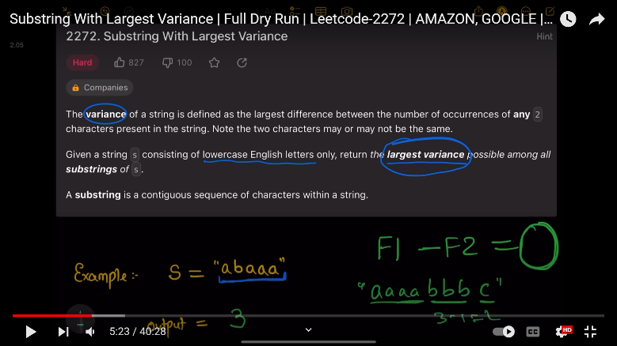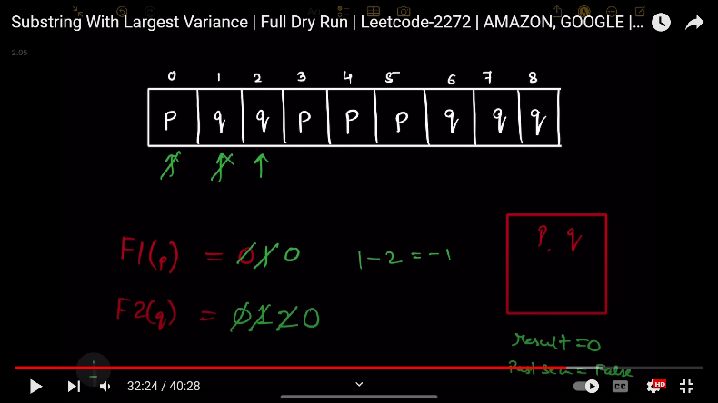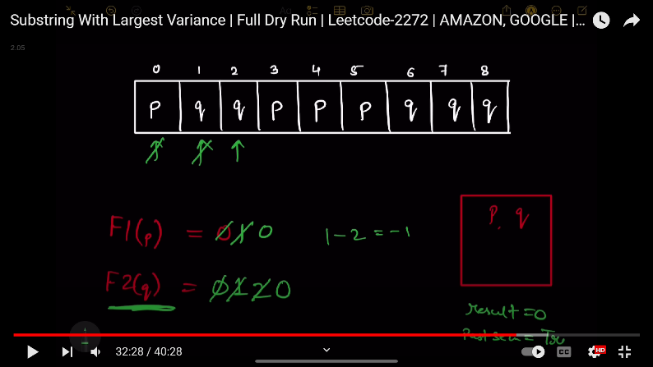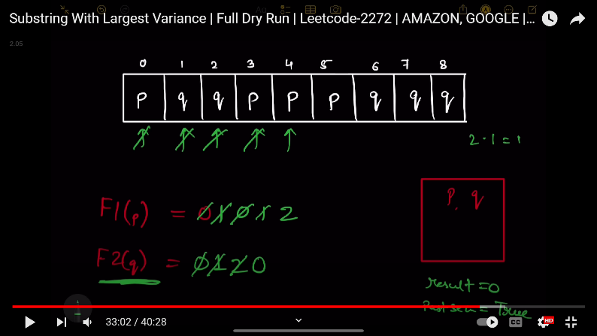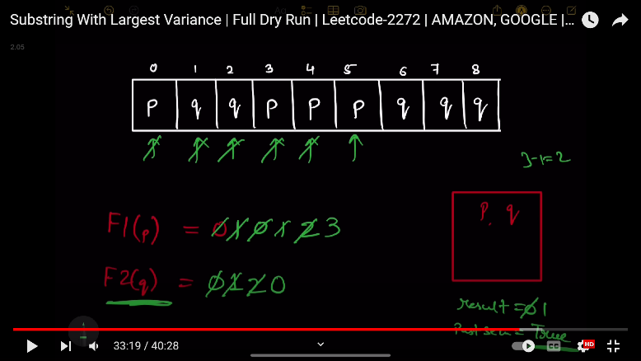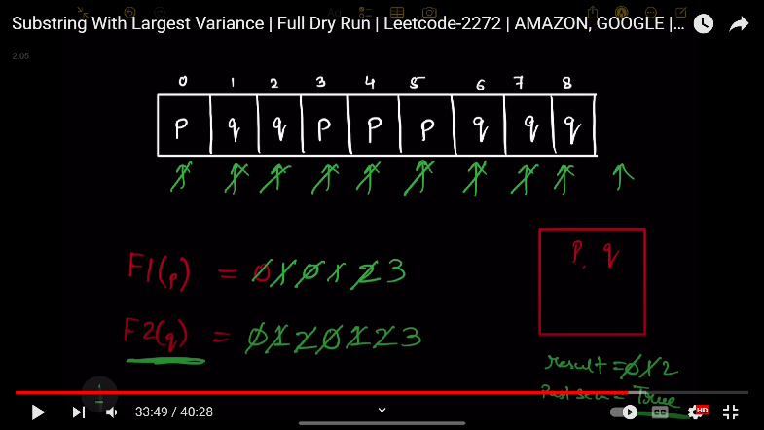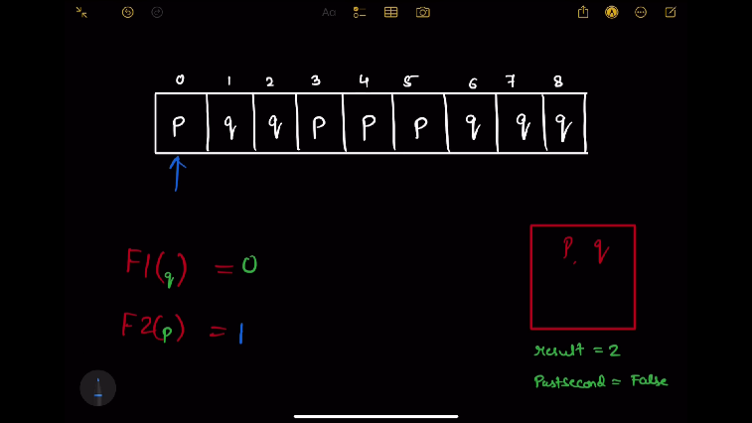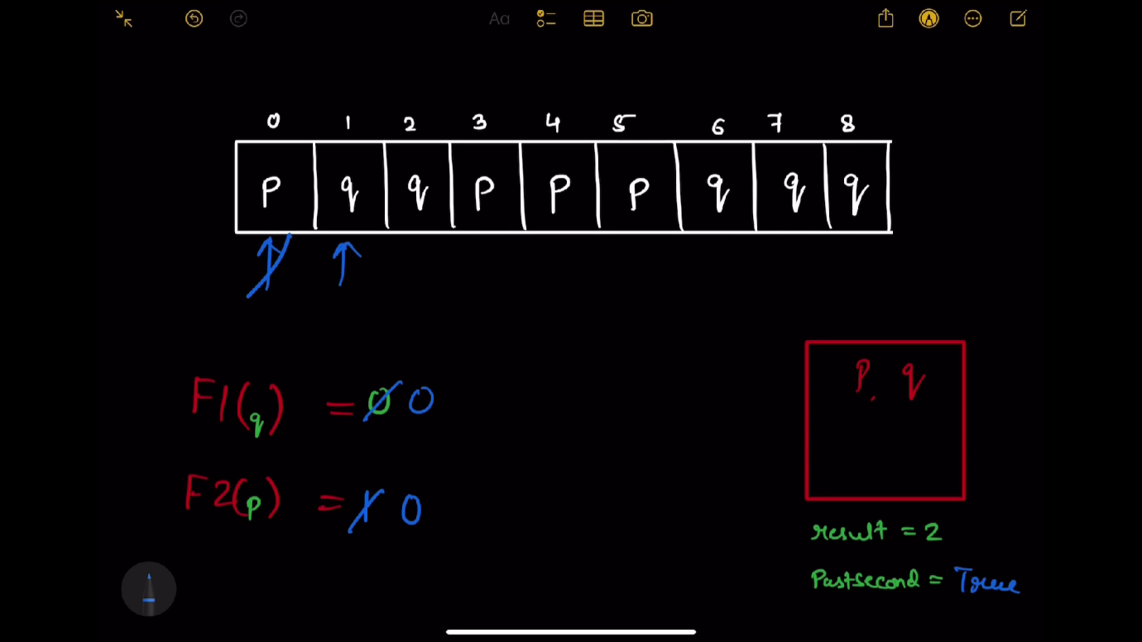

class Solution {

public:

    int largestVariance(string s) {

        vector<int>count(26,0);

        for(int i=0;i<s.size();i++){

            count[s[i]-'a']++;

        }

        int result=0;

        for(char first='a'; first<='z';first++){

            for(char second='a';second<='z';second++){

                if(count[first-'a']==0 || count[second-'a']==0){

                    continue;

                }

                int firstCount=0;  //f1

                int secondCount=0;  //f2

                bool pastSecond=false;

                for(auto &ch:s){

                    if(first==ch){

                        firstCount++;

                    }

                    if(second==ch){

                        secondCount++;

                    }

                    if(secondCount>0){

                        result=max(result,firstCount-secondCount);

                    }

                    else{

                        if(pastSecond==true){

                            result=max(result,firstCount-1);

                        }

                    }

                    if(secondCount>firstCount){

                        firstCount=0;

                        secondCount=0; //kadane’s thing

                        pastSecond=true;

                    }

                }

            }

        }

        return result;

    }

};

**287: Single Number ||**

Given an integer array nums where every element appears **three times** except for one, which appears **exactly once**. *Find the single element and return it*.

You must implement a solution with a linear runtime complexity and use only constant extra space.

**Example 1:**

**Input:** nums = [2,2,3,2]

**Output:** 3

**Example 2:**

**Input:** nums = [0,1,0,1,0,1,99]

**Output:** 99

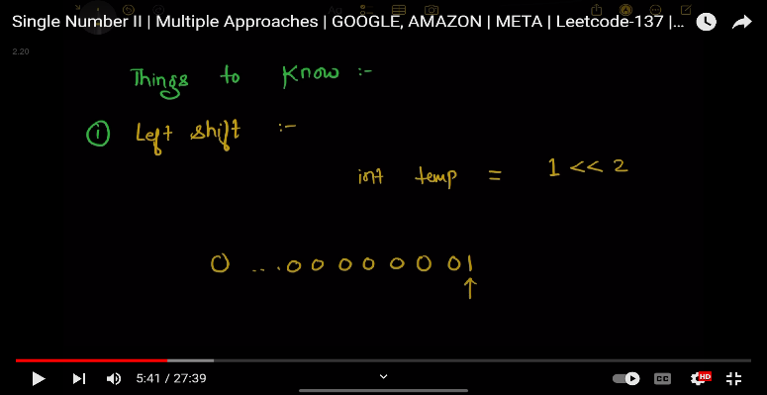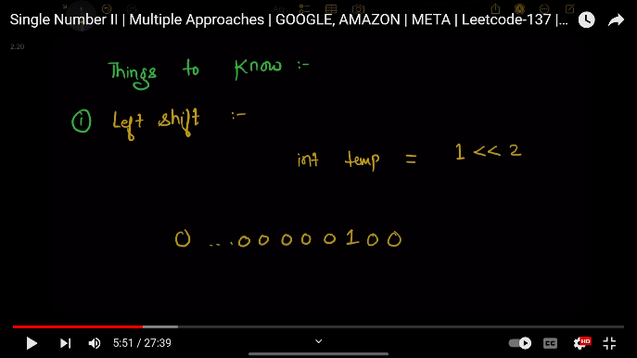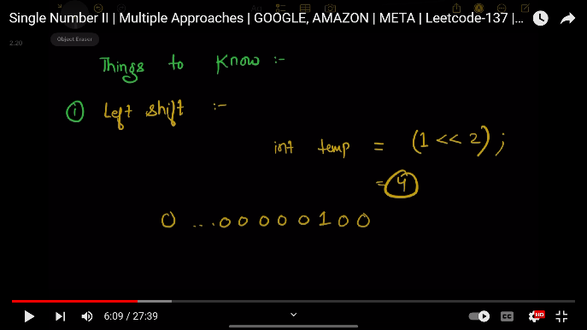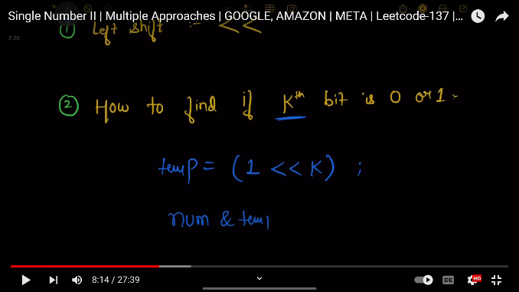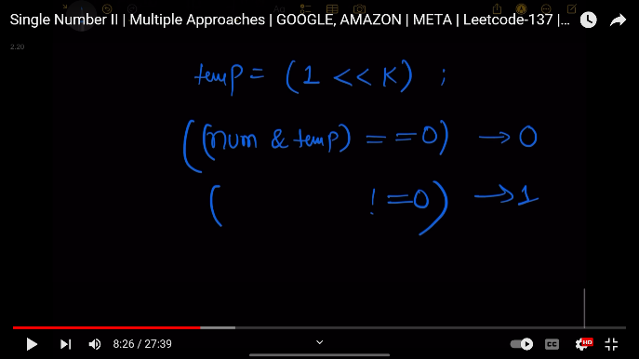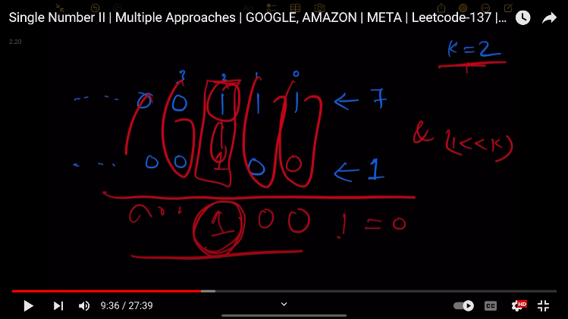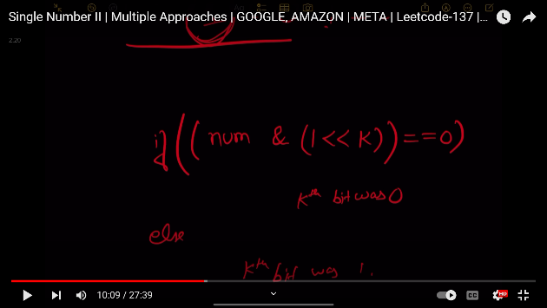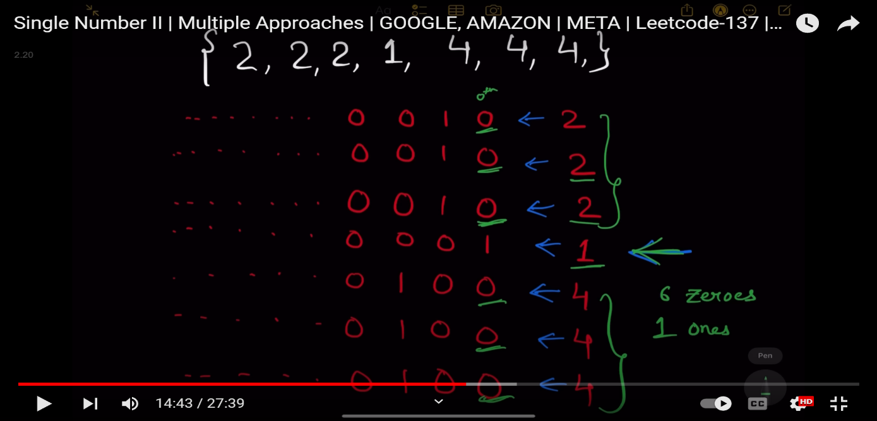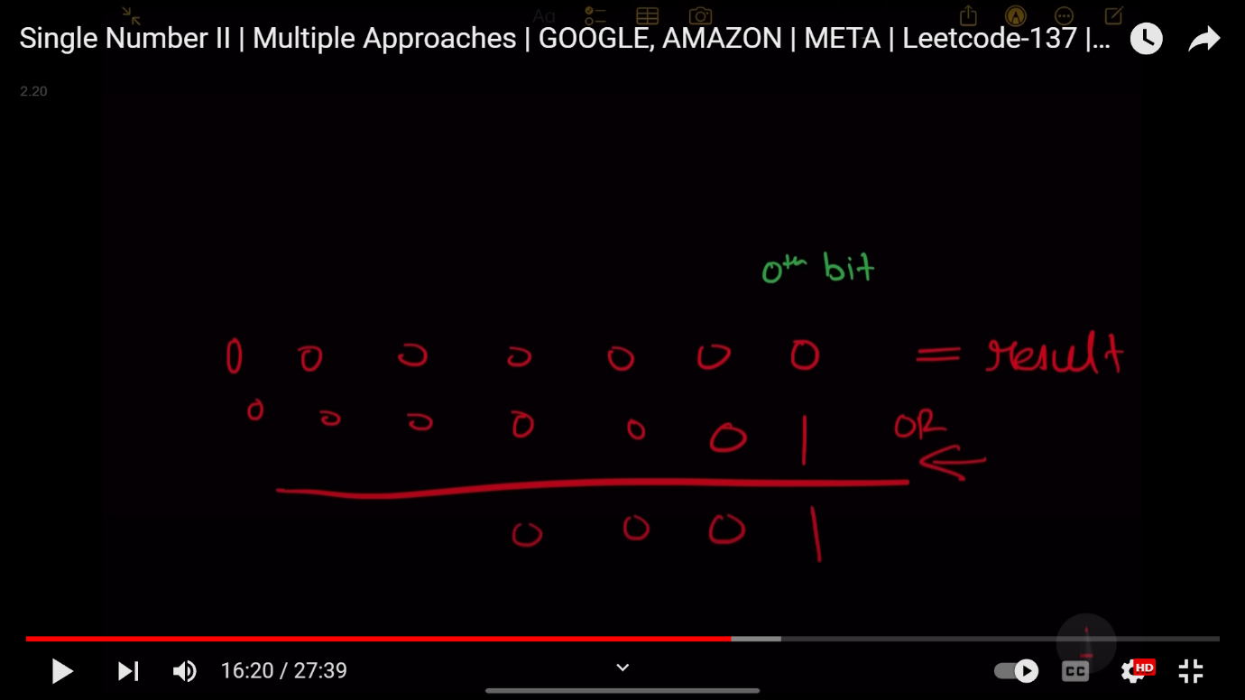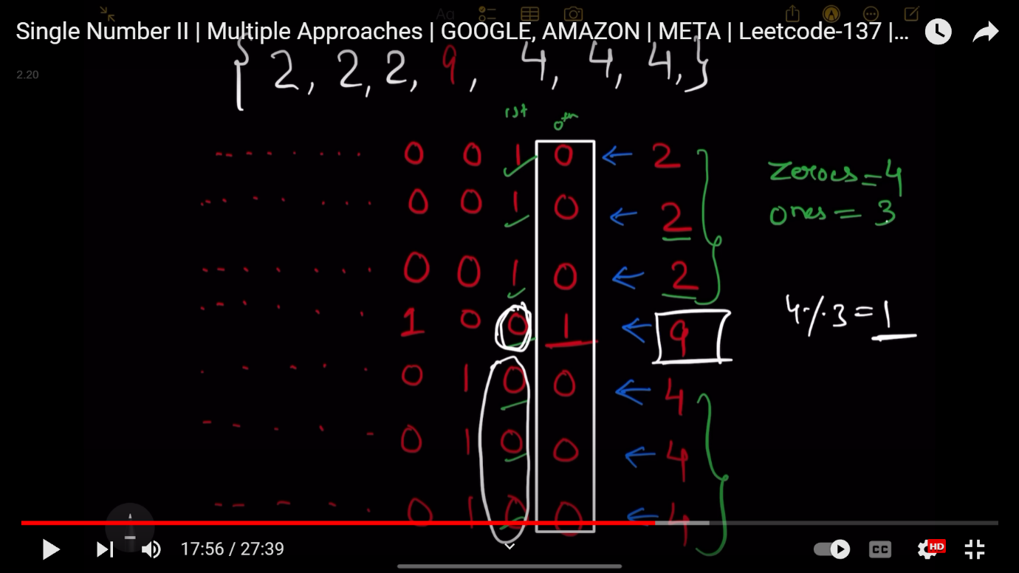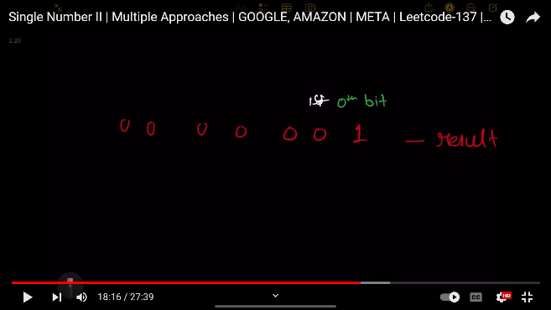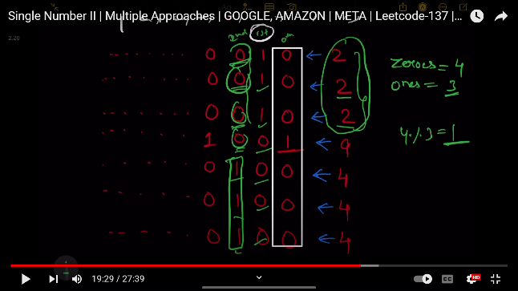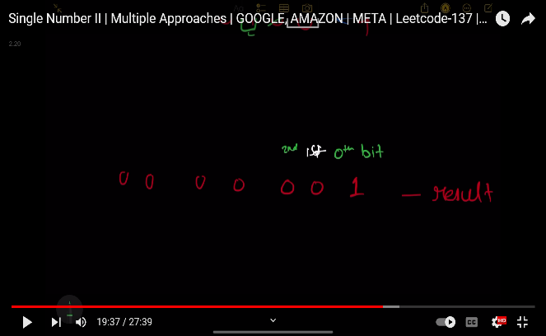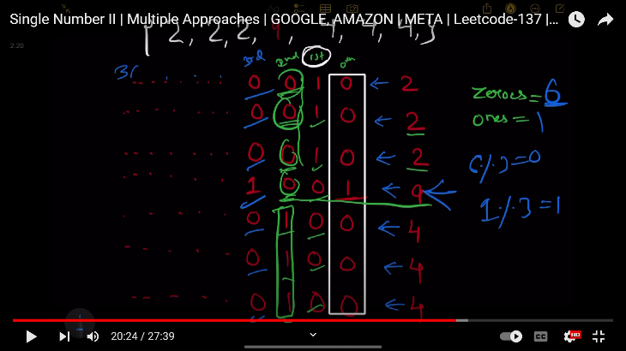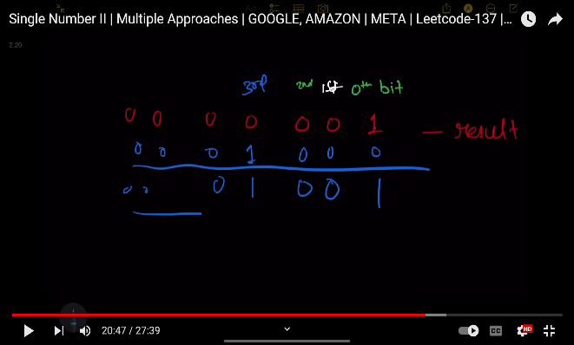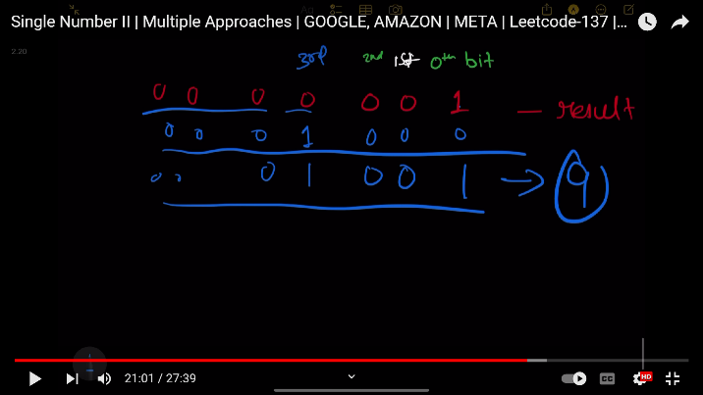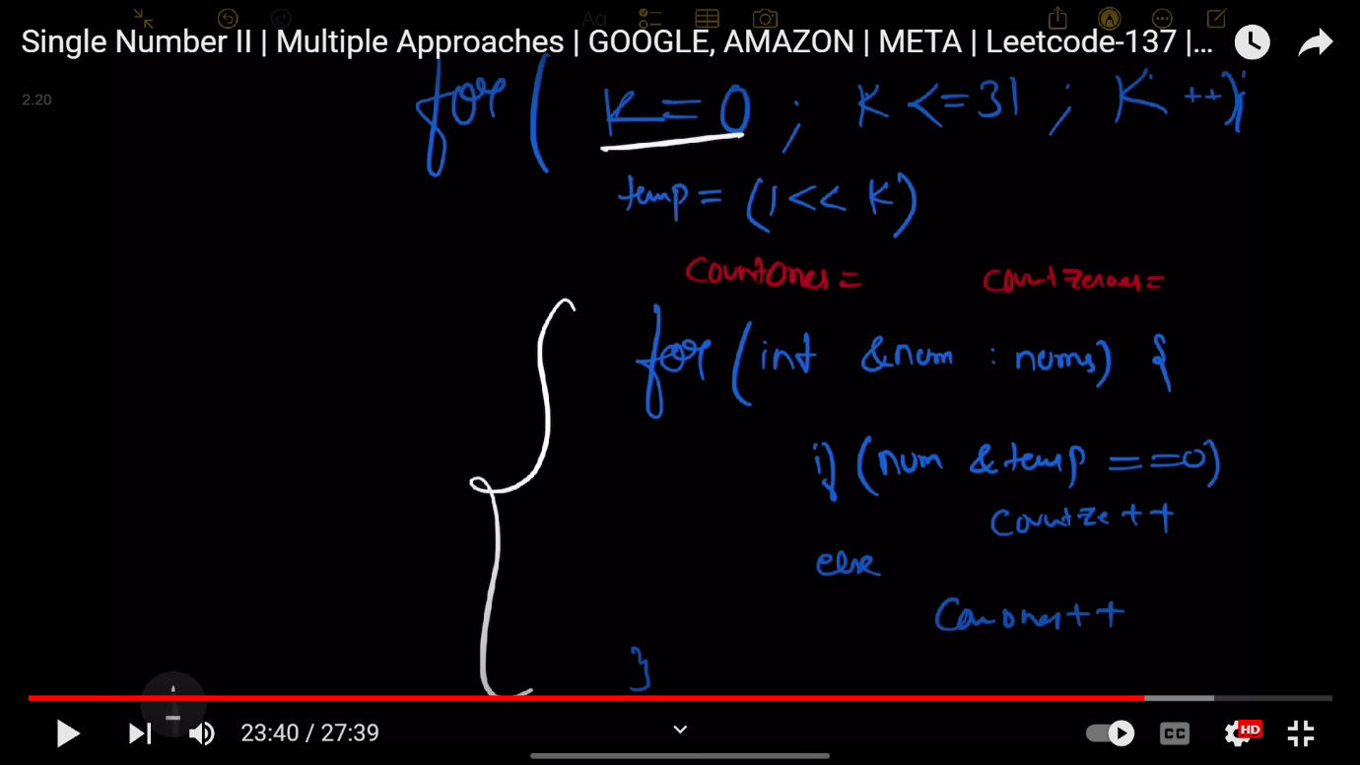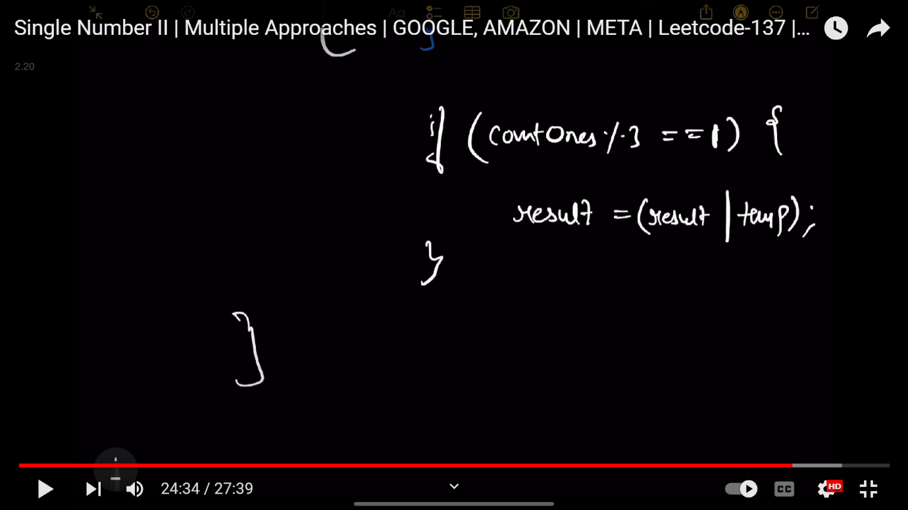

/*class Solution {

public:

    int singleNumber(vector<int>& nums) {

        unordered_map<int, int> m;

        for(auto x: nums){

            m[x]++;

        }

        for(auto x: m){

            if(x.second == 1){

                return x.first;

            }

        }

        return -1;

    }

};*/

//using bit manipulation

class Solution {

public:

    int singleNumber(vector<int>& nums) {

        int result=0;

        for(int k=0;k<32;k++){

            int temp=(1 << k); //left-shift of 1

            int cnt1=0,cnt0=0;

            for(auto &num:nums){

                if((num & temp)==0){

                    cnt0++;

                }                     //checking if kth bit is 1 or 0, on the basis of this incrementing count0 and count1

                else{

                    cnt1++;

                }

            }

            if(cnt1 % 3==1){    //it means we found that one ele appearing one time and whose kth bit is 1, if kth bit is 0 of that ele , then we dont need to do anything

                result=(result|temp); //setting the bit and forming that one odd elment appearing once

            }

        }

        return result;

    }

};

**288: Put Marbles in Bags**

You have k bags. You are given a **0-indexed** integer array weights where weights[i] is the weight of the ith marble. You are also given the integer k.

Divide the marbles into the k bags according to the following rules:

* No bag is empty.
* If the ith marble and jth marble are in a bag, then all marbles with an index between the ith and jth indices should also be in that same bag.
* If a bag consists of all the marbles with an index from i to j inclusively, then the cost of the bag is weights[i] + weights[j].

The **score** after distributing the marbles is the sum of the costs of all the k bags.

Return *the****difference****between the****maximum****and****minimum****scores among marble distributions*.

**Example 1:**

**Input:** weights = [1,3,5,1], k = 2

**Output:** 4

**Explanation:**

The distribution [1],[3,5,1] results in the minimal score of (1+1) + (3+1) = 6.

The distribution [1,3],[5,1], results in the maximal score of (1+3) + (5+1) = 10.

Thus, we return their difference 10 - 6 = 4.

**Example 2:**

**Input:** weights = [1, 3], k = 2

**Output:** 0

**Explanation:** The only distribution possible is [1],[3].

Since both the maximal and minimal score are the same, we return 0.

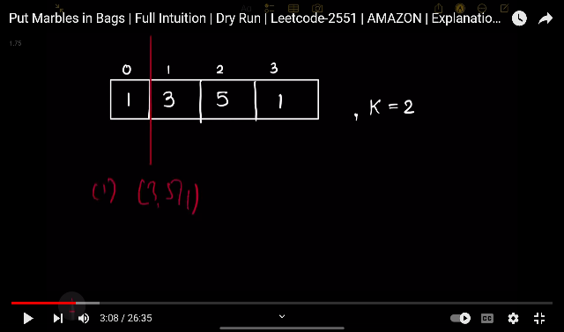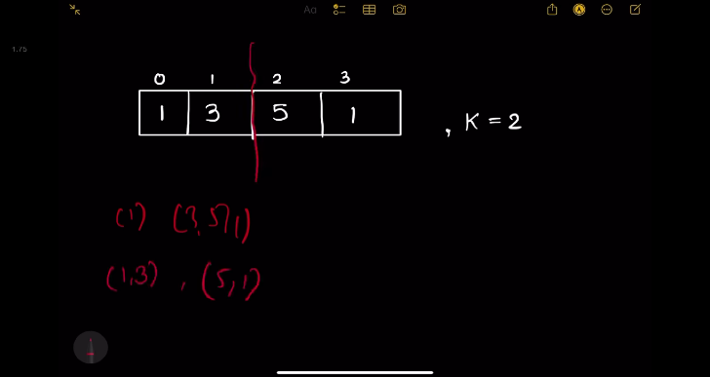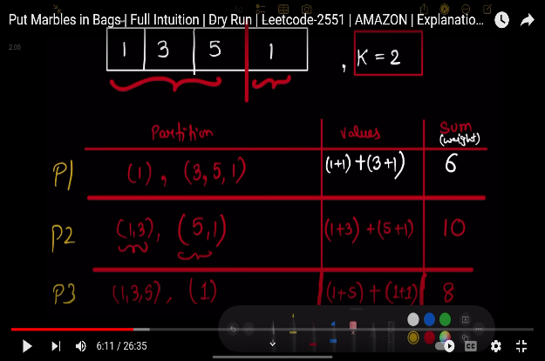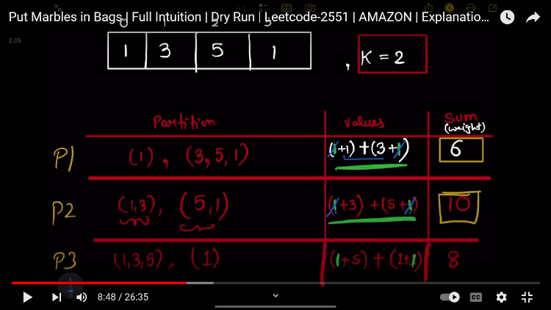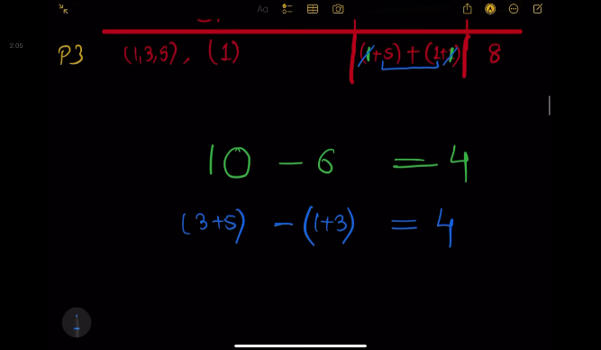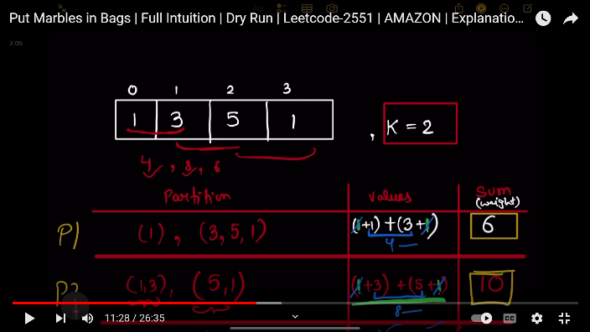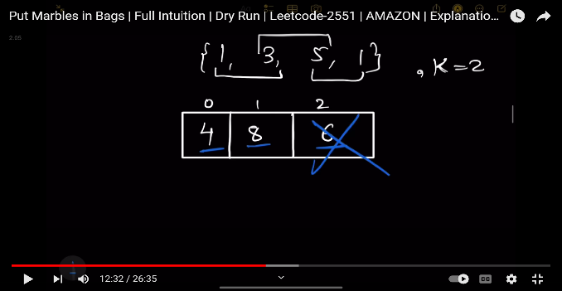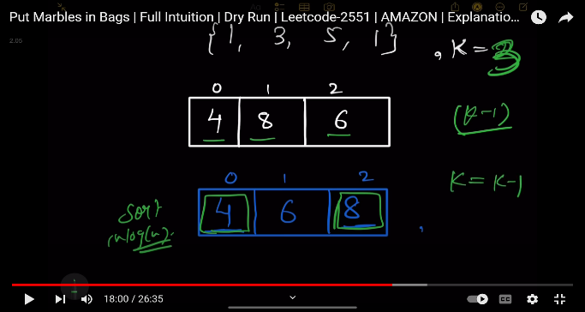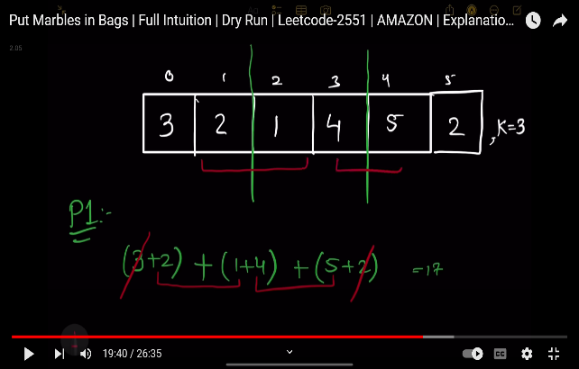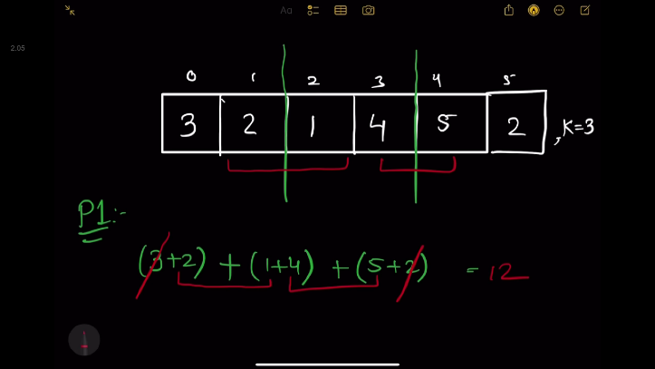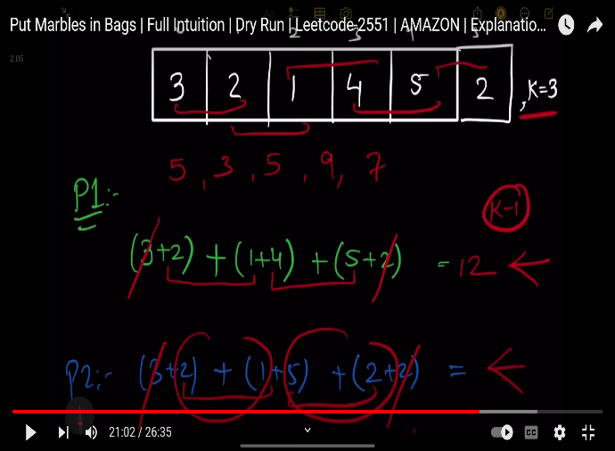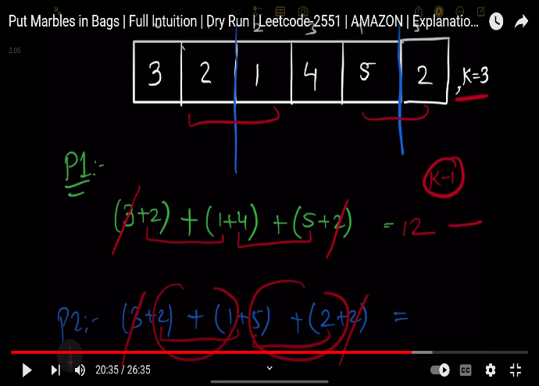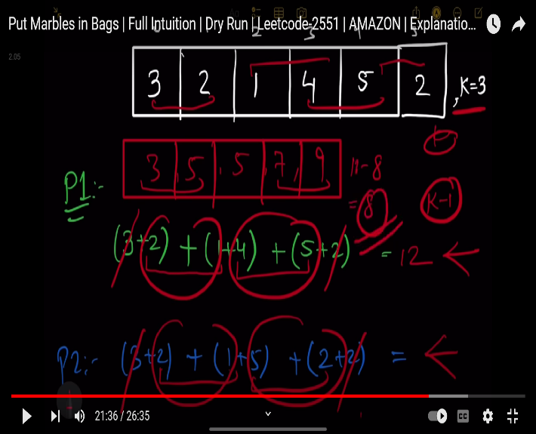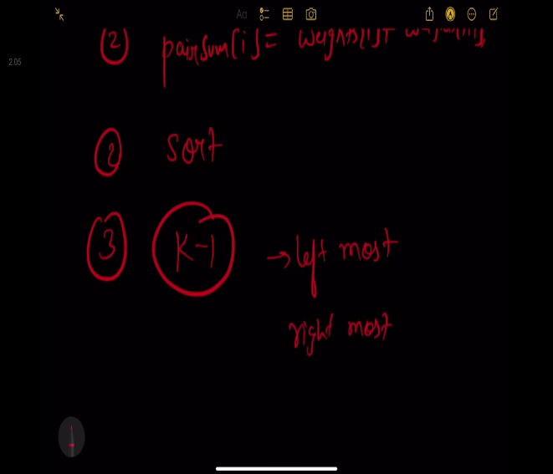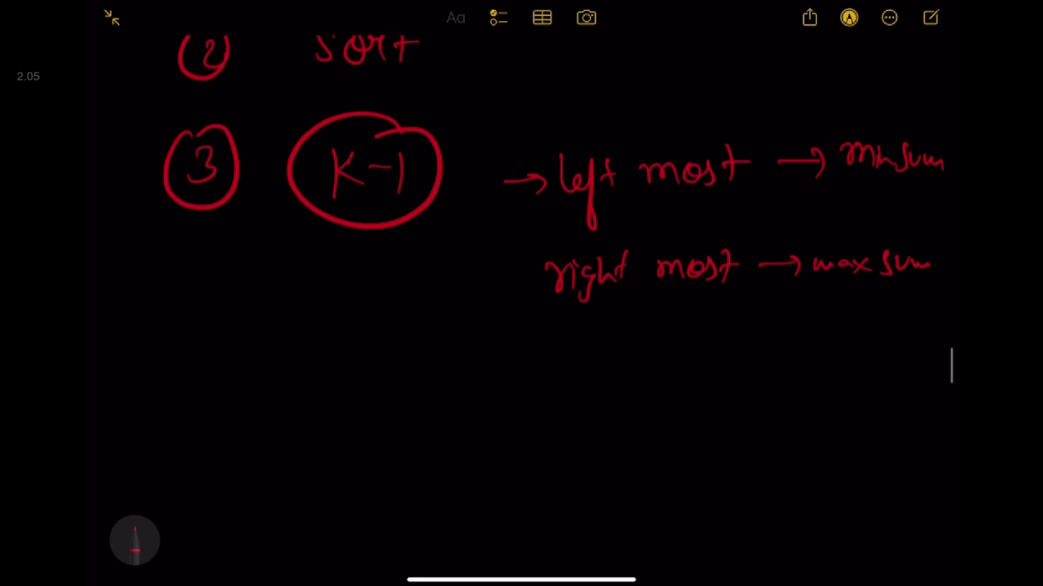

class Solution {

public:

    long long putMarbles(vector<int>& weights, int k) {

        if(weights.size()==2){    //weights' size =2 then max and min score will be same

            return 0;

        }

        vector<long long>vec;

        for(int i=0;i<weights.size()-1;i++){

            vec.push_back(weights[i]+weights[i+1]);

        }

        sort(vec.begin(),vec.end());

        long long sum1=0,sum2=0;

        int n=vec.size();

        for(int i=0;i<k-1;i++){

            sum1+=vec[i];

            sum2+=vec[n-1-i];

        }

        // for(int i=n-1;i>n-k;i--){

        //     sum2+=vec[i];

        // }

        return sum2-sum1;

    }

};

//using priority_queue

class Solution {

public:

    long long putMarbles(vector<int>& weights, int k) {

        int n=weights.size();

        priority_queue<int>pq1;

        priority_queue<int,vector<int>,greater<int>>pq2;

        for(int i=1;i<n;i++){

            pq1.push(weights[i]+weights[i-1]);

            pq2.push(weights[i]+weights[i-1]);

            if(pq1.size()>=k){

                pq1.pop();

                pq2.pop();

            }

        }

        long long ans=0;

        while(pq1.size()>0){

            ans+=pq2.top()-pq1.top();

            pq1.pop();

            pq2.pop();

        }

        return ans;

    }

};

**289: Maximum No of Achievable Transfer Requests**

We have n buildings numbered from 0 to n - 1. Each building has a number of employees. It's transfer season, and some employees want to change the building they reside in.

You are given an array requests where requests[i] = [fromi, toi] represents an employee's request to transfer from building fromi to building toi.

**All buildings are full**, so a list of requests is achievable only if for each building, the **net change in employee transfers is zero**. This means the number of employees **leaving** is **equal** to the number of employees **moving in**. For example if n = 3 and two employees are leaving building 0, one is leaving building 1, and one is leaving building 2, there should be two employees moving to building 0, one employee moving to building 1, and one employee moving to building 2.

Return *the maximum number of achievable requests*.

**Example 1:**

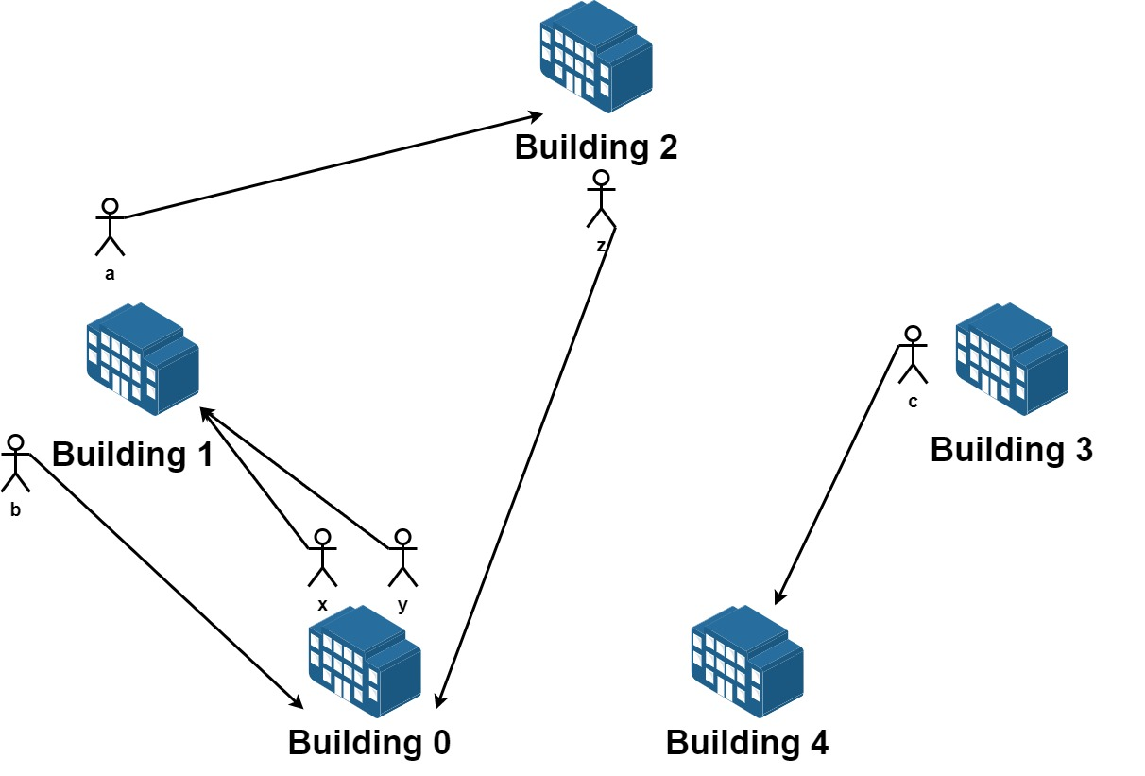

**Input:** n = 5, requests = [[0,1],[1,0],[0,1],[1,2],[2,0],[3,4]]

**Output:** 5

**Explantion:** Let's see the requests:

From building 0 we have employees x and y and both want to move to building 1.

From building 1 we have employees a and b and they want to move to buildings 2 and 0 respectively.

From building 2 we have employee z and they want to move to building 0.

From building 3 we have employee c and they want to move to building 4.

From building 4 we don't have any requests.

We can achieve the requests of users x and b by swapping their places.

We can achieve the requests of users y, a and z by swapping the places in the 3 buildings.

**Example 2:**

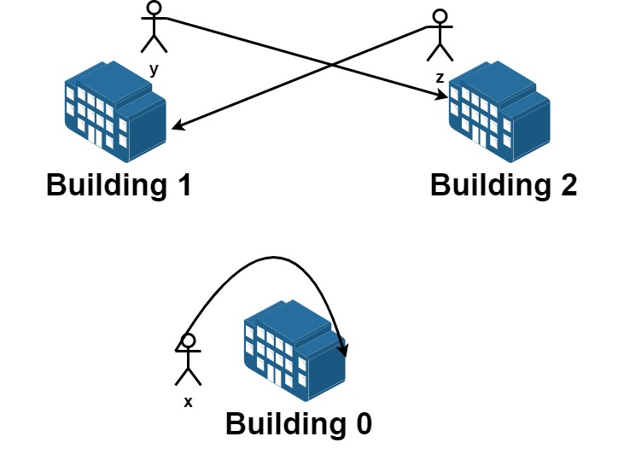

**Input:** n = 3, requests = [[0,0],[1,2],[2,1]]

**Output:** 3

**Explantion:** Let's see the requests:

From building 0 we have employee x and they want to stay in the same building 0.

From building 1 we have employee y and they want to move to building 2.

From building 2 we have employee z and they want to move to building 1.

We can achieve all the requests.

class Solution {

public:

    int ans=0;

    void solve(int i,vector<int>&vec,vector<vector<int>>& requests,int count,int n){

        if(i>=requests.size()){

            bool all0=true;

            for(auto &it:vec){

                if(it!=0){

                    all0=false;

                    break;

                }

            }

            if(all0==true){

                ans=max(ans,count);

            }

            return ;

        }

        //take

        vec[requests[i][0]]--;

        vec[requests[i][1]]++;

        solve(i+1,vec,requests,count+1,n);

        //not take

        //bracktrack;

        vec[requests[i][0]]++;

        vec[requests[i][1]]--;

        solve(i+1,vec,requests,count,n);

    }

    int maximumRequests(int n, vector<vector<int>>& requests) {

        vector<int>vec(n,0);

        solve(0,vec,requests,0,n);

        return ans;

    }

};

**290: Longest Arithmetic subsequence of Given Difference**

Given an integer array arr and an integer difference, return the length of the longest subsequence in arr which is an arithmetic sequence such that the difference between adjacent elements in the subsequence equals difference.

A **subsequence** is a sequence that can be derived from arr by deleting some or no elements without changing the order of the remaining elements.

**Example 1:**

**Input:** arr = [1,2,3,4], difference = 1

**Output:** 4

**Explanation:** The longest arithmetic subsequence is [1,2,3,4].

**Example 2:**

**Input:** arr = [1,3,5,7], difference = 1

**Output:** 1

**Explanation:** The longest arithmetic subsequence is any single element.

**Example 3:**

**Input:** arr = [1,5,7,8,5,3,4,2,1], difference = -2

**Output:** 4

**Explanation:** The longest arithmetic subsequence is [7,5,3,1].

**Constraints:**

* 1 <= arr.length <= 105
* -104 <= arr[i], difference <= 104
* /*/brute force TLE
* class Solution {
* public:
* int longestSubsequence(vector<int>& arr, int difference) {
* int ans=0;
* for(int i=0;i<arr.size();i++){
* int cnt=1;
* int temp=arr[i];
* for(int j=i+1;j<arr.size();j++){
* if(arr[j]-temp==difference){
* cnt++;
* temp=arr[j];
* }
* }
* ans=max(ans,cnt);
* }
* return ans;
* }
* };*/
* /*
* //using recursion and memoization  TLE
* class Solution {
* public:
* int n,d;
* int dp[100001];
* int solve(int idx,vector<int>&arr){
* if(dp[idx]!=-1){
* return dp[idx];
* }
* int result=0;
* for(int j=idx+1;j<n;j++){
* int preval=arr[idx];
* int currval=arr[j];
* if(currval-preval==d){
* result=max(result,1+solve(j,arr));
* }
* }
* return dp[idx]=result;
* }
* int longestSubsequence(vector<int>& arr, int difference) {
* memset(dp,-1,sizeof(dp));
* n=arr.size();
* d=difference;
* int result=0;
* for(int i=0;i<n;i++){
* result=max(result,1+solve(i,arr));
* }
* return result;
* }
* };*/
* class Solution {
* public:
* int longestSubsequence(vector<int>& arr, int difference) {
* int n = arr.size();
* unordered_map<int, int> mp; // Stores the maximum length at each index
* int ans = 1; // Initialize with the minimum length of 1
* for (int i = 0; i < n; i++) {
* int num = arr[i];
* if (mp.find(num - difference) != mp.end()) {
* mp[num] = mp[num - difference] + 1;
* } else {
* mp[num] = 1;
* }
* ans = max(ans, mp[num]);
* }
* return ans;
* }
* };

**291: Maximum No of events that can be Attended**

**//intervals type question**

You are given an array of events where events[i] = [startDayi, endDayi, valuei]. The ith event starts at startDayiand ends at endDayi, and if you attend this event, you will receive a value of valuei. You are also given an integer k which represents the maximum number of events you can attend.

You can only attend one event at a time. If you choose to attend an event, you must attend the **entire** event. Note that the end day is **inclusive**: that is, you cannot attend two events where one of them starts and the other ends on the same day.

Return *the****maximum sum****of values that you can receive by attending events.*

**Example 1:**

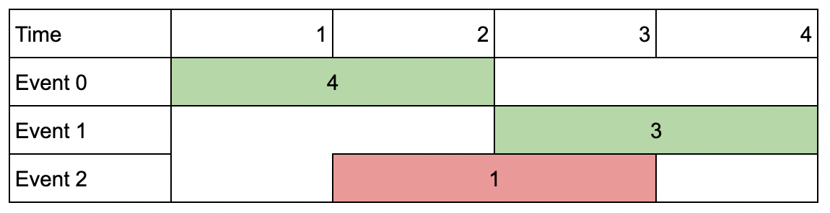

**Input:** events = [[1,2,4],[3,4,3],[2,3,1]], k = 2

**Output:** 7

**Explanation:** Choose the green events, 0 and 1 (0-indexed) for a total value of 4 + 3 = 7.

**Example 2:**

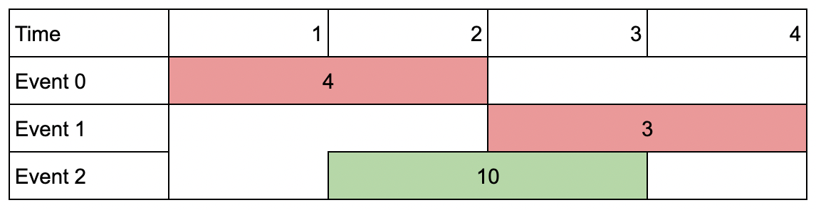

**Input:** events = [[1,2,4],[3,4,3],[2,3,10]], k = 2

**Output:** 10

**Explanation:** Choose event 2 for a total value of 10.

Notice that you cannot attend any other event as they overlap, and that you do **not** have to attend k events.

**Example 3:**

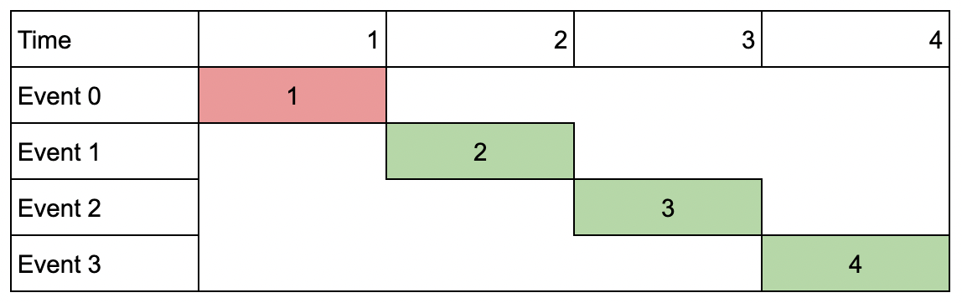

**Input:** events = [[1,1,1],[2,2,2],[3,3,3],[4,4,4]], k = 3

**Output:** 9

**Explanation:** Although the events do not overlap, you can only attend 3 events. Pick the highest valued three.

//recursion + memoization (time-->O(n+1*k+1)*O(n))

class Solution {

public:

    vector<vector<int>>dp;

    int solve(int i,vector<vector<int>>& events, int k){

        //base condition

        if(i>=events.size() ||k==0){

            return 0;

        }

        if(dp[i][k]!=-1){

            return dp[i][k];

        }

        int start=events[i][0];

        int end=events[i][1];

        int value=events[i][2];

        //notake

        int notake=solve(i+1,events,k);

        //checking on what element we can make decision like we can take or not

        //linear search

        int j=i+1;

        for(;j<events.size();j++){

            if(events[j][0]>events[i][1]){

                break;

            }

        }

        //take

        int take=value+solve(j,events,k-1);

        return dp[i][k]=max(take,notake);

    }

    int maxValue(vector<vector<int>>& events, int k) {

        //memset(dp,-1,sizeof(dp));

        int n=events.size();

        dp.resize(n+1,vector<int>(k+1,-1));

        sort(events.begin(),events.end());

        return solve(0,events,k);

    }

};

//using upper_bound

class Solution {

public:

    vector<vector<int>>dp;

    int solve(int i,vector<vector<int>>& events, int k){

        //base condition

        if(i>=events.size() ||k==0){

            return 0;

        }

        if(dp[i][k]!=-1){

            return dp[i][k];

        }

        int start=events[i][0];

        int end=events[i][1];

        int value=events[i][2];

        //notake

        int notake=solve(i+1,events,k);

        //checking on what element we can make decision like we can take or not

        vector<int>temp={end,INT_MAX,INT_MAX};

        int j=upper_bound(events.begin()+i+1,events.end(),temp)-events.begin();

        //take

        int take=value+solve(j,events,k-1);

        return dp[i][k]=max(take,notake);

    }

    int maxValue(vector<vector<int>>& events, int k) {

        //memset(dp,-1,sizeof(dp));

        int n=events.size();

        dp.resize(n+1,vector<int>(k+1,-1));

        sort(events.begin(),events.end());

        return solve(0,events,k);

    }

};

**292: Tree Transformation (minimum moves to convert tree to star tree**

Given a connected undirected tree with **N**nodes. In one move, you can merge any two adjacent nodes. Calculate the minimum number of moves required to turn the tree into a **star** tree.

-> Merging adjacent nodes means deleting the edge between them and considering both the nodes as a single one.

-> A Star tree is a tree with a center node, and all other nodes are connected to the center node only.

**Example 1:**

**Input:**

N = 5

p[] = {-1, 0, 0, 1, 1}

**Output:**

1

**Explanation**:

Tree looks like:

0

  / \

1 2

/ \

3 4

Merge the edge 0 - 2 in one operation

**Example 2:**

**Input:** N = 8

p[] = {-1 0 0 0 0 2 2 5}

**Output:**

2

**Explanation**:

Tree looks like:

0

/ / \ \

/ | | \

1 2 3 4

/ \

5 6

|

7

Merge node 5 to 2 and then 2 to 0,

thus tree formed will be a star tree.

class Solution {

    public:

    int solve(int n, vector<int>p)

{

        vector<int> indegree(n);

        int count = 0, root = 0;

        for(int i = 1; i < n; i++){

            indegree[i]++;

            indegree[p[i]]++;

            if(indegree[i] > count){

                count = indegree[i];

                root = i;

            }

            if(indegree[p[i]] > count){

                count = indegree[p[i]];

                root = p[i];

            }

        }

        int ans = 0;

        for(int i = 0; i < n; i++){

            if(i == root || indegree[i] == 1) continue;

            if(indegree[i] > 1) ans++;

        }

        return ans;

    }

};

**293: No of longest increasing subsequence**

**Prerequisite: longest increasing subsequence (bottom up approach)**

**Watch for clarity:** [**https://www.youtube.com/watch?v=ZoSVDi7lk-4**](https://www.youtube.com/watch?v=ZoSVDi7lk-4%20)

Given an integer array nums, return *the number of longest increasing subsequences.*

**Notice** that the sequence has to be **strictly** increasing.

**Example 1:**

**Input:** nums = [1,3,5,4,7]

**Output:** 2

**Explanation:** The two longest increasing subsequences are [1, 3, 4, 7] and [1, 3, 5, 7].

**Example 2:**

**Input:** nums = [2,2,2,2,2]

**Output:** 5

**Explanation:** The length of the longest increasing subsequence is 1, and there are 5 increasing subsequences of length 1, so output 5.

**Constraints:**

* 1 <= nums.length <= 2000
* -106 <= nums[i] <= 106
* class Solution {
* public:
* int findNumberOfLIS(vector<int>& nums) {
* int n=nums.size();
* vector<int>t(n,1); //lis ending at i
* vector<int>count(n,1); //count of lis ending at i;
* for(int i=0;i<n;i++){
* for(int j=0;j<i;j++){
* if(nums[j]<nums[i]){
* if(t[j]+1==t[i]){  //we are incrementing count here because if we get length of lis already at i , it means we got another lis of same length at i
* count[i]+=count[j];
* }
* else if(t[j]+1>t[i]){
* t[i]=t[j]+1;
* count[i]=count[j];
* }
* }
* }
* }
* int cnt=0;
* int max_value=*max_element(t.begin(),t.end());
* for(int i=0;i<n;i++){
* if(t[i]==max_value){
* cnt+=count[i];
* }
* }
* return cnt;
* }
* };

**294: Visit array positions to maximize the score**

You are given a **0-indexed** integer array nums and a positive integer x.

You are **initially** at position 0 in the array and you can visit other positions according to the following rules:

* If you are currently in position i, then you can move to **any** position j such that i < j.
* For each position i that you visit, you get a score of nums[i].
* If you move from a position i to a position j and the **parities** of nums[i] and nums[j] differ, then you lose a score of x.

Return *the****maximum****total score you can get*.

**Note** that initially you have nums[0] points.

**Example 1:**

**Input:** nums = [2,3,6,1,9,2], x = 5

**Output:** 13

**Explanation:** We can visit the following positions in the array: 0 -> 2 -> 3 -> 4.

The corresponding values are 2, 6, 1 and 9. Since the integers 6 and 1 have different parities, the move 2 -> 3 will make you lose a score of x = 5.

The total score will be: 2 + 6 + 1 + 9 - 5 = 13.

**Example 2:**

**Input:** nums = [2,4,6,8], x = 3

**Output:** 20

**Explanation:** All the integers in the array have the same parities, so we can visit all of them without losing any score.

The total score is: 2 + 4 + 6 + 8 = 20.

//resursive code TLE

/*class Solution {

public:

    long long ans=0;

    long long solve(vector<int>& nums, int x, int i, int prev){

        if(i>=nums.size()){

            return 0;

        }

        //no take

        int notake=solve(nums,x,i+1,prev);

        //take

        int take=nums[i]+solve(nums,x,i+1,nums[i]);

        if((nums[i]%2 !=0 && prev%2==0) || (nums[i]%2 ==0 && prev%2!=0)){

            take-=x;

        }

        return max(take,notake);

    }

    long long maxScore(vector<int>& nums, int x) {

        int n=nums.size();

        //vector<vector<int>>dp(n+1,vector<int>())

        int prev=nums[0];

        return solve(nums,x,1,prev)+nums[0];

    }

};*/

/*

//memoized code TLE

#include <unordered_map>

#include <vector>

using namespace std;

class Solution {

public:

    unordered_map<int, long long> memo;

    long long solve(vector<int>& nums, int x, int i, int prev) {

        if (i >= nums.size()) {

            return 0;

        }

        // Check if the result for this state is already calculated and stored in the memo.

        int memoKey = (i << 16) | prev;

        if (memo.count(memoKey)) {

            return memo[memoKey];

        }

        // No take

        long long notake = solve(nums, x, i + 1, prev);

        // Take

        long long take = nums[i] + solve(nums, x, i + 1, nums[i]);

        if ((nums[i] % 2 != 0 && prev % 2 == 0) || (nums[i] % 2 == 0 && prev % 2 != 0)) {

            take -= x;

        }

        // Store the result in the memo before returning

        memo[memoKey] = max(take, notake);

        return memo[memoKey];

    }

    long long maxScore(vector<int>& nums, int x) {

        int n = nums.size();

        int prev = nums[0];

        return solve(nums, x, 1, prev) + nums[0];

    }

};

*/

//another way of resusion and memoization , 0/1 knapsack, accepted

using ll = long long;

class Solution {

public:

    ll func(int idx, vector<int> &nums, int x, int prev, vector<vector<ll>> &dp)

    {

        if (idx == nums.size())

            return 0;

        ll pick = -1e12, notpick = -1e12;

        // Pick

        if (dp[idx][prev] != -1)

            return dp[idx][prev];

        if (nums[idx] % 2 != 0)

        {

            if (prev)

                pick = nums[idx] + func(idx + 1, nums, x, (nums[idx] % 2 != 0), dp);

            else

                pick = nums[idx] - x + func(idx + 1, nums, x, (nums[idx] % 2 != 0), dp);

        }

        else

        {

            if (prev == 0)

                pick = nums[idx] + func(idx + 1, nums, x, (nums[idx] % 2 != 0), dp);

            else

                pick = nums[idx] - x + func(idx + 1, nums, x, (nums[idx] % 2 != 0), dp);

        }

        notpick = 0 + func(idx + 1, nums, x, prev, dp);

        return dp[idx][prev] = max(notpick, pick);

    }

    long long maxScore(vector<int>& nums, int x) {

        vector<vector<ll>> dp(nums.size() + 1, vector<ll> (2, -1));

        return func(0, nums, x, (nums[0] % 2 == 1), dp);

    }

};

/* 100% fast

//another way of thinking

class Solution {

public:

    long long maxScore(vector<int>& n, int x) {

        long long eve,odd;

        if (n[0] % 2 == 1) {

            eve = n[0] - x;

            odd = n[0];

        }

        else {

            eve = n[0];

            odd = n[0] - x;

        }

        for (int i = 1; i < n.size(); ++i)

            if (n[i] % 2==1)

                odd = n[i] + max(odd, eve - x); //is wale odd tak max score kitna hai wo find kr rhe ,max (odd,even-x) ko add to karenge but max islye le rhe hai taki hmlog ko pta chal sake is wale index tak prev odd or even score kitna rha hai , even me se -x isliye kr rhe hai because even or odd ka parity change hai, similar in else path vice versa

            else

                eve = n[i] + max(eve, odd - x);

        return max(eve, odd);

    }

};*/

**295: All possible Full Binary Trees**

Given an integer n, return *a list of all possible****full binary trees****with* n *nodes*. Each node of each tree in the answer must have Node.val == 0.

Each element of the answer is the root node of one possible tree. You may return the final list of trees in **any order**.

A **full binary tree** is a binary tree where each node has exactly 0 or 2 children.

**Example 1:**

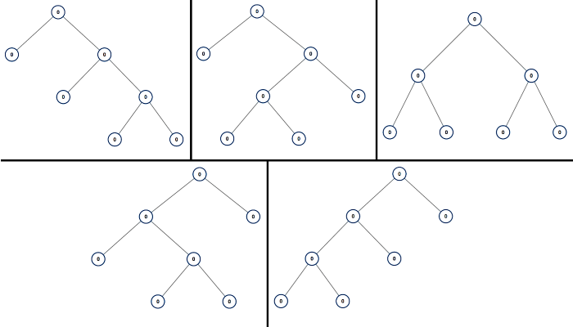

**Input:** n = 7

**Output:** [[0,0,0,null,null,0,0,null,null,0,0],[0,0,0,null,null,0,0,0,0],[0,0,0,0,0,0,0],[0,0,0,0,0,null,null,null,null,0,0],[0,0,0,0,0,null,null,0,0]]

**Example 2:**

**Input:** n = 3

**Output:** [[0,0,0]]

class Solution {

public:

    unordered_map<int,vector<TreeNode*>>mp;

    vector<TreeNode*> solve(int n){

        //base condition

        if(n%2==0){

            return {};

        }

        if(n==1){

            TreeNode* root=new TreeNode(0);

            return {root};

        }

        if(mp.find(n)!=mp.end()){

            return mp[n];

        }

        vector<TreeNode*>result;

        for(int i=1;i<n;i+=2){

            vector<TreeNode*>leftAllFBT=solve(i);

            vector<TreeNode*>rightAllFBT=solve(n-i-1);

            for(auto &l:leftAllFBT){

                for(auto &r:rightAllFBT){

                    TreeNode* root=new TreeNode(0);

                    root->left=l;

                    root->right=r;

                    result.push_back(root);

                }

            }

        }

        return mp[n]=result;

    }

    vector<TreeNode*> allPossibleFBT(int n) {

        return solve(n);

    }

};

**296: Knight Probability in ChessBoard**

On an n x n chessboard, a knight starts at the cell (row, column) and attempts to make exactly k moves. The rows and columns are **0-indexed**, so the top-left cell is (0, 0), and the bottom-right cell is (n - 1, n - 1).

A chess knight has eight possible moves it can make, as illustrated below. Each move is two cells in a cardinal direction, then one cell in an orthogonal direction.



Each time the knight is to move, it chooses one of eight possible moves uniformly at random (even if the piece would go off the chessboard) and moves there.

The knight continues moving until it has made exactly k moves or has moved off the chessboard.

Return *the probability that the knight remains on the board after it has stopped moving*.

**Example 1:**

**Input:** n = 3, k = 2, row = 0, column = 0

**Output:** 0.06250

**Explanation:** There are two moves (to (1,2), (2,1)) that will keep the knight on the board.

From each of those positions, there are also two moves that will keep the knight on the board.

The total probability the knight stays on the board is 0.0625.

**Example 2:**

**Input:** n = 1, k = 0, row = 0, column = 0

**Output:** 1.00000

//Using simple recursion and memoization (T.C : We visit each state once only and we have k possible tries - O(k * n^2)

class Solution {

public:

    unordered_map<string, double> mp;

    vector<pair<int, int>> directions = {{1, 2}, {1, -2}, {-1, 2}, {-1, -2}, {2, 1}, {2, -1}, {-2, 1}, {-2, -1}};

    double helper( int N, int K , int row, int col ) {

        if ( row < 0 || row >= N || col < 0 || col >= N )

            return 0;

        if (K==0)

            return 1;  //one possibility over, return now

        string key = to_string(K) + "_" + to_string(row) + "_" + to_string(col);

        if(mp.find(key) != mp.end())

            return mp[key];

        double ans = 0;

        for(auto &dir : directions) {

            int new_row = row + dir.first;

            int new_col = col + dir.second;

            ans += (double)helper(N, K-1, new_row, new_col);

        }

        return mp[key] = (double)(ans/8.0);

    }

    double knightProbability(int n, int k, int row, int column) {

        return helper( n , k , row , column);

    }

};

**297: Ways to express integers as sum of powers**

Given two **positive** integers n and x.

Return *the number of ways*n*can be expressed as the sum of the*xth*power of****unique****positive integers, in other words, the number of sets of unique integers*[n1, n2, ..., nk]*where*n = n1x + n2x + ... + nkx*.*

Since the result can be very large, return it modulo 109 + 7.

For example, if n = 160 and x = 3, one way to express n is n = 23 + 33 + 53.

**Example 1:**

**Input:** n = 10, x = 2

**Output:** 1

**Explanation:** We can express n as the following: n = 32 + 12 = 10.

It can be shown that it is the only way to express 10 as the sum of the 2nd power of unique integers.

**Example 2:**

**Input:** n = 4, x = 1

**Output:** 2

**Explanation:** We can express n in the following ways:

- n = 41 = 4.

- n = 31 + 11 = 4.

**Constraints:**

* 1 <= n <= 300
* 1 <= x <= 5
* #define ll long long
* class Solution {
* public:
* int mod = 1e9 + 7;
* vector<vector<int>> dp;
* // Recursive function to count the number of ways to express 'req' as the sum of 'x'-th powers
* int countways(int req, int x, int ind) {
* // Base case: if 'req' is 0, we have found a valid way to express it
* if (req == 0) return 1;
* // If the current 'ind'-th power of 'x' is greater than 'req', it is not possible to continue
* if (pow(ind, x) > req) return 0;
* if (dp[req][ind] != -1) return dp[req][ind];
* // Calculate the number of ways by considering two options:
* // 1. Take the current 'ind'-th power of 'x'
* ll take = countways(req - pow(ind, x), x, ind + 1);
* // 2. Do not take the current 'ind'-th power of 'x'
* ll nottake = countways(req, x, ind + 1);
* return dp[req][ind] = (take + nottake) % mod;
* }
* int numberOfWays(int n, int x) {
* // Find the maximum power of 'x' that is less than or equal to 'n'
* int mx = 1;
* while (pow(mx, x) <= n) mx++;
* dp = vector<vector<int>>(301, (vector<int>(mx + 1, -1)));
* return countways(n, x, 1);
* }
* };

**298: Minimum speed to arrive on time (binary search)**

You are given a floating-point number hour, representing the amount of time you have to reach the office. To commute to the office, you must take n trains in sequential order. You are also given an integer array dist of length n, where dist[i] describes the distance (in kilometers) of the ith train ride.

Each train can only depart at an integer hour, so you may need to wait in between each train ride.

* For example, if the 1st train ride takes 1.5 hours, you must wait for an additional 0.5 hours before you can depart on the 2nd train ride at the 2 hour mark.

Return *the****minimum positive integer****speed****(in kilometers per hour)****that all the trains must travel at for you to reach the office on time, or*-1*if it is impossible to be on time*.

Tests are generated such that the answer will not exceed 107 and hour will have **at most two digits after the decimal point**.

**Example 1:**

**Input:** dist = [1,3,2], hour = 6

**Output:** 1

**Explanation:** At speed 1:

- The first train ride takes 1/1 = 1 hour.

- Since we are already at an integer hour, we depart immediately at the 1 hour mark. The second train takes 3/1 = 3 hours.

- Since we are already at an integer hour, we depart immediately at the 4 hour mark. The third train takes 2/1 = 2 hours.

- You will arrive at exactly the 6 hour mark.

**Example 2:**

**Input:** dist = [1,3,2], hour = 2.7

**Output:** 3

**Explanation:** At speed 3:

- The first train ride takes 1/3 = 0.33333 hours.

- Since we are not at an integer hour, we wait until the 1 hour mark to depart. The second train ride takes 3/3 = 1 hour.

- Since we are already at an integer hour, we depart immediately at the 2 hour mark. The third train takes 2/3 = 0.66667 hours.

- You will arrive at the 2.66667 hour mark.

**Example 3:**

**Input:** dist = [1,3,2], hour = 1.9

**Output:** -1

**Explanation:** It is impossible because the earliest the third train can depart is at the 2 hour mark.

**Constraints:**

* n == dist.length
* 1 <= n <= 105
* 1 <= dist[i] <= 105
* 1 <= hour <= 109
* There will be at most two digits after the decimal point in hour.
* //tle
* /*
* class Solution {
* public:
* int minSpeedOnTime(vector<int>& dist, double hour) {
* int ans;
* int n=dist.size();
* int flag=0;
* for(int i=1;i<=10000000;i++){
* double hr=0.0;
* for(int j=0;j<n-1;j++){
* double d=(double)dist[j]/(double)i;
* hr+=ceil(d);
* }
* hr+=dist[n-1]/double(i);
* if(hr<=hour){
* ans=i;
* flag=1;
* break;
* }
* }
* if(flag){
* return ans;
* }
* return -1;
* }
* };*/
* //using binary search
* class Solution {
* public:
* int minSpeedOnTime(vector<int>& dist, double hour) {
* double low = 1, high = 1e7;
* int n = dist.size();
* int result = -1;
* while (low <= high) {
* int mid = low + (high - low) / 2;
* double totalHours = 0;
* for (int i = 0; i < n - 1; i++) {
* double d = (double)dist[i] / (double)mid;
* totalHours += ceil(d);
* }
* // Handle the last segment separately
* totalHours += (double)dist[n - 1] / (double)mid;
* if (totalHours <= hour) {
* result = mid;
* high = mid - 1;
* } else {
* low = mid + 1;
* }
* }
* return result;
* }
* };

**299: Koko Eating bananas (binary search same concept as of previous)**

Koko loves to eat bananas. There are n piles of bananas, the ith pile has piles[i] bananas. The guards have gone and will come back in h hours.

Koko can decide her bananas-per-hour eating speed of k. Each hour, she chooses some pile of bananas and eats k bananas from that pile. If the pile has less than k bananas, she eats all of them instead and will not eat any more bananas during this hour.

Koko likes to eat slowly but still wants to finish eating all the bananas before the guards return.

Return *the minimum integer* k *such that she can eat all the bananas within* h *hours*.

**Example 1:**

**Input:** piles = [3,6,7,11], h = 8

**Output:** 4

**Example 2:**

**Input:** piles = [30,11,23,4,20], h = 5

**Output:** 30

**Example 3:**

**Input:** piles = [30,11,23,4,20], h = 6

**Output:** 23

class Solution {

public:

int timefnc(int mid,vector<int>&piles,int h)

    {

        long long sum = 0;

        for(int i=0;i<piles.size();i++)

        {

            //sum+=(piles[i]/mid)+((piles[i]%mid)!=0);

            sum+=ceil( (double)piles[i]/(double)mid );

            if(sum>h){

                return INT_MAX;

            }

        }

        return sum;

    }

     int minEatingSpeed(vector<int>& piles, int h) {

        int low = 1;

        int high = *max_element(piles.begin(),piles.end());

        int ans = 0;

        while(low<=high)

        {

            int mid = low+(-low+high)/2;

            int time = timefnc(mid,piles,h);

            if(time<=h)

            {

                ans = mid;

                high = mid-1;

            }

            else low = mid+1;

        }

        return ans;

    }

};

**300: Capacity to ship packages within D days (binary search)**

A conveyor belt has packages that must be shipped from one port to another within days days.

The ith package on the conveyor belt has a weight of weights[i]. Each day, we load the ship with packages on the conveyor belt (in the order given by weights). We may not load more weight than the maximum weight capacity of the ship.

Return the least weight capacity of the ship that will result in all the packages on the conveyor belt being shipped within days days.

**Example 1:**

**Input:** weights = [1,2,3,4,5,6,7,8,9,10], days = 5

**Output:** 15

**Explanation:** A ship capacity of 15 is the minimum to ship all the packages in 5 days like this:

1st day: 1, 2, 3, 4, 5

2nd day: 6, 7

3rd day: 8

4th day: 9

5th day: 10

Note that the cargo must be shipped in the order given, so using a ship of capacity 14 and splitting the packages into parts like (2, 3, 4, 5), (1, 6, 7), (8), (9), (10) is not allowed.

**Example 2:**

**Input:** weights = [3,2,2,4,1,4], days = 3

**Output:** 6

**Explanation:** A ship capacity of 6 is the minimum to ship all the packages in 3 days like this:

1st day: 3, 2

2nd day: 2, 4

3rd day: 1, 4

**Example 3:**

**Input:** weights = [1,2,3,1,1], days = 4

**Output:** 3

**Explanation:**

1st day: 1

2nd day: 2

3rd day: 3

4th day: 1, 1

class Solution {

public:

    int shipWithinDays(vector<int>& weights, int days) {

        int n = weights.size();

        int low = *max_element(weights.begin(), weights.end());

        int high = accumulate(weights.begin(), weights.end(), 0);

        int result = 0;

        while (low <= high) {

            int mid = low + (high - low) / 2;

            int sum = 0, cnt = 0;

            for (int i = 0; i < n; i++) {

                sum += weights[i];

                if (sum > mid) {

                    cnt++;

                    sum = weights[i]; // Start a new segment

                }

            }

            cnt++; // Add the last segment

            if (cnt <= days) {

                result = mid;

                high = mid - 1;

            } else {

                low = mid + 1;

            }

        }

        return result;

    }

};

**301: Maximum candies allocated to k children (binary search)**

You are given a **0-indexed** integer array candies. Each element in the array denotes a pile of candies of size candies[i]. You can divide each pile into any number of **sub piles**, but you **cannot** merge two piles together.

You are also given an integer k. You should allocate piles of candies to k children such that each child gets the **same** number of candies. Each child can take **at most one** pile of candies and some piles of candies may go unused.

Return *the****maximum number of candies****each child can get.*

**Example 1:**

**Input:** candies = [5,8,6], k = 3

**Output:** 5

**Explanation:** We can divide candies[1] into 2 piles of size 5 and 3, and candies[2] into 2 piles of size 5 and 1. We now have five piles of candies of sizes 5, 5, 3, 5, and 1. We can allocate the 3 piles of size 5 to 3 children. It can be proven that each child cannot receive more than 5 candies.

**Example 2:**

**Input:** candies = [2,5], k = 11

**Output:** 0

**Explanation:** There are 11 children but only 7 candies in total, so it is impossible to ensure each child receives at least one candy. Thus, each child gets no candy and the answer is 0.

**Constraints:**

* 1 <= candies.length <= 105
* 1 <= candies[i] <= 107
* 1 <= k <= 1012
* /*#define ll long long
* class Solution {
* public:
* int maximumCandies(std::vector<int>& candies, long long k) {
* ll low = 1; // Minimum candies that can be distributed to each child
* ll high = *max_element(candies.begin(), candies.end());
* // ll high = (sum); // Maximum candies that can be distributed to each child if sum lies in a single pile
* // Now the answer lies between low and high, we check it using binary search
* ll ans = 0;
* while (low <= high) {
* ll mid = low + (high - low) / 2;
* if (mid == 0) {
* return 0;
* }
* ll cnt = 0;
* for (int i = 0; i < candies.size(); i++) {
* cnt += (candies[i] / mid);
* }
* if (cnt >= k) {
* ans = mid;
* low = mid + 1;
* } else {
* high = mid - 1;
* }
* }
* return ans;
* }
* };*/
* class Solution {
* public:
* int maximumCandies(vector<int>& candies, long long k) {
* long long  low=1;
* long high=*max_element(candies.begin(),candies.end());
* long  ans=0;
* while(low<=high){
* long long mid=low+(high-low)/2;
* long long cnt=0;
* for(int i=0;i<candies.size();i++){
* cnt+=candies[i]/mid;
* }
* if(cnt>=k){
* ans=mid;
* low=mid+1;
* }
* else{
* high=mid-1;
* }
* }
* return ans;
* }
* };

**301: Jump game**

You are given an integer array nums. You are initially positioned at the array's **first index**, and each element in the array represents your maximum jump length at that position.

Return true*if you can reach the last index, or*false*otherwise*.

**Example 1:**

**Input:** nums = [2,3,1,1,4]

**Output:** true

**Explanation:** Jump 1 step from index 0 to 1, then 3 steps to the last index.

**Example 2:**

**Input:** nums = [3,2,1,0,4]

**Output:** false

**Explanation:** You will always arrive at index 3 no matter what. Its maximum jump length is 0, which makes it impossible to reach the last index.

**Constraints:**

* 1 <= nums.length <= 104
* 0 <= nums[i] <= 105
* /*
* //only recursion (TLE)
* class Solution {
* public:
* bool solve(vector<int>&nums,int idx){
* //base condition
* if(idx==nums.size()-1){
* return true;
* }
* //if at any moment nums[i]=0 , we will stuck
* if(nums[idx]==0){
* return false;
* }



* int reach=idx+nums[idx];



* //explore all possible ways



* 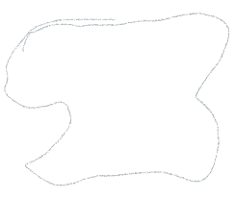        for(int jump=idx+1;jump<=reach;jump++){

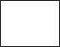

* if(jump<nums.size()){
* if(solve(nums,jump)==true){
* return true;



* }
* }



* }



* return false;



* }







* bool canJump(vector<int>& nums) {
* return solve(nums,0);
* }
* };
* */
* //recursion+memoized
* class Solution {
* public:
* int dp[10001];
* bool solve(vector<int>& nums, int idx) {
* // Base condition
* if (idx >= nums.size() - 1) {
* return true;
* }
* // If at any moment nums[i]=0, we will be stuck
* if (nums[idx] == 0) {
* return false;
* }
* if (dp[idx] != -1) {
* return dp[idx];
* }
* int reach = idx + nums[idx];
* // Explore all possible ways
* for (int j = 1; j <= nums[idx]; j++) {
* if (solve(nums, idx + j) == true) {
* return dp[idx] = true;
* }
* }
* return dp[idx] = false;
* }
* bool canJump(vector<int>& nums) {
* int n = nums.size();
* if (n == 1 && nums[n - 1] == 0) {
* return true;
* }
* memset(dp, -1, sizeof(dp));
* return solve(nums, 0);
* }
* };

//greedy solution o(n)

class Solution {

public:

    bool canJump(vector<int>& nums) {

        int index=nums.size()-1;

        for(int i=nums.size()-1;i>=0;i--){

            if(i+nums[i]>=index){

                index=i;

            }

        }

        if(index==0){

            return true;

        }

        return false;

    }

};

**302: Jump Game 2**

You are given a **0-indexed** array of integers nums of length n. You are initially positioned at nums[0].

Each element nums[i] represents the maximum length of a forward jump from index i. In other words, if you are at nums[i], you can jump to any nums[i + j] where:

* 0 <= j <= nums[i] and
* i + j < n

Return *the minimum number of jumps to reach*nums[n - 1]. The test cases are generated such that you can reach nums[n - 1].

**Example 1:**

**Input:** nums = [2,3,1,1,4]

**Output:** 2

**Explanation:** The minimum number of jumps to reach the last index is 2. Jump 1 step from index 0 to 1, then 3 steps to the last index.

**Example 2:**

**Input:** nums = [2,3,0,1,4]

**Output:** 2

**Constraints:**

* 1 <= nums.length <= 104
* 0 <= nums[i] <= 1000
* It's guaranteed that you can reach nums[n - 1].
* //recursive o(n!)
* // Time Complexity : O(N!). At each index i we have N-i choices and we recursively explore each of them till end. So we require O(N*(N-1)*(N-2)...1) = O(N!).
* // Space Complexity : O(N)
* int jump(vector<int>& nums, int pos = 0) {
* if(pos >= size(nums) - 1) return 0;
* int minJumps = 10001;  // initialising to max possible jumps + 1
* //here j is jump
* for(int j = 1; j <= nums[pos]; j++)  // explore all possible jump sizes from current position
* minJumps = min(minJumps, 1 + jump(nums, pos + j));
* return minJumps;
* }
* //memoized o(n^2)
* class Solution {
* public:
* int solve(vector<int>&nums,int ind,vector<int>&dp){
* if(ind>=nums.size()-1){  //if we reached the last index
* return 0;
* }
* if(dp[ind]!=10001){
* return dp[ind];
* }
* for(int j=1;j<=nums[ind];j++){
* dp[ind]=min(dp[ind],1+solve(nums,ind+j,dp));
* }
* return dp[ind];
* }
* int jump(vector<int>& nums) {
* vector<int>dp(nums.size()+1,10001);
* return solve(nums,0,dp);
* }
* };*/
* //greedy o(n)
* class Solution {
* public:
* int jump(vector<int>& nums) {          //greedy solt ,best one
* int jumps=0;
* int farthest_ind=0;
* int curr_ind=0;
* for(int i=0;i<nums.size()-1;i++){
* farthest_ind=max(farthest_ind,nums[i]+i);
* if(i==curr_ind){
* curr_ind=farthest_ind;
* jumps++;
* }
* }
* return jumps;
* }
* };*/

**303: Jump game 3 (dfs or bfs)**

Given an array of non-negative integers arr, you are initially positioned at start index of the array. When you are at index i, you can jump to i + arr[i] or i - arr[i], check if you can reach to **any** index with value 0.

Notice that you can not jump outside of the array at any time.

**Example 1:**

**Input:** arr = [4,2,3,0,3,1,2], start = 5

**Output:** true

**Explanation:**

All possible ways to reach at index 3 with value 0 are:

index 5 -> index 4 -> index 1 -> index 3

index 5 -> index 6 -> index 4 -> index 1 -> index 3

**Example 2:**

**Input:** arr = [4,2,3,0,3,1,2], start = 0

**Output:** true

**Explanation:**

One possible way to reach at index 3 with value 0 is:

index 0 -> index 4 -> index 1 -> index 3

**Example 3:**

**Input:** arr = [3,0,2,1,2], start = 2

**Output:** false

**Explanation:** There is no way to reach at index 1 with value 0.

**Constraints:**

* 1 <= arr.length <= 5 * 104
* 0 <= arr[i] < arr.length
* 0 <= start < arr.length
* class Solution {
* public:
* int n;
* bool dfs(vector<int>& arr, int i,vector<bool>&visited){
* //base condition
* if(i>=n || i<0){
* return false;
* }
* if(arr[i]==0){
* return true;
* }
* if(visited[i]){
* return false;
* }
* visited[i]=true;
* bool l=dfs(arr,i+arr[i],visited);
* bool r=dfs(arr,i-arr[i],visited);
* return l||r;
* }
* bool canReach(vector<int>& arr, int start) {
* n=arr.size();
* vector<bool>visited(n,false);
* return dfs(arr,start,visited);
* }
* };*/
* class Solution{
* public:
* bool canReach(vector<int>& arr, int start) {
* queue<int>q;
* int n=arr.size();
* vector<bool>visited(n,false);
* q.push(start);
* while(!q.empty()){
* int i=q.front();
* q.pop();
* if(arr[i]==0){
* return true;
* }
* if(visited[i]==true){
* continue;
* }
* visited[i]=true;
* if(i+arr[i]<n){
* q.push(i+arr[i]);
* }
* if(i-arr[i]>=0){
* q.push(i-arr[i]);
* }
* }
* return false;
* }
* };

**304: Jump Game 4 (bfs)**

Given an array of integers arr, you are initially positioned at the first index of the array.

In one step you can jump from index i to index:

* i + 1 where: i + 1 < arr.length.
* i - 1 where: i - 1 >= 0.
* j where: arr[i] == arr[j] and i != j.

Return *the minimum number of steps* to reach the **last index** of the array.

Notice that you can not jump outside of the array at any time.

**Example 1:**

**Input:** arr = [100,-23,-23,404,100,23,23,23,3,404]

**Output:** 3

**Explanation:** You need three jumps from index 0 --> 4 --> 3 --> 9. Note that index 9 is the last index of the array.

**Example 2:**

**Input:** arr = [7]

**Output:** 0

**Explanation:** Start index is the last index. You do not need to jump.

**Example 3:**

**Input:** arr = [7,6,9,6,9,6,9,7]

**Output:** 1

**Explanation:** You can jump directly from index 0 to index 7 which is last index of the array.

**Constraints:**

* 1 <= arr.length <= 5 * 104
* -108 <= arr[i] <= 108

class Solution {

public:

    int minJumps(vector<int>& arr) {

        unordered_map<int,vector<int>>mp;

        for(int i=0;i<arr.size();i++){

            mp[arr[i]].push_back(i);

        }

        int n=arr.size();

        vector<bool>visited(n);

        visited[0]=true;               //time complexity=o(n), space=o(n);

        queue<int>q;

        q.push(0);

        int step=0;

        while(!q.empty()){

            int size=q.size();

            while(size--){

                int i=q.front();

                q.pop();

                if(i==n-1){

                    return step;

                }

                vector<int>&next=mp[arr[i]];

                next.push_back(i-1);

                next.push_back(i+1);

                for(int j:next){

                    if(j>=0 && j<n && !visited[j]){

                        visited[j]=true;

                        q.push(j);

                    }

                }

                mp[arr[i]].clear();

            }

            step++;

        }

        return -1;

    }

};

**305: Jump Game 5**

Given an array of integers arr and an integer d. In one step you can jump from index i to index:

* i + x where: i + x < arr.length and  0 < x <= d.
* i - x where: i - x >= 0 and  0 < x <= d.

In addition, you can only jump from index i to index j if arr[i] > arr[j] and arr[i] > arr[k] for all indices k between i and j (More formally min(i, j) < k < max(i, j)).

You can choose any index of the array and start jumping. Return *the maximum number of indices* you can visit.

Notice that you can not jump outside of the array at any time.

**Example 1:**

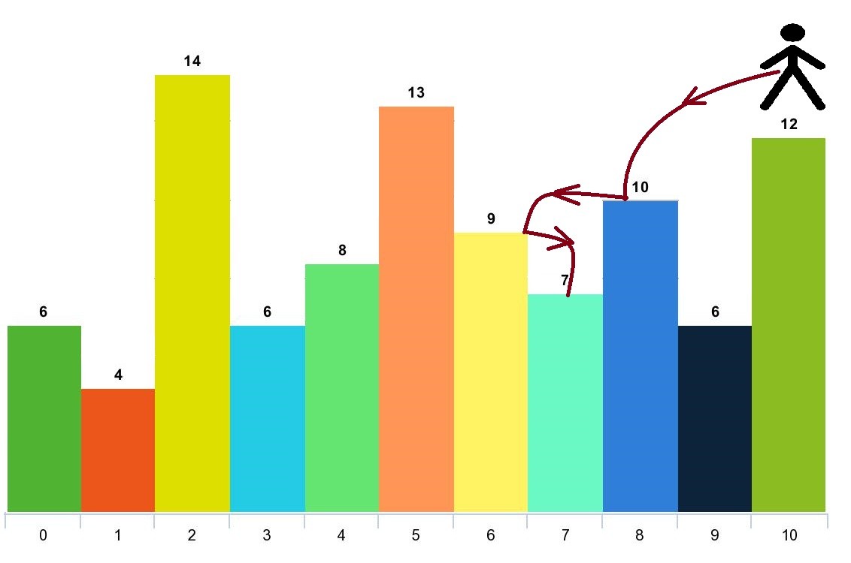

**Input:** arr = [6,4,14,6,8,13,9,7,10,6,12], d = 2

**Output:** 4

**Explanation:** You can start at index 10. You can jump 10 --> 8 --> 6 --> 7 as shown.

Note that if you start at index 6 you can only jump to index 7. You cannot jump to index 5 because 13 > 9. You cannot jump to index 4 because index 5 is between index 4 and 6 and 13 > 9.

Similarly You cannot jump from index 3 to index 2 or index 1.

**Example 2:**

**Input:** arr = [3,3,3,3,3], d = 3

**Output:** 1

**Explanation:** You can start at any index. You always cannot jump to any index.

**Example 3:**

**Input:** arr = [7,6,5,4,3,2,1], d = 1

**Output:** 7

**Explanation:** Start at index 0. You can visit all the indicies.

**Constraints:**

* 1 <= arr.length <= 1000
* 1 <= arr[i] <= 105
* 1 <= d <= arr.length
* class Solution {
* public:
* int dp[1001];
* int n;
* int solve(vector<int>&arr,int d,int i){
* int ans=1;
* if(dp[i]!=-1){
* return dp[i];
* }
* //right
* for(int j=i+1; j<=min(i+d,n-1)&&arr[i]>arr[j] ;j++){
* ans=max(ans,1+solve(arr,d,j));
* }
* //left
* for(int j=i-1; j>=max(i-d,0)&&arr[i]>arr[j] ;j--){
* ans=max(ans,1+solve(arr,d,j));
* }
* return dp[i]=ans;
* }
* int maxJumps(vector<int>& arr, int d) {
* memset(dp,-1,sizeof(dp));
* n=arr.size();
* int ans=0;
* for(int i=0;i<n;i++){
* ans=max(ans,solve(arr,d,i));
* }
* return ans;
* }
* };

**306: Jump Game 6 (deque , dp(top down)->tle)**

You are given a **0-indexed** integer array nums and an integer k.

You are initially standing at index 0. In one move, you can jump at most k steps forward without going outside the boundaries of the array. That is, you can jump from index i to any index in the range [i + 1, min(n - 1, i + k)] **inclusive**.

You want to reach the last index of the array (index n - 1). Your **score** is the **sum** of all nums[j] for each index j you visited in the array.

Return *the****maximum score****you can get*.

**Example 1:**

**Input:** nums = [1,-1,-2,4,-7,3], k = 2

**Output:** 7

**Explanation:** You can choose your jumps forming the subsequence [1,-1,4,3] (underlined above). The sum is 7.

**Example 2:**

**Input:** nums = [10,-5,-2,4,0,3], k = 3

**Output:** 17

**Explanation:** You can choose your jumps forming the subsequence [10,4,3] (underlined above). The sum is 17.

**Example 3:**

**Input:** nums = [1,-5,-20,4,-1,3,-6,-3], k = 2

**Output:** 0

**Constraints:**

//recursive TLE (5/72)

class Solution {

public:

    int n;

    int solve(vector<int>&nums,int k,int idx){

        if(idx==nums.size()-1){

            return nums[n-1];

        }

        if(idx>n-1){

            return -1e9;

        }

        int maxi=-1e9;

        // for(int j=idx+1;j<=min(n-1,idx+k);j++){

        //     maxi=max(maxi,nums[idx]+solve(nums,k,j));

        // }

        for(int j=1;j<=k;j++){

            maxi=max(maxi,nums[idx]+solve(nums,k,idx+j));

        }

        return maxi;

    }

    int maxResult(vector<int>& nums, int k) {

        n=nums.size();

        return solve(nums,k,0);

    }

};*/

//memoized TLE (57/72)

class Solution {

public:

    int n;

    //int dp[10001];

    vector<int>dp;

    int solve(vector<int>&nums,int k,int idx){

        if(idx==nums.size()-1){

            return nums[n-1];

        }

        if(idx>n-1){

            return -1e9;

        }

        if(dp[idx]!=-1){

            return dp[idx];

        }

        int maxi=-1e9;

        // for(int j=idx+1;j<=min(n-1,idx+k);j++){

        //     maxi=max(maxi,nums[idx]+solve(nums,k,j));

        // }

        for(int j=1;j<=k;j++){

            maxi=max(maxi,nums[idx]+solve(nums,k,idx+j));

        }

        return dp[idx]=maxi;

    }

    int maxResult(vector<int>& nums, int k) {

        //memset(dp,-1,sizeof(dp));

        n=nums.size();

        dp.resize(n+1,-1);

        return solve(nums,k,0);

    }

};

* 1 <= nums.length, k <= 105
* -104 <= nums[i] <= 104
* class Solution {
* public:
* int maxResult(vector<int>& nums, int k) {
* deque<int> d{0};//max deque
* // cout<<d.front()<<endl;
* for (int i = 1; i < nums.size(); ++i) {
* if ( i > d.front() + k)
* d.pop_front();
* nums[i] += nums[d.front()];
* while (!d.empty() && nums[d.back()] <= nums[i])
* d.pop_back();
* d.push_back(i);
* }
* return nums.back();
* }
* };

**307: Job Sequencing Problem**

Given an array of jobs where every job has a deadline and associated profit if the job is finished before the deadline. It is also given that every job takes a single unit of time, so the minimum possible deadline for any job is 1. Maximize the total profit if only one job can be scheduled at a time.

**Examples:**

**a           4          20     
  b           1          10  
  c           1          40    
  d          1          30**

**Output: Following is maximum profit sequence of jobs: c, a**

**Input:  Five Jobs with following deadlines and profits**

**JobID   Deadline  Profit**

**a            2          100  
  b            1          19  
  c            2          27  
 d            1          25  
 e            3          15**

**Output: Following is maximum profit sequence of jobs: c, a, e**

sol1:

#include <bits/stdc++.h>

using namespace std;

// Sorting based on the increasing profit

bool comp(pair<int, int>& a, pair<int, int>& b) {

    return a.second > b.second;

}

vector<int> jobScheduling(vector<vector<int>>& jobs) {

    int n = jobs.size();

    vector<pair<int, int>> vec;

    for (int i = 0; i < n; i++) {

        vec.push_back({ jobs[i][1], jobs[i][2] });

    }

    sort(vec.begin(), vec.end(), comp);

    vector<int> slots_taken(n, false);

    int job_count = 0, profit = 0;

    for (int i = 0; i < n; i++) {

        auto& job = vec[i];

        for (int j = min(n, job.first) - 1; j >= 0; j--) {

            if (!slots_taken[j]) {

                slots_taken[j] = true;

                profit += job.second;

                job_count++;

                break;

            }

        }

    }

    return { job_count, profit };

}*/

sol2:

#include <bits/stdc++.h>

using namespace std;

vector<int> jobScheduling(vector<vector<int>>& jobs) {

    unordered_map<int, vector<int>> mp;

    int maxi_deadline = 0;

    for (int i = 0; i < jobs.size(); i++) {

        mp[jobs[i][1]].push_back(jobs[i][2]);

        maxi_deadline = max(maxi_deadline, jobs[i][1]);

    }

    int ans = 0;

    int jobcount = 0;

    priority_queue<int> pq; // made to give the max profit

    for (int i = maxi_deadline; i > 0; i--) {

        for (auto &v : mp[i]) {

            pq.push(v);

        }

        if (!pq.empty()) {

            ans += pq.top();

            pq.pop();

            jobcount++;

        }

    }

    return { jobcount, ans };

}

**307: Maximum Profit in Job Scheduling**

We have n jobs, where every job is scheduled to be done from startTime[i] to endTime[i], obtaining a profit of profit[i].

You're given the startTime, endTime and profit arrays, return the maximum profit you can take such that there are no two jobs in the subset with overlapping time range.

If you choose a job that ends at time X you will be able to start another job that starts at time X.

**Example 1:**

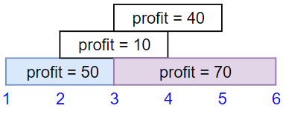

**Input:** startTime = [1,2,3,3], endTime = [3,4,5,6], profit = [50,10,40,70]

**Output:** 120

**Explanation:** The subset chosen is the first and fourth job.

Time range [1-3]+[3-6] , we get profit of 120 = 50 + 70.

**Example 2:**

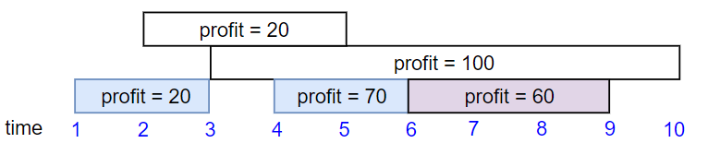

**Input:** startTime = [1,2,3,4,6], endTime = [3,5,10,6,9], profit = [20,20,100,70,60]

**Output:** 150

**Explanation:** The subset chosen is the first, fourth and fifth job.

Profit obtained 150 = 20 + 70 + 60.

**Example 3:**

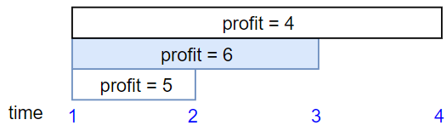

**Input:** startTime = [1,1,1], endTime = [2,3,4], profit = [5,6,4]

**Output:** 6

**Constraints:**

* 1 <= startTime.length == endTime.length == profit.length <= 5 * 104
* 1 <= startTime[i] < endTime[i] <= 109
* 1 <= profit[i] <= 104
* //dp+for loop
* class Solution {
* public:
* int getnext_index(vector<vector<int>>&vec,int j,int curr_end){
* for(int i=j;i<vec.size();i++){
* if(vec[i][0]>=curr_end){
* return i;
* }
* }
* int n=vec.size();
* return n+1;
* }
* int solve(vector<vector<int>>&vec,int i,vector<int>&dp){
* if(i>=vec.size()){
* return 0;
* }
* if(dp[i]!=-1){
* return dp[i];
* }
* int next=getnext_index(vec,i+1,vec[i][1]);
* //take
* int take=vec[i][2]+solve(vec,next,dp);
* //notake
* int notake=solve(vec,i+1,dp);
* return dp[i]=max(take,notake);
* }
* int jobScheduling(vector<int>& startTime, vector<int>& endTime, vector<int>& profit) {
* int n=startTime.size();
* vector<int>dp(n+1,-1);
* vector<vector<int>>vec(n,vector<int>(3,0));
* for(int i=0;i<n;i++){
* vec[i][0]=startTime[i];
* vec[i][1]=endTime[i];
* vec[i][2]=profit[i];
* }
* //we are sorting acc to starting time //here no need to use cmp as merely simple sort acc to starttime but we should know this lambda function
* auto cmp=[&](auto &vec1 ,auto &vec2){
* return vec1[0]<=vec2[0];
* };
* sort(vec.begin(),vec.end(),cmp);
* return solve(vec,0,dp);
* }
* };*/
* //dp+binary_search O(nlogn)
* class Solution {
* public:
* int getnext_index(vector<vector<int>>&vec,int j,int curr_end){
* int n=vec.size();
* int low=j,high=n-1,result=n+1;
* while(low<=high){
* int mid=low+(high-low)/2;
* if(vec[mid][0]>=curr_end){
* result=mid;
* high=mid-1;
* }
* else{
* low=mid+1;
* }
* }
* return result;
* }
* int solve(vector<vector<int>>&vec,int i,vector<int>&dp){
* if(i>=vec.size()){
* return 0;
* }
* if(dp[i]!=-1){
* return dp[i];
* }
* int next=getnext_index(vec,i+1,vec[i][1]);//getting valid next ind where we can make take or not
* //take
* int take=vec[i][2]+solve(vec,next,dp);
* //notake
* int notake=solve(vec,i+1,dp);
* return dp[i]=max(take,notake);
* }
* int jobScheduling(vector<int>& startTime, vector<int>& endTime, vector<int>& profit) {
* int n=startTime.size();
* vector<int>dp(n+1,-1);
* vector<vector<int>>vec(n,vector<int>(3,0));
* for(int i=0;i<n;i++){
* vec[i][0]=startTime[i];
* vec[i][1]=endTime[i];
* vec[i][2]=profit[i];
* }
* //we are sorting acc to starting time //here no need to use cmp as merely simple sort acc to starttime but we should know this lambda function
* auto cmp=[&](auto &vec1 ,auto &vec2){
* return vec1[0]<=vec2[0];
* };
* sort(vec.begin(),vec.end(),cmp);
* return solve(vec,0,dp);
* }
* };

**308: Strange Printer (can leave)**

There is a strange printer with the following two special properties:

* The printer can only print a sequence of **the same character** each time.
* At each turn, the printer can print new characters starting from and ending at any place and will cover the original existing characters.

Given a string s, return *the minimum number of turns the printer needed to print it*.

**Example 1:**

**Input:** s = "aaabbb"

**Output:** 2

**Explanation:** Print "aaa" first and then print "bbb".

**Example 2:**

**Input:** s = "aba"

**Output:** 2

**Explanation:** Print "aaa" first and then print "b" from the second place of the string, which will cover the existing character 'a'.

**Constraints:**

* 1 <= s.length <= 100
* s consists of lowercase English letters.
* //Approach-1 (Recursion + Memoization)
* class Solution {
* public:
* int n;
* vector<vector<int>> t;
* int solve(int l, int r, string& s){
* if(l == r)
* return 1;
* else if(l > r)
* return 0;
* if(t[l][r] != -1)
* return t[l][r];
* int i = l+1;
* while(i <= r && s[i] == s[l])
* i++;
* if(i == r+1)
* return 1;
* int normal = 1 + solve(i,r,s);
* int aage_ka = INT_MAX;
* for(int j = i; j <= r; j++){
* if(s[l] == s[j]){
* int x = solve(i,j-1,s) + solve(j,r,s);
* aage_ka = min(aage_ka, x);
* }
* }
* return t[l][r] = min(aage_ka, normal);
* }
* int strangePrinter(string s) {
* n = s.length() ;
* t.resize(n,vector<int>(n+1, -1));
* return solve(0, n-1, s);
* }
* };

**309: House Robber 1**

You are a professional robber planning to rob houses along a street. Each house has a certain amount of money stashed, the only constraint stopping you from robbing each of them is that adjacent houses have security systems connected and **it will automatically contact the police if two adjacent houses were broken into on the same night**.

Given an integer array nums representing the amount of money of each house, return *the maximum amount of money you can rob tonight****without alerting the police***.

**Example 1:**

**Input:** nums = [1,2,3,1]

**Output:** 4

**Explanation:** Rob house 1 (money = 1) and then rob house 3 (money = 3).

Total amount you can rob = 1 + 3 = 4.

**Example 2:**

**Input:** nums = [2,7,9,3,1]

**Output:** 12

**Explanation:** Rob house 1 (money = 2), rob house 3 (money = 9) and rob house 5 (money = 1).

Total amount you can rob = 2 + 9 + 1 = 12.

**Constraints:**

* 1 <= nums.length <= 100
* 0 <= nums[i] <= 400
* //Approach-1 (Recur + Memo)
* class Solution {
* public:
* int t[101];
* int solve(vector<int>& nums, int i, int& n) {
* if(i >= n)
* return 0;
* if(t[i] != -1)
* return t[i];
* int take = nums[i] + solve(nums, i+2, n); //steals ith house and moves to i+2 (because we can't steal adjacent)
* int skip = solve(nums, i+1, n); //skips this house, now we can move to adjacent next house
* return t[i]=max(take, skip);
* }
* int rob(vector<int>& nums) {
* int n = nums.size();
* memset(t, -1, sizeof(t));
* return solve(nums, 0, n);
* }
* };
* //Approach-2 (Bottom up)

    class Solution {

public:

    int rob(vector<int>& nums) {

        if(nums.size()==1)return nums[0];

        vector<int>dp(nums.size());

        dp[0]=nums[0];

        dp[1]=max(nums[0],nums[1]);

        for(int i=2;i<nums.size();i++){

            dp[i]=max(dp[i-1],dp[i-2]+nums[i]);

        }

        return dp[nums.size()-1];

    }

};

* class Solution {
* public:
* int rob(vector<int>& nums) {
* int n = nums.size();
* if(n == 1)
* return nums[0];
* vector<int> t(n+1);
* //t[i] = max profit till house i
* t[0] = 0;
* t[1] = nums[0];
* for(int i = 2; i<=n; i++) {
* int skip  = t[i-1];
* int steal = nums[i-1] + t[i-2];
* t[i] = max(skip, steal); //max(skip, steal)
* /*
* SKIP  : If we skip this house,  then we have money till previous house  =  t[i-1]
* STEAL : If we steal this house, then we can't take prev profit, we can take till (i-2)th house profit = t[i-2]
* */
* }
* return t[n];
* }
* };
* //Approach-3 (Space Optimized Bottom Up - Converting Approach-2)
* class Solution {
* public:
* int rob(vector<int>& nums) {
* int n = nums.size();
* int prevPrev = 0;
* int prev     = nums[0];
* for(int i = 2; i<=n; i++) {
* int skip = prev;
* int take = nums[i-1] + prevPrev;
* int temp = max(skip, take);
* prevPrev = prev;
* prev     = temp;
* }
* return prev;
* }
* };

**310: House Robber 2**

You are a professional robber planning to rob houses along a street. Each house has a certain amount of money stashed. All houses at this place are **arranged in a circle.** That means the first house is the neighbor of the last one. Meanwhile, adjacent houses have a security system connected, and **it will automatically contact the police if two adjacent houses were broken into on the same night**.

Given an integer array nums representing the amount of money of each house, return *the maximum amount of money you can rob tonight****without alerting the police***.

**Example 1:**

**Input:** nums = [2,3,2]

**Output:** 3

**Explanation:** You cannot rob house 1 (money = 2) and then rob house 3 (money = 2), because they are adjacent houses.

**Example 2:**

**Input:** nums = [1,2,3,1]

**Output:** 4

**Explanation:** Rob house 1 (money = 1) and then rob house 3 (money = 3).

Total amount you can rob = 1 + 3 = 4.

**Example 3:**

**Input:** nums = [1,2,3]

**Output:** 3

**Constraints:**

* 1 <= nums.length <= 100
* 0 <= nums[i] <= 1000
* //Approach-1 (Recur + Memo)
* class Solution {
* public:
* int t[101];
* int solve(vector<int>& nums, int i, int n) {
* if(i > n)
* return 0;
* if(t[i] != -1)
* return t[i];
* int take = nums[i] + solve(nums, i+2, n); //steals ith house and moves to i+2 (because we can't steal adjacent)
* int skip = solve(nums, i+1, n); //skips this house, now we can move to adjacent next house
* return t[i]=max(take, skip);
* }
* int rob(vector<int>& nums) {
* int n = nums.size();
* if(n == 1)
* return nums[0];
* if(n == 2)
* return max(nums[0], nums[1]);
* memset(t, -1, sizeof(t));
* //case-1 - Take first house 0th index wala house
* int take_0th_index_house = solve(nums, 0, n-2);
* memset(t, -1, sizeof(t));
* //case-2  - Take second house 1st index wala house
* int take_1st_index_house = solve(nums, 1, n-1);

* return max(take_0th_index_house, take_1st_index_house);

* }
* };
* //Approach-2 (Using Bottom Up similar to House Robber-1 and just taking two cases
* /*
* Case-1 (Take from 1st House - Hence skip the last house)
* Case-2 (Take from 2nd House - Hence take the last house)
* */
* class Solution {
* public:
* int n;
* int rob(vector<int>& nums) {
* n = nums.size();
* if(n == 1)
* return nums[0];
* vector<int> t(n+1, 0);
* //t[i] = Max money gained from i houses
* int result1 = 0;
* int result2 = 0;
* //Case-1 (Take from 1st House - Hence skip the last house)
* t[0] = 0;
* for(int i = 1; i<=n-1; i++) {
* t[i] = max(t[i-1] , nums[i-1]+ ((i-2 >= 0) ? t[i-2] : 0 ));
* }
* result1 = t[n-1];
* t.clear();
* //Case-2 (Take from 2nd House - Hence take the last house)
* t[0] = 0;
* t[1] = 0;
* for(int i = 2; i<=n; i++) {
* t[i] = max(t[i-1] , nums[i-1]+ ((i-2 >= 0) ? t[i-2] : 0 ));
* }
* result2 = t[n];
* return max(result1, result2);
* }
* };
* //Approach-3 (Converting Bottom Up to constant space)
* class Solution {
* public:
* //this function is solution of House robber I. We just use it to solve House Robber II
* int solve(vector<int>& nums, int l, int r) {
* int prevPrev = 0, prev = 0;
* for(int i = l; i<=r; i++) {
* int skip = prev;
* int take = nums[i] + prevPrev;
* int temp = max(skip, take);
* prevPrev = prev;
* prev     = temp;
* }
* return prev;
* }
* int rob(vector<int>& nums) {
* int n = nums.size();
* if(n == 1)
* return nums[0];
* if(n == 2)
* return max(nums[0], nums[1]);
* int take_first_house = solve(nums, 0, n-2);
* int skip_first_house = solve(nums, 1, n-1);

* return max(take_first_house, skip_first_house);
* }
* };

**311: Minimum ASCII delete sum for two strings (dp)**

Given two strings s1 and s2, return *the lowest****ASCII****sum of deleted characters to make two strings equal*.

**Example 1:**

**Input:** s1 = "sea", s2 = "eat"

**Output:** 231

**Explanation:** Deleting "s" from "sea" adds the ASCII value of "s" (115) to the sum.

Deleting "t" from "eat" adds 116 to the sum.

At the end, both strings are equal, and 115 + 116 = 231 is the minimum sum possible to achieve this.

**Example 2:**

**Input:** s1 = "delete", s2 = "leet"

**Output:** 403

**Explanation:** Deleting "dee" from "delete" to turn the string into "let",

adds 100[d] + 101[e] + 101[e] to the sum.

Deleting "e" from "leet" adds 101[e] to the sum.

At the end, both strings are equal to "let", and the answer is 100+101+101+101 = 403.

If instead we turned both strings into "lee" or "eet", we would get answers of 433 or 417, which are higher.

class Solution {

public:

    int m,n;

    int dp[1001][1001];

    int solve(string &s1,string &s2,int i,int j){

        if(i>=m && j>=n){

            return 0;

        }

        if(i>=m){

            return s2[j]+solve(s1,s2,i,j+1);

        }

        else if(j>=n){

            return s1[i]+solve(s1,s2,i+1,j);

        }

        if(dp[i][j]!=-1){

            return dp[i][j];

        }

        if(s1[i]==s2[j]){

            return solve(s1,s2,i+1,j+1);

        }

        //two possibilities

        int del_from_s1=s1[i]+solve(s1,s2,i+1,j);

        int del_from_s2=s2[j]+solve(s1,s2,i,j+1);

        return dp[i][j]=min(del_from_s1,del_from_s2);

    }

    int minimumDeleteSum(string s1, string s2) {

        memset(dp,-1,sizeof(dp));

        m=s1.size(),n=s2.size();

        return solve(s1,s2,0,0);

    }

};

**312: Longest Common subsequence(recu+mem0 & tabulation)**

Given two strings text1 and text2, return *the length of their longest****common subsequence****.*If there is no **common subsequence**, return 0.

A **subsequence** of a string is a new string generated from the original string with some characters (can be none) deleted without changing the relative order of the remaining characters.

* For example, "ace" is a subsequence of "abcde".

A **common subsequence** of two strings is a subsequence that is common to both strings.

**Example 1:**

**Input:** text1 = "abcde", text2 = "ace"

**Output:** 3

**Explanation:** The longest common subsequence is "ace" and its length is 3.

**Example 2:**

**Input:** text1 = "abc", text2 = "abc"

**Output:** 3

**Explanation:** The longest common subsequence is "abc" and its length is 3.

**Example 3:**

**Input:** text1 = "abc", text2 = "def"

**Output:** 0

**Explanation:** There is no such common subsequence, so the result is 0.

**Constraints:**

* 1 <= text1.length, text2.length <= 1000
* text1 and text2 consist of only lowercase English characters.
* #include <bits/stdc++.h>
* using namespace std;
* int lcsUtil(string& s1, string& s2, int ind1, int ind2,  vector<vector<int>>& dp){
* if(ind1<0 || ind2<0)
* return 0;
* if(dp[ind1][ind2]!=-1)
* return dp[ind1][ind2];
* if(s1[ind1] == s2[ind2])
* return dp[ind1][ind2] = 1 + lcsUtil(s1,s2,ind1-1,ind2-1,dp);
* else
* return dp[ind1][ind2] = 0 + max(lcsUtil(s1,s2,ind1,ind2-1,dp),lcsUtil
* (s1,s2,ind1-1,ind2,dp));
* }
* int lcs(string s1, string s2) {
* int n=s1.size();
* int m=s2.size();
* vector<vector<int>> dp(n,vector<int>(m,-1));
* return lcsUtil(s1,s2,n-1,m-1,dp);
* }
* int main() {
* string s1= "acd";
* string s2= "ced";
* cout<<"The Length of Longest Common Subsequence is "<<lcs(s1,s2);
* }

#include <bits/stdc++.h>

using namespace std;

int lcs(string s1, string s2) {

    int n=s1.size();

    int m=s2.size();

    vector<vector<int>> dp(n+1,vector<int>(m+1,-1));

    for(int i=0;i<=n;i++){

        dp[i][0] = 0;

    }

    for(int i=0;i<=m;i++){

        dp[0][i] = 0;

    }

    for(int ind1=1;ind1<=n;ind1++){

        for(int ind2=1;ind2<=m;ind2++){

            if(s1[ind1-1]==s2[ind2-1])

                dp[ind1][ind2] = 1 + dp[ind1-1][ind2-1];

            else

                dp[ind1][ind2] = 0 + max(dp[ind1-1][ind2],dp[ind1][ind2-1]);

        }

    }

    return dp[n][m];

}

int main() {

  string s1= "acd";

  string s2= "ced";

  cout<<"The Length of Longest Common Subsequence is "<<lcs(s1,s2);

}

**313: Longest Common Substring**

int solve(int i, int j, int n, int m, string &s1, string &s2,vector<vector<int>>&dp){

    if(i == n || j == m){

        return 0;

    }

    if(dp[i][j]!=-1) return dp[i][j];

//matching found

    if(s1[i] == s2[j]){

        return dp[i][j] =  1 + solve(i+1,j+1,n,m,s1,s2,dp);

    }

//not found matching

    return 0;

}

int lcs(string &str1, string &str2){

    int n = str1.size();

    int m = str2.size();

    int res = 0;

    vector<vector<int>>dp(n+1,vector<int>(m+1,-1));

    for(int i = 0;i<n;i++){

        for(int j = 0;j<m;j++)

        res = max(res,solve(i,j,n,m,str1,str2,dp));

    }

    return res;

}

#include <bits/stdc++.h>

using namespace std;

int lcs(string &s1, string &s2){

    int n = s1.size();

    int m = s2.size();

    vector<vector<int>> dp(n+1,vector<int>(m+1,0));

    int ans = 0;

    for(int i=1;i<=n;i++){

        for(int j=1;j<=m;j++){

            if(s1[i-1]==s2[j-1]){

                int val = 1 + dp[i-1][j-1];

                dp[i][j] = val;

                ans = max(ans,val);

            }

            else

                dp[i][j] = 0;

        }

    }

    return ans;

}

int main() {

  string s1= "abcjklp";

  string s2= "acjkp";

  cout<<"The Length of Longest Common Substring is "<<lcs(s1,s2);

}

**313: Cominations**

Given two integers n and k, return *all possible combinations of* k *numbers chosen from the range* [1, n].

You may return the answer in **any order**.

**Example 1:**

**Input:** n = 4, k = 2

**Output:** [[1,2],[1,3],[1,4],[2,3],[2,4],[3,4]]

**Explanation:** There are 4 choose 2 = 6 total combinations.

Note that combinations are unordered, i.e., [1,2] and [2,1] are considered to be the same combination.

**Example 2:**

**Input:** n = 1, k = 1

**Output:** [[1]]

**Explanation:** There is 1 choose 1 = 1 total combination.

**Constraints:**

* 1 <= n <= 20
* 1 <= k <= n
* //using backtrack
* class Solution {
* public:
* vector<vector<int>>ans;
* void solve(int start,int n,int k,vector<int>&temp){
* if(k==0){
* ans.push_back(temp);
* return ;
* }
* if(start>n){
* return ;
* }
* temp.push_back(start); //element ko liye
* solve(start+1,n,k-1,temp); //explore kiye
* temp.pop_back();      //nhi liye
* solve(start+1,n,k,temp); //again explore kiye
* }
* vector<vector<int>> combine(int n, int k) {
* vector<int>temp;
* solve (1,n,k,temp);
* return ans;
* }
* };
* */
* //2nd way of writing same backtrack concept, we wre doing the same thing as done in the previous
* class Solution {
* public:
* vector<vector<int>>ans;
* void solve(int start,int n,int k,vector<int>&temp){
* if(k==0){
* ans.push_back(temp);
* return ;
* }
* if(start>n){
* return ;
* }
* for(int i=start;i<=n;i++){
* temp.push_back(i);
* solve(i+1,n,k-1,temp);
* temp.pop_back();
* }
* }
* vector<vector<int>> combine(int n, int k) {
* vector<int>temp;
* solve (1,n,k,temp);
* return ans;
* }
* };
* //iterative approach
* class Solution {
* public:
* vector<vector<int>> combine(int n, int k) {
* vector<vector<int>> result;
* vector<int> nums(n);
* for (int i = 0; i < n; ++i) {
* nums[i] = i + 1;
* }
* vector<int> indices(k, 0);
* for (int i = 0; i < k; ++i) {
* indices[i] = i;
* }
* while (true) {
* vector<int> combination(k);
* for (int i = 0; i < k; ++i) {
* combination[i] = nums[indices[i]];
* }
* result.push_back(combination);
* // Generate the next combination using nested loops.
* int i = k - 1;
* while (i >= 0 && indices[i] == n - k + i) {
* --i;
* }
* if (i < 0) {
* break;
* }
* ++indices[i];
* for (int j = i + 1; j < k; ++j) {
* indices[j] = indices[j - 1] + 1;
* }
* }
* return result;
* }
* };*/

**313: Combinations Sum**

Given an array of **distinct** integers candidates and a target integer target, return *a list of all****unique combinations****of*candidates*where the chosen numbers sum to*target*.* You may return the combinations in **any order**.

The **same** number may be chosen from candidates an **unlimited number of times**. Two combinations are unique if the

frequency

 of at least one of the chosen numbers is different.

The test cases are generated such that the number of unique combinations that sum up to target is less than 150 combinations for the given input.

**Example 1:**

**Input:** candidates = [2,3,6,7], target = 7

**Output:** [[2,2,3],[7]]

**Explanation:**

2 and 3 are candidates, and 2 + 2 + 3 = 7. Note that 2 can be used multiple times.

7 is a candidate, and 7 = 7.

These are the only two combinations.

**Example 2:**

**Input:** candidates = [2,3,5], target = 8

**Output:** [[2,2,2,2],[2,3,3],[3,5]]

**Example 3:**

**Input:** candidates = [2], target = 1

**Output:** []

class Solution {

public:

    int n;

    void solve(vector<int>& candidates, int target,int i,vector<vector<int>>&ans,vector<int>ds){

        if(i==n){

            if(target==0){

                ans.push_back(ds);

            }

            return ;

        }

        // Include the current element

        if (target - candidates[i] >= 0) {

            ds.push_back(candidates[i]);

            solve(candidates, target - candidates[i], i, ans, ds);

            ds.pop_back(); // Backtrack by removing the last element

        }

        // Exclude the current element

        solve(candidates, target, i + 1, ans, ds);

    }

    vector<vector<int>> combinationSum(vector<int>& candidates, int target) {

        n=candidates.size();

        vector<vector<int>>ans;

        vector<int>ds;

        solve(candidates,target,0,ans,ds);

        return ans;

    }

};

**313: Permutations**

Given an array nums of distinct integers, return *all the possible permutations*. You can return the answer in **any order**.

**Example 1:**

**Input:** nums = [1,2,3]

**Output:** [[1,2,3],[1,3,2],[2,1,3],[2,3,1],[3,1,2],[3,2,1]]

**Example 2:**

**Input:** nums = [0,1]

**Output:** [[0,1],[1,0]]

**Example 3:**

**Input:** nums = [1]

**Output:** [[1]]

**Constraints:**

* 1 <= nums.length <= 6
* -10 <= nums[i] <= 10
* All the integers of nums are **unique**.
* class Solution {
* public:
* void recurpermute(vector<int>&nums,vector<vector<int>>&ans,vector<int>&ds,int freq[])
* {
* if(ds.size()==nums.size())
* {
* ans.push_back(ds);
* return ;
* }
* for(int i=0;i<nums.size();i++)
* {
* if(!freq[i]){
* freq[i]=1;
* ds.push_back(nums[i]);
* recurpermute(nums,ans,ds,freq);
* freq[i]=0;
* ds.pop_back();
* }
* }
* }
* vector<vector<int>> permute(vector<int>& nums) {
* vector<vector<int>>ans;
* vector<int>ds;
* int n=nums.size();
* int freq[n];
* for(int i=0;i<n;i++)freq[i]=0;
* recurpermute(nums,ans,ds,freq);
* return ans;
* }
* };

**314: Allocate Books**

**Problem Description**

Given an array of integers **A** of size **N** and an integer **B**.

The College library has **N** books. The **ith** book has **A[i]** number of pages.

You have to allocate books to **B** number of students so that the maximum number of pages allocated to a student is minimum.

1. A book will be allocated to exactly one student.
2. Each student has to be allocated at least one book.
3. Allotment should be in contiguous order, for example: A student cannot be allocated book 1 and book 3, skipping book 2.

Calculate and return that minimum possible number.

**NOTE:** Return -1 if a valid assignment is not possible.

**Problem Constraints**

1 <= **N** <= 105  
1 <= **A[i]**, **B** <= 105

**Example Input**

Input 1:

A = [12, 34, 67, 90]

B = 2

Input 2:

A = [5, 17, 100, 11]

B = 4

**Example Output**

Output 1:

113

Output 2:

100

**Example Explanation**

Explanation 1:

There are two students. Books can be distributed in following fashion :

1) [12] and [34, 67, 90]

Max number of pages is allocated to student 2 with 34 + 67 + 90 = 191 pages

2) [12, 34] and [67, 90]

Max number of pages is allocated to student 2 with 67 + 90 = 157 pages

3) [12, 34, 67] and [90]

Max number of pages is allocated to student 1 with 12 + 34 + 67 = 113 pages

Of the 3 cases, Option 3 has the minimum pages = 113.

#include <bits/stdc++.h>

int pages_allocated(vector<int>&books,int pages){

    int pages_to_stu=0;

    int student=1;

    for(int i=0;i<books.size();i++){

        if(pages_to_stu+books[i]<=pages){

            pages_to_stu+=books[i];

        }

        else{

            student+=1;

            pages_to_stu=books[i];

        }

    }

    return student;

}

int Solution::books(vector<int> &books, int n) {

    if(books.size()<n){

        return -1;

    }

    int low=*max_element(books.begin(),books.end());

    int high=accumulate(books.begin(),books.end(),0);

    int ans=-1;

    while(low<=high){

        int mid=low+(high-low)/2;

        int students=pages_allocated(books,mid);

        if(students<=n){

            ans=mid;

            high=mid-1;

        }

        else{

            low=mid+1;

        }

    }

    return ans;

}

**315: Minimized Maximum of Products distributed to any store**

You are given an integer n indicating there are n specialty retail stores. There are m product types of varying amounts, which are given as a **0-indexed** integer array quantities, where quantities[i] represents the number of products of the ith product type.

You need to distribute **all products** to the retail stores following these rules:

* A store can only be given **at most one product type** but can be given **any** amount of it.
* After distribution, each store will have been given some number of products (possibly 0). Let x represent the maximum number of products given to any store. You want x to be as small as possible, i.e., you want to **minimize** the **maximum** number of products that are given to any store.

Return *the minimum possible* x.

**Example 1:**

**Input:** n = 6, quantities = [11,6]

**Output:** 3

**Explanation:** One optimal way is:

- The 11 products of type 0 are distributed to the first four stores in these amounts: 2, 3, 3, 3

- The 6 products of type 1 are distributed to the other two stores in these amounts: 3, 3

The maximum number of products given to any store is max(2, 3, 3, 3, 3, 3) = 3.

**Example 2:**

**Input:** n = 7, quantities = [15,10,10]

**Output:** 5

**Explanation:** One optimal way is:

- The 15 products of type 0 are distributed to the first three stores in these amounts: 5, 5, 5

- The 10 products of type 1 are distributed to the permutaiontwo stores in these amounts: 5, 5

- The 10 products of type 2 are distributed to the last two stores in these amounts: 5, 5

The maximum number of products given to any store is max(5, 5, 5, 5, 5, 5, 5) = 5.

**Example 3:**

**Input:** n = 1, quantities = [100000]

**Output:** 100000

**Explanation:** The only optimal way is:

- The 100000 products of type 0 are distributed to the only store.

The maximum number of products given to any store is max(100000) = 100000.

**Constraints:**

* m == quantities.length
* 1 <= m <= n <= 105
* 1 <= quantities[i] <= 105

**Intution and approach**

Minimum amount which can be given is 1 and maximum is max(quantities), so 1-max(quantites) will be our search space.

If it is possible for a particular mid then we will shift our search space to left side as we want minimize the no. of products otherwise will shift to the right if not possible

In **isPossible function** if cnt<n then we will give 0 quantites to the remaining stores , so that barrier will be possible

But if at any point cnt becomes greater than n , it means that after distributing to all stores some quantites are still left , so we will return false

class Solution {

public:

    bool isPossible(vector<int>&quantities,int cap,int n){

        int cnt=0;

        for(int i=0;i<quantities.size();i++){

            if(quantities[i]<=cap){

                cnt++;

            }

            else{

                int temp=quantities[i];

                while(temp>0){

                    temp-=cap;

                    cnt++;

                }

            }

            if(cnt>n){

                return false;

            }

        }

        return true;

    }

    int minimizedMaximum(int n, vector<int>& quantities) {

        if(quantities.size()>n){

            return -1;

        }

        int low=1;

        int high=*max_element(quantities.begin(),quantities.end());

        int ans=-1;

        while(low<=high){

            int mid=low+(high-low)/2;

            if(isPossible(quantities,mid,n)){

                ans=mid; //A store can only be given at most one product type but can be given any amount of it.it means a store can have 0 quantitiy possible

                high=mid-1;

            }

            else{

                low=mid+1;

            }

        }

        return ans;

    }

};

**316: Minimize maximum of array**

You are given a **0-indexed** array nums comprising of n non-negative integers.

In one operation, you must:

* Choose an integer i such that 1 <= i < n and nums[i] > 0.
* Decrease nums[i] by 1.
* Increase nums[i - 1] by 1.

Return*the****minimum****possible value of the****maximum****integer of*nums*after performing****any****number of operations*.

**Example 1:**

**Input:** nums = [3,7,1,6]

**Output:** 5

**Explanation:**

One set of optimal operations is as follows:

1. Choose i = 1, and nums becomes [4,6,1,6].

2. Choose i = 3, and nums becomes [4,6,2,5].

3. Choose i = 1, and nums becomes [5,5,2,5].

The maximum integer of nums is 5. It can be shown that the maximum number cannot be less than 5.

Therefore, we return 5.

**Example 2:**

**Input:** nums = [10,1]

**Output:** 10

**Explanation:**

It is optimal to leave nums as is, and since 10 is the maximum value, we return 10.

**Constraints:**

* n == nums.length
* 2 <= n <= 105
* 0 <= nums[i] <= 109
* //using binary search
* class Solution {
* public:
* bool isPossible(vector<int>& nums,int val){
* long long cnt=0;
* for(int i=0;i<nums.size();i++){
* cnt+=(nums[i]-val);
* if(cnt>0){
* return false;
* }
* }
* return true;
* }
* int minimizeArrayValue(vector<int>& nums) {
* int low=1;
* int high=*max_element(nums.begin(),nums.end());
* int ans=0;
* while(low<=high){
* int mid=low+(high-low)/2;
* if(isPossible(nums,mid)){
* ans=mid;
* high=mid-1;
* }
* else{
* low=mid+1;
* }
* }
* return ans;
* }
* };

Sol2:

class Solution {

public:

    int minimizeArrayValue(vector<int>& A) {

    long sum = 0, res = 0;

    for (int i = 0; i < A.size(); ++i) {

        sum += A[i];

        res = max(res, (sum + i) / (i + 1));  //ceil value

    }

    return res;

    }

};*/

//explanation about ceil value

// depending on the language, sum / (i + 1) can be an integer division and the result is already truncated to a lower value and ceil doesn't serve its purpose.

// Ex: ceil(5/2) = ceil(2) = 2, whereas you're expecting it to be 3 = ceil(5.0/2) = ceil(2.5)

// You can use ceil((double)sum / (i+1)).

**317:**

# Delete Edge to minimize subtree sum difference

[**https://www.geeksforgeeks.org/delete-edge-minimize-subtree-sum-difference/**](https://www.geeksforgeeks.org/delete-edge-minimize-subtree-sum-difference/)

**318:**

you are given a string s. You should start removing every substring starting from 0 till n-2 in the string and return the sum of the longest common prefix with the original string s of each of such substrings.

Eg:  
Input:  
s = "abcdabca"

Output:  
12

Explanation:  
Order => removed substring, remaining substring, common prefix of remaining and original string, length  
"", "abcdabca", "abcdabca", 8  
"a", "bcdabca", "", 0  
"ab", "cdabca", "", 0  
"abc", "dabca", "", 0  
"abcd", "abca", "abc", 3  
"abcda", "bca", "", 0  
"abcdab", "ca", "", 0  
"abcdabc", "a", "a", 1

Total = 8 + 3 + 1 = 12

Using KMP Algorithm

#include <bits/stdc++.h>

using namespace std;

int solve(const string& s){

    int n=s.length();

    int ans=n;

    vector<int> lps(n,0);

    int i=1;

    int len=0;

    int temp=0;

    while(i<n)

    {

        if(s[i]==s[len])

        {

            len++;

            lps[i]=len;

            i++;

            temp=max(temp,len);

        }

        else

        {

            if(len>0)

            {

                len=lps[len-1];

            }

            else

            {

                lps[i]=0;

                i++;

            }

            ans+=temp;

            temp=0;

        }

    }

    ans+=temp;

    return ans;

}

int main()

{

    cout<<solve("abcdabca")<<endl;

    return 0;

}

**319:**

A subsequence of an array is formed by removing zero or more elements from an array without changing the order of the remaining elements. In a valid subsequence, each pair of adjacent elements of the subsequence has bitwise XOR equal to k. Note that any subsequence of length 1 is valid regardless of the value of k, because there is no pair of adjacent elements in such a subsequence.

Given an array of integers and integer k, determine the length of the longest valid subsequence in the array.

Example

n=5

arr [2, 1, 3, 5, 2]

k=2

answer = 2 ( [1,3] )

ust use value as the key instead of using index.

Using a hash map gives a linear time solution.

int solution(const vector<int> &a, int k) {

    unordered_map<int, int> dp;

    int r = 0;

    for (int i = a.size() - 1; i >= 0; --i) {

        const int v = a[i] ^ k;

        dp[a[i]] = max(dp[a[i]], dp.count(v) ? (dp[v] + 1) : 1);

        r = max(r, dp[a[i]]);

    }

    return r;

}

int main() {

    cout << solution({2, 1, 3, 5, 2}, 2) << endl;

}

**320: Comination sum 2**

Given a collection of candidate numbers (candidates) and a target number (target), find all unique combinations in candidates where the candidate numbers sum to target.

Each number in candidates may only be used **once** in the combination.

**Note:** The solution set must not contain duplicate combinations.

**Example 1:**

**Input:** candidates = [10,1,2,7,6,1,5], target = 8

**Output:**

[

[1,1,6],

[1,2,5],

[1,7],

[2,6]

]

**Example 2:**

**Input:** candidates = [2,5,2,1,2], target = 5

**Output:**

[

[1,2,2],

[5]

]

**Constraints:**

* 1 <= candidates.length <= 100
* 1 <= candidates[i] <= 50
* 1 <= target <= 30
* class Solution {
* public:
* int n;
* void solve(vector<int>& candidates, int target, int ind, vector<vector<int>>&ans, vector<int>& ds) {
* if (target == 0) {
* ans.push_back(ds);
* return ;
* }
* for(int i=ind; i<n && candidates[i]<=target;i++){
* if(i!=ind && candidates[i]==candidates[i-1]){
* continue; //skipping duplicates
* }
* ds.push_back(candidates[i]);// Include the current element
* solve(candidates,target-candidates[i],i+1,ans,ds);// Explore further combinations
* ds.pop_back(); // Backtrack by removing the last element
* }
* }
* vector<vector<int>> combinationSum2(vector<int>& candidates, int target) {
* n = candidates.size();
* vector<vector<int>> ans;
* vector<int> ds;
* sort(candidates.begin(),candidates.end());
* solve(candidates, target, 0, ans, ds);
* return ans;
* }
* };

**321: Letter Conination of a phone number**

Given a string containing digits from 2-9 inclusive, return all possible letter combinations that the number could represent. Return the answer in **any order**.

A mapping of digits to letters (just like on the telephone buttons) is given below. Note that 1 does not map to any letters.

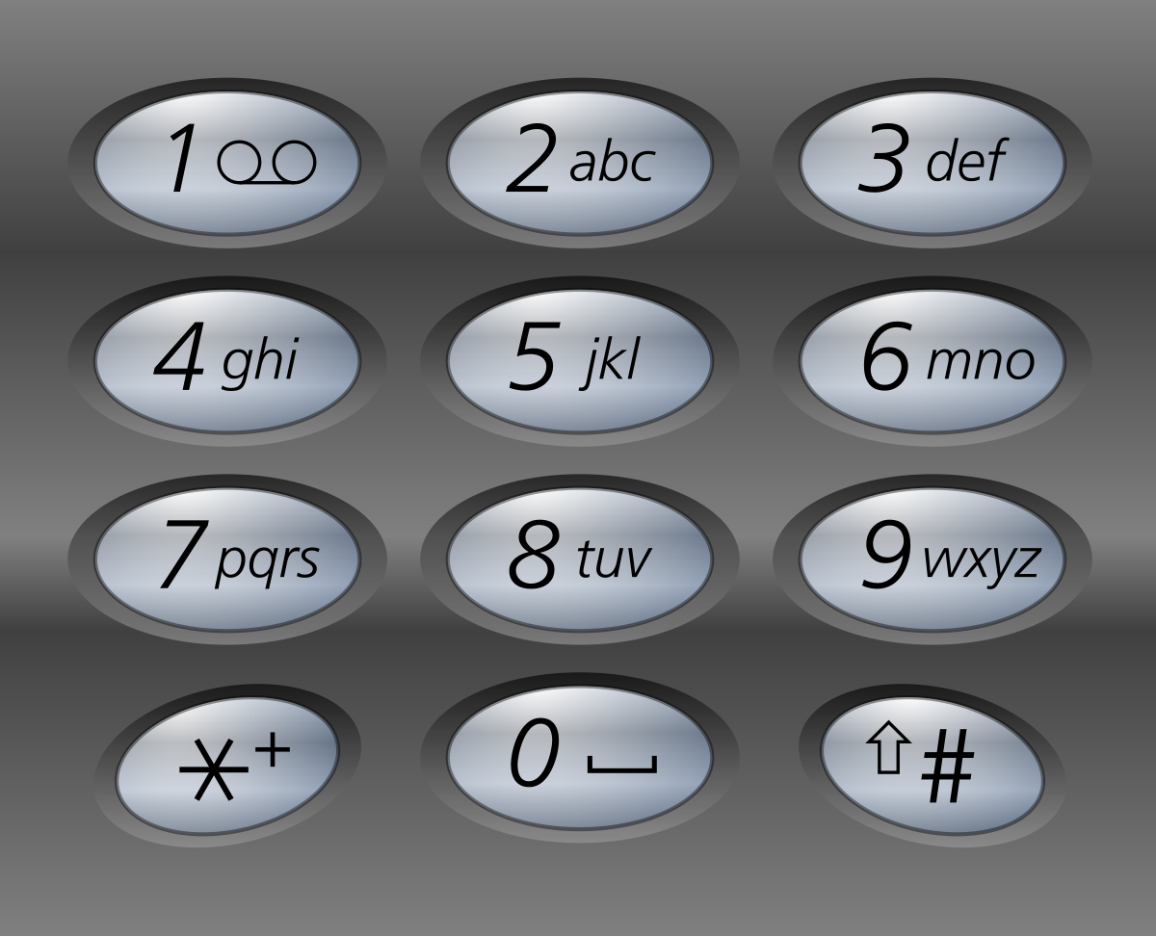

**Example 1:**

**Input:** digits = "23"

**Output:** ["ad","ae","af","bd","be","bf","cd","ce","cf"]

**Example 2:**

**Input:** digits = ""

**Output:** []

**Example 3:**

**Input:** digits = "2"

**Output:** ["a","b","c"]

**Constraints:**

* 0 <= digits.length <= 4
* digits[i] is a digit in the range ['2', '9'].
* class Solution {
* public:
* vector<string>result;
* void solve(int ind,string &digits,string &temp,unordered_map<char,string>&mp){
* if(ind>=digits.size()){
* result.push_back(temp);
* return ;
* }
* char ch=digits[ind];
* string str=mp[ch];
* for(int i=0;i<str.size();i++){
* temp.push_back(str[i]);
* solve(ind+1,digits,temp,mp);
* temp.pop_back();
* }
* }
* vector<string> letterCombinations(string digits) {
* if(digits.size()==0){
* return {};
* }
* unordered_map<char,string>mp;
* mp['2']="abc";
* mp['3']="def";
* mp['4']="ghi";
* mp['5']="jkl";
* mp['6']="mno";
* mp['7']="pqrs";
* mp['8']="tuv";
* mp['9']="wxyz";
* string temp;
* solve(0,digits,temp,mp);
* return result;
* }
* };

**322: Binary Watch**

A binary watch has 4 LEDs on the top to represent the hours (0-11), and 6 LEDs on the bottom to represent the minutes (0-59). Each LED represents a zero or one, with the least significant bit on the right.

* For example, the below binary watch reads "4:51".



Given an integer turnedOn which represents the number of LEDs that are currently on (ignoring the PM), return *all possible times the watch could represent*. You may return the answer in **any order**.

The hour must not contain a leading zero.

* For example, "01:00" is not valid. It should be "1:00".

The minute must be consist of two digits and may contain a leading zero.

* For example, "10:2" is not valid. It should be "10:02".

**Example 1:**

**Input:** turnedOn = 1

**Output:** ["0:01","0:02","0:04","0:08","0:16","0:32","1:00","2:00","4:00","8:00"]

**Example 2:**

**Input:** turnedOn = 9

**Output:** []

**Constraints:**

* 0 <= turnedOn <= 10
* #include <vector>
* #include <string>
* using namespace std;
* class Solution {
* public:
* vector<int> hours = {1, 2, 4, 8};
* vector<int> minutes = {1, 2, 4, 8, 16, 32};
* vector<string> res;
* void solve(pair<int, int> time, int turnedOn, int start) {
* if (turnedOn == 0) {
* res.push_back(to_string(time.first) + (time.second < 10 ? ":0" : ":") + to_string(time.second));
* return;
* }
* for (int i = start; i < hours.size() + minutes.size(); i++) {
* if (i < hours.size()) {
* time.first += hours[i];
* if (time.first < 12) {
* solve(time, turnedOn - 1, i + 1);
* }
* time.first -= hours[i];
* } else {
* time.second += minutes[i - hours.size()];
* if (time.second < 60) {
* solve(time, turnedOn - 1, i + 1);
* }
* time.second -= minutes[i - hours.size()];
* }
* }
* }
* vector<string> readBinaryWatch(int turnedOn) {
* solve(make_pair(0, 0), turnedOn, 0);
* return res;
* }
* };

**321: Word break 1**

Given a string s and a dictionary of strings wordDict, return true if s can be segmented into a space-separated sequence of one or more dictionary words.

**Note** that the same word in the dictionary may be reused multiple times in the segmentation.

**Example 1:**

**Input:** s = "leetcode", wordDict = ["leet","code"]

**Output:** true

**Explanation:** Return true because "leetcode" can be segmented as "leet code".

**Example 2:**

**Input:** s = "applepenapple", wordDict = ["apple","pen"]

**Output:** true

**Explanation:** Return true because "applepenapple" can be segmented as "apple pen apple".

Note that you are allowed to reuse a dictionary word.

**Example 3:**

**Input:** s = "catsandog", wordDict = ["cats","dog","sand","and","cat"]

**Output:** false

**Constraints:**

* 1 <= s.length <= 300
* 1 <= wordDict.length <= 1000
* 1 <= wordDict[i].length <= 20
* s and wordDict[i] consist of only lowercase English letters.
* All the strings of wordDict are **unique**.
* //using recursion and memoization
* class Solution {
* public:
* unordered_set<string>st;
* int dp[301];
* bool solve(string &s,int idx){
* if(idx==s.size()){
* return true;
* }
* if(dp[idx]!=-1){
* return dp[idx];
* }
* if(st.find(s)!=st.end()){
* return true;
* }
* for(int l=1;l<s.size();l++){
* string temp=s.substr(idx,l);
* if(st.find(temp)!=st.end() && solve(s,l+idx)){
* return dp[idx]=true;
* }
* }
* return dp[idx]= false;
* }
* bool wordBreak(string s, vector<string>& wordDict) {
* memset(dp,-1,sizeof(dp));
* for(int i=0;i<wordDict.size();i++){
* st.insert(wordDict[i]);
* }
* return solve(s,0);
* }
* };

/Approach-2 (Bottom Up DP)

class Solution {

public:

    bool solve(string s, vector<string>& wordDict) {

        unordered_set<string> st(begin(wordDict), end(wordDict));

        int n = s.length();

        vector<bool> t(n+1, false);

        /*

            t[i] = True;

            It means that for string of length i, its possible to break

            the word such that broken words are in wordDict

        */

        t[0] = true; //string of length 0 is always true

        for(int i = 1; i<=n; i++) {

            //we choose different point (j) to break

            for(int j = 0; j<i; j++) {

                string temp = s.substr(j, i-j);

                if(st.count(temp) && t[j]) {

                    /*

                        It means from s[j...i] is in wordDict

                        And, t[j] = true means s[0...j] could

                        also be broken correctly

                    */

                    t[i] = true;

                    break;

                }

            }

        }

        return t[n]; //length n

    }

    bool wordBreak(string s, vector<string>& wordDict) {

        return solve(s, wordDict);

    }

};

**322: Word break 2**

Given a string s and a dictionary of strings wordDict, add spaces in s to construct a sentence where each word is a valid dictionary word. Return all such possible sentences in **any order**.

**Note** that the same word in the dictionary may be reused multiple times in the segmentation.

**Example 1:**

**Input:** s = "catsanddog", wordDict = ["cat","cats","and","sand","dog"]

**Output:** ["cats and dog","cat sand dog"]

**Example 2:**

**Input:** s = "pineapplepenapple", wordDict = ["apple","pen","applepen","pine","pineapple"]

**Output:** ["pine apple pen apple","pineapple pen apple","pine applepen apple"]

**Explanation:** Note that you are allowed to reuse a dictionary word.

**Example 3:**

**Input:** s = "catsandog", wordDict = ["cats","dog","sand","and","cat"]

**Output:** []

**Constraints:**

* 1 <= s.length <= 20
* 1 <= wordDict.length <= 1000
* 1 <= wordDict[i].length <= 10
* s and wordDict[i] consist of only lowercase English letters.
* All the strings of wordDict are **unique**.
* Input is generated in a way that the length of the answer doesn't exceed 105.
* //using recursion only (implicit backtracking)
* class Solution {
* public:
* unordered_set<string>st;
* vector<string>ans;
* void solve(string s,int idx,string curr){
* if(idx==s.size()){
* curr.pop_back(); // removing the trailing spaces
* ans.push_back(curr);
* }
* string temp="";
* for(int i=idx;i<s.size();i++){
* temp.push_back(s[i]);
* if(st.find(temp)!=st.end()){
* solve(s,i+1,curr+temp+" ");
* }
* }
* }
* vector<string> wordBreak(string s, vector<string>& wordDict) {
* for(int i=0;i<wordDict.size();i++){
* st.insert(wordDict[i]);
* }
* string curr="";
* solve(s,0,curr);
* return ans;
* }
* };

**323: Minimum no of days to make m bouquets (binary search)**

You are given an integer array bloomDay, an integer m and an integer k.

You want to make m bouquets. To make a bouquet, you need to use k **adjacent flowers** from the garden.

The garden consists of n flowers, the ith flower will bloom in the bloomDay[i] and then can be used in **exactly one** bouquet.

Return *the minimum number of days you need to wait to be able to make*m*bouquets from the garden*. If it is impossible to make m bouquets return -1.

**Example 1:**

**Input:** bloomDay = [1,10,3,10,2], m = 3, k = 1

**Output:** 3

**Explanation:** Let us see what happened in the first three days. x means flower bloomed and _ means flower did not bloom in the garden.

We need 3 bouquets each should contain 1 flower.

After day 1: [x, _, _, _, _] // we can only make one bouquet.

After day 2: [x, _, _, _, x] // we can only make two bouquets.

After day 3: [x, _, x, _, x] // we can make 3 bouquets. The answer is 3.

**Example 2:**

**Input:** bloomDay = [1,10,3,10,2], m = 3, k = 2

**Output:** -1

**Explanation:** We need 3 bouquets each has 2 flowers, that means we need 6 flowers. We only have 5 flowers so it is impossible to get the needed bouquets and we return -1.

**Example 3:**

**Input:** bloomDay = [7,7,7,7,12,7,7], m = 2, k = 3

**Output:** 12

**Explanation:** We need 2 bouquets each should have 3 flowers.

Here is the garden after the 7 and 12 days:

After day 7: [x, x, x, x, _, x, x]

We can make one bouquet of the first three flowers that bloomed. We cannot make another bouquet from the last three flowers that bloomed because they are not adjacent.

After day 12: [x, x, x, x, x, x, x]

It is obvious that we can make two bouquets in different ways.

**Constraints:**

* bloomDay.length == n
* 1 <= n <= 105
* 1 <= bloomDay[i] <= 109
* 1 <= m <= 106
* 1 <= k <= n
* lass Solution {
* public:
* int minDays(vector<int>& bloomDay, int m, int k) {
* int low=*min_element(bloomDay.begin(),bloomDay.end());
* int high=*max_element(bloomDay.begin(),bloomDay.end());
* int res=-1;
* while(low<=high){
* int mid=low+(high-low)/2;
* int cnt=0,ans=0;
* for(int i=0;i<bloomDay.size();i++){
* if(bloomDay[i]<=mid){
* cnt++;
* if(cnt==k){
* ans++;
* cnt=0;
* }
* }
* else{
* cnt=0;
* }
* }
* if(ans>=m){
* res=mid;
* high=mid-1;
* }
* else{
* low=mid+1;
* }
* }
* return res;
* }
* };

**324: Magnetic Force between two balls**

In the universe Earth C-137, Rick discovered a special form of magnetic force between two balls if they are put in his new invented basket. Rick has n empty baskets, the ith basket is at position[i], Morty has m balls and needs to distribute the balls into the baskets such that the **minimum magnetic force** between any two balls is **maximum**.

Rick stated that magnetic force between two different balls at positions x and y is |x - y|.

Given the integer array position and the integer m. Return *the required force*.

**Example 1:**

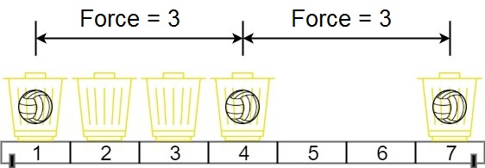

**Input:** position = [1,2,3,4,7], m = 3

**Output:** 3

**Explanation:** Distributing the 3 balls into baskets 1, 4 and 7 will make the magnetic force between ball pairs [3, 3, 6]. The minimum magnetic force is 3. We cannot achieve a larger minimum magnetic force than 3.

**Example 2:**

**Input:** position = [5,4,3,2,1,1000000000], m = 2

**Output:** 999999999

**Explanation:** We can use baskets 1 and 1000000000.

**Constraints:**

* n == position.length
* 2 <= n <= 105
* 1 <= position[i] <= 109
* All integers in position are **distinct**.
* 2 <= m <= position.length
* class Solution {
* public:
* int maxDistance(vector<int>& position, int m) {
* sort(position.begin(),position.end());
* int low=0; //min diff can be 0
* int high=position.back()-position.front(); // max diff can be=7-1
* int res=0;
* while(low<=high){
* int mid=low+(high-low)/2; //mid🡪force
* int ans=1;
* int curr=position[0];
* for(int i=1;i<position.size();i++){
* if(position[i]-curr>=mid){
* ans++;
* curr=position[i];
* }
* }
* if(ans>=m){
* res=mid;
* low=mid+1;
* }
* else{
* high=mid-1;
* }
* }
* return res;
* }
* };

**325: Predict the Winner**

You are given an integer array nums. Two players are playing a game with this array: player 1 and player 2.

Player 1 and player 2 take turns, with player 1 starting first. Both players start the game with a score of 0. At each turn, the player takes one of the numbers from either end of the array (i.e., nums[0] or nums[nums.length - 1]) which reduces the size of the array by 1. The player adds the chosen number to their score. The game ends when there are no more elements in the array.

Return true if Player 1 can win the game. If the scores of both players are equal, then player 1 is still the winner, and you should also return true. You may assume that both players are playing optimally.

**Example 1:**

**Input:** nums = [1,5,2]

**Output:** false

**Explanation:** Initially, player 1 can choose between 1 and 2.

If he chooses 2 (or 1), then player 2 can choose from 1 (or 2) and 5. If player 2 chooses 5, then player 1 will be left with 1 (or 2).

So, final score of player 1 is 1 + 2 = 3, and player 2 is 5.

Hence, player 1 will never be the winner and you need to return false.

**Example 2:**

**Input:** nums = [1,5,233,7]

**Output:** true

**Explanation:** Player 1 first chooses 1. Then player 2 has to choose between 5 and 7. No matter which number player 2 choose, player 1 can choose 233.

Finally, player 1 has more score (234) than player 2 (12), so you need to return True representing player1 can win.

**Constraints:**

* 1 <= nums.length <= 20
* 0 <= nums[i] <= 107
* //optimal game ques where each player wants to maximize their score , considering one player if it takes the max then he should expect min or worst from the result as other player will try to maximize his score
* //rec+memo
* class Solution {
* public:
* int n;
* int dp[21][21];
* int solve(vector<int>& nums, int l, int r) {
* if (l > r) {
* return 0;
* }
* if (l == r) {
* dp[l][r] = nums[l];
* return nums[l];
* }
* if (dp[l][r] != -1) {
* return dp[l][r];
* }
* //if left taken
* int take_left = nums[l] + min(solve(nums, l + 2, r),
* // if right taken
* solve(nums, l + 1, r - 1)); //left liya and then next move wo min expect krega if wo left or right me jo leta hai
* int take_right = nums[r] + min(solve(nums, l, r - 2), solve(nums, l + 1, r - 1));//right liya and then next move wo min expect krega if wo left or right me jo leta hai
* return dp[l][r] = max(take_left, take_right);
* }
* bool predictTheWinner(vector<int>& nums) {
* int total = accumulate(nums.begin(), nums.end(), 0);
* memset(dp, -1, sizeof(dp));
* n = nums.size();
* int player1 = solve(nums, 0, n - 1); // Writing recursion for player 1 only
* int player2 = total - player1;
* return player1 >= player2;
* }
* };
* //Recursion + Memo - II
* //Approach-2 (Using diff of score between players)
* class Solution {
* public:
* int n;
* int t[23][23];
* //Player1 - Player2
* int maxDiff(vector<int>& nums, int l, int r) {
* if(l == r)
* return nums[l];
* if(t[l][r] != -1)
* return t[l][r];
* int take_left  = nums[l] - maxDiff(nums, l+1, r);
* int take_right = nums[r] - maxDiff(nums, l, r-1);
* return t[l][r] = max(take_left, take_right);
* }
* bool PredictTheWinner(vector<int>& nums) {
* n = nums.size();
* memset(t, -1, sizeof(t));
* return maxDiff(nums, 0, n-1) >= 0;
* }
* };

**326: Assign Cookies (greedy) two pointer**

Assume you are an awesome parent and want to give your children some cookies. But, you should give each child at most one cookie.

Each child i has a greed factor g[i], which is the minimum size of a cookie that the child will be content with; and each cookie j has a size s[j]. If s[j] >= g[i], we can assign the cookie j to the child i, and the child i will be content. Your goal is to maximize the number of your content children and output the maximum number.

**Example 1:**

**Input:** g = [1,2,3], s = [1,1]

**Output:** 1

**Explanation:** You have 3 children and 2 cookies. The greed factors of 3 children are 1, 2, 3.

And even though you have 2 cookies, since their size is both 1, you could only make the child whose greed factor is 1 content.

You need to output 1.

**Example 2:**

**Input:** g = [1,2], s = [1,2,3]

**Output:** 2

**Explanation:** You have 2 children and 3 cookies. The greed factors of 2 children are 1, 2.

You have 3 cookies and their sizes are big enough to gratify all of the children,

You need to output 2.

**Constraints:**

* 1 <= g.length <= 3 * 104
* 0 <= s.length <= 3 * 104
* 1 <= g[i], s[j] <= 231 - 1
* //two pointer and sorting
* class Solution {
* public:
* int findContentChildren(vector<int>& g, vector<int>& s) {
* sort(g.begin(),g.end());
* sort(s.begin(),s.end());
* int cnt=0;
* int i=g.size()-1,j=s.size()-1;
* while(i>=0 && j>=0){
* if(s[j]>=g[i]){
* i--;
* j--;
* cnt++;
* }
* else{
* i--;
* }
* }
* return cnt;
* }
* };

**327: Array partition (greedy+sorting)**

Given an integer array nums of 2n integers, group these integers into n pairs (a1, b1), (a2, b2), ..., (an, bn) such that the sum of min(ai, bi) for all i is **maximized**. Return*the maximized sum*.

**Example 1:**

**Input:** nums = [1,4,3,2]

**Output:** 4

**Explanation:** All possible pairings (ignoring the ordering of elements) are:

1. (1, 4), (2, 3) -> min(1, 4) + min(2, 3) = 1 + 2 = 3

2. (1, 3), (2, 4) -> min(1, 3) + min(2, 4) = 1 + 2 = 3

3. (1, 2), (3, 4) -> min(1, 2) + min(3, 4) = 1 + 3 = 4

So the maximum possible sum is 4.

**Example 2:**

**Input:** nums = [6,2,6,5,1,2]

**Output:** 9

**Explanation:** The optimal pairing is (2, 1), (2, 5), (6, 6). min(2, 1) + min(2, 5) + min(6, 6) = 1 + 2 + 6 = 9.

**Constraints:**

* 1 <= n <= 104
* nums.length == 2 * n
* -104 <= nums[i] <= 104
* class Solution {
* public:
* int arrayPairSum(vector<int>& nums) {
* int sum=0;
* sort(nums.begin(),nums.end());
* for(int i=0;i<nums.size();i=i+2){
* sum+=(nums[i]);
* }
* return sum;
* }
* };

**328: Minimize maximum pair sum in an array (greedy + sorting)**

The **pair sum** of a pair (a,b) is equal to a + b. The **maximum pair sum** is the largest **pair sum** in a list of pairs.

* For example, if we have pairs (1,5), (2,3), and (4,4), the **maximum pair sum** would be max(1+5, 2+3, 4+4) = max(6, 5, 8) = 8.

Given an array nums of **even** length n, pair up the elements of nums into n / 2 pairs such that:

* Each element of nums is in **exactly one** pair, and
* The **maximum pair sum**is **minimized**.

Return *the minimized****maximum pair sum****after optimally pairing up the elements*.

**Example 1:**

**Input:** nums = [3,5,2,3]

**Output:** 7

**Explanation:** The elements can be paired up into pairs (3,3) and (5,2).

The maximum pair sum is max(3+3, 5+2) = max(6, 7) = 7.

**Example 2:**

**Input:** nums = [3,5,4,2,4,6]

**Output:** 8

**Explanation:** The elements can be paired up into pairs (3,5), (4,4), and (6,2).

The maximum pair sum is max(3+5, 4+4, 6+2) = max(8, 8, 8) = 8.

**Constraints:**

* n == nums.length
* 2 <= n <= 105
* n is **even**.
* 1 <= nums[i] <= 105
* class Solution {
* public:
* int minPairSum(vector<int>& nums) {
* sort(nums.begin(),nums.end());
* int n=nums.size();
* int ans=0;
* for(int i=0;i<(n/2);i++){
* ans=max(ans,nums[i]+nums[n-1-i]);
* }
* return ans;
* }
* };

**329: Find The value of the partition**

You are given a **positive** integer array nums.

Partition nums into two arrays, nums1 and nums2, such that:

* Each element of the array nums belongs to either the array nums1 or the array nums2.
* Both arrays are **non-empty**.
* The value of the partition is **minimized**.

The value of the partition is |max(nums1) - min(nums2)|.

Here, max(nums1) denotes the maximum element of the array nums1, and min(nums2) denotes the minimum element of the array nums2.

Return *the integer denoting the value of such partition*.

**Example 1:**

**Input:** nums = [1,3,2,4]

**Output:** 1

**Explanation:** We can partition the array nums into nums1 = [1,2] and nums2 = [3,4].

- The maximum element of the array nums1 is equal to 2.

- The minimum element of the array nums2 is equal to 3.

The value of the partition is |2 - 3| = 1.

It can be proven that 1 is the minimum value out of all partitions.

**Example 2:**

**Input:** nums = [100,1,10]

**Output:** 9

**Explanation:** We can partition the array nums into nums1 = [10] and nums2 = [100,1].

- The maximum element of the array nums1 is equal to 10.

- The minimum element of the array nums2 is equal to 1.

The value of the partition is |10 - 1| = 9.

It can be proven that 9 is the minimum value out of all partitions.

**Constraints:**

* 2 <= nums.length <= 105
* 1 <= nums[i] <= 109
* class Solution {
* public:
* int findValueOfPartition(vector<int>& nums) {
* sort(nums.begin(),nums.end());
* int mini_diff=INT_MAX;
* for(int i=0;i<nums.size()-1;i++){
* mini_diff=min(mini_diff,nums[i+1]-nums[i]);
* }
* return mini_diff;
* }
* };

**330: find the shortest distance between any pair of two good nodes**

[**https://www.geeksforgeeks.org/find-the-shortest-distance-between-any-pair-of-two-different-good-nodes/**](https://www.geeksforgeeks.org/find-the-shortest-distance-between-any-pair-of-two-different-good-nodes/)

**331: Recover binary search tree**

You are given the root of a binary search tree (BST), where the values of **exactly** two nodes of the tree were swapped by mistake. *Recover the tree without changing its structure*.

**Example 1:**

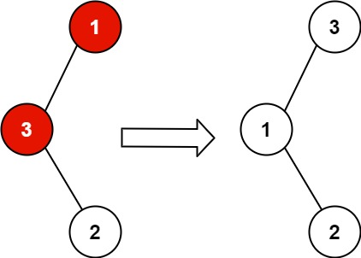

**Input:** root = [1,3,null,null,2]

**Output:** [3,1,null,null,2]

**Explanation:** 3 cannot be a left child of 1 because 3 > 1. Swapping 1 and 3 makes the BST valid.

**Example 2:**

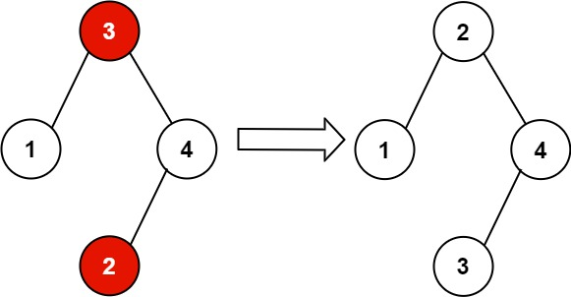

**Input:** root = [3,1,4,null,null,2]

**Output:** [2,1,4,null,null,3]

**Explanation:** 2 cannot be in the right subtree of 3 because 2 < 3. Swapping 2 and 3 makes the BST valid.

**Constraints:**

* The number of nodes in the tree is in the range [2, 1000].
* -231 <= Node.val <= 231 - 1

**Follow up:** A solution using O(n) space is pretty straight-forward. Could you devise a constant O(1) space solution?

//sol1

class Solution {

public:

    TreeNode* incorrectNode1;

    TreeNode* incorrectNode2;

    void inorder(TreeNode* root, vector<int>& in) {

        if (root == nullptr) {

            return;

        }

        inorder(root->left, in);

        in.push_back(root->val);

        inorder(root->right, in);

    }

    void check(TreeNode* root, vector<int>& in, int& i) {

        if (root == nullptr) {

            return;

        }

        check(root->left, in, i);

        if (in[i++] != root->val) {

            if (incorrectNode1 == nullptr) {

                incorrectNode1 = root;

            }

            else if (incorrectNode2 == nullptr) {

                incorrectNode2 = root;

            }

        }

        check(root->right, in, i);

    }

    void recoverTree(TreeNode* root) {

        incorrectNode1 = nullptr;

        incorrectNode2 = nullptr;

        vector<int> in;

        inorder(root, in);

        sort(in.begin(), in.end());

        int i = 0;

        check(root, in, i);

        swap(incorrectNode1->val, incorrectNode2->val);

    }

};*/

sol2:

class Solution {

public:

    TreeNode *first;

    TreeNode *middle;

    TreeNode *prev;

    TreeNode *last;

    void inorder(TreeNode *root){

        if(root==NULL){

            return ;

        }

        inorder(root->left);

        if(prev!=NULL && (root->val < prev->val)){

            if(first==NULL){

                first=prev;

                middle=root;

            }

            else{

                last=root;

            }

        }

        prev=root;

        inorder(root->right);

    }

    void recoverTree(TreeNode* root) {

        first=middle=last=NULL;

        prev=new TreeNode(INT_MIN);

        inorder(root);

        if(first !=NULL && last!=NULL){

            swap(first->val , last->val);

        }

        else if(first !=NULL && middle!=NULL){

            swap(first->val , middle->val);

        }

    }

};

**332: Unique binary search tree**

Given an integer n, return *the number of structurally unique****BST'****s (binary search trees) which has exactly*n*nodes of unique values from* 1 *to* n.

**Example 1:**

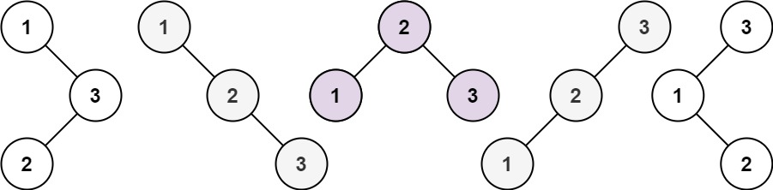

**Input:** n = 3

**Output:** 5

**Example 2:**

**Input:** n = 1

**Output:** 1

**Constraints:**

* 1 <= n <= 19
* //bottom up approach
* class Solution {
* public:
* int numTrees(int n) {
* vector<int> dp(n + 1, 0);
* dp[0] = 1;
* for (int i = 1; i <= n; i++) {
* for (int j = 1; j <= i; j++) {
* dp[i] += dp[j - 1] * dp[i - j];
* }
* }
* return dp[n];
* }
* };
* */
* class Solution {
* public:
* vector<vector<int>>memo;
* int countUniqueBST(int start, int end) {
* if (start > end) {
* return 1;
* }
* if (memo[start][end] != -1) {
* return memo[start][end];
* }
* int totalCount = 0;
* for (int i = start; i <= end; i++) {
* int leftCount = countUniqueBST(start, i - 1);
* int rightCount = countUniqueBST(i + 1, end);
* totalCount += leftCount * rightCount;
* }
* return memo[start][end] = totalCount;
* }
* int numTrees(int n) {
* memo.resize(n + 1, vector<int>(n + 1, -1));
* return countUniqueBST(1, n);
* }
* };

**333: Unique Binary search trees 2**

Given an integer n, return *all the structurally unique****BST'****s (binary search trees), which has exactly*n*nodes of unique values from* 1 *to* n. Return the answer in **any order**.

**Example 1:**



**Input:** n = 3

**Output:** [[1,null,2,null,3],[1,null,3,2],[2,1,3],[3,1,null,null,2],[3,2,null,1]]

**Example 2:**

**Input:** n = 1

**Output:** [[1]]

**Constraints:**

* 1 <= n <= 8
* /**
* * Definition for a binary tree node.
* * struct TreeNode {
* *     int val;
* *     TreeNode *left;
* *     TreeNode *right;
* *     TreeNode() : val(0), left(nullptr), right(nullptr) {}
* *     TreeNode(int x) : val(x), left(nullptr), right(nullptr) {}
* *     TreeNode(int x, TreeNode *left, TreeNode *right) : val(x), left(left), right(right) {}
* * };
* */
* class Solution {
* public:
* vector<TreeNode*>solve(int start,int end){
* vector<TreeNode*>ans;
* //base condition
* if(start>end){
* ans.push_back(NULL);
* }
* for(int i=start ;i<=end;i++){
* vector<TreeNode*>left=solve(start,i-1);
* vector<TreeNode*>right=solve(i+1,end);
* //connecting nodes
* for(int j=0;j<left.size();j++){
* for(int k=0;k<right.size();k++){
* TreeNode *root=new TreeNode(i);
* root->left=left[j];
* root->right=right[k];
* ans.push_back(root);
* }
* }
* }
* return ans;
* }
* vector<TreeNode*> generateTrees(int n) {
* return solve(1,n);
* }
* };*/
* //Approach-1 Recursion - ACCEPTED
* class Solution {
* public:
* vector<TreeNode*> solve(int start, int end) {
* if(start > end) {
* return {NULL};
* }
* if(start == end) {
* TreeNode* root = new TreeNode(start);
* return {root};
* }

* vector<TreeNode*> result;
* for(int i = start; i <= end; i++) {
* vector<TreeNode*> leftList  = solve(start, i-1);
* vector<TreeNode*> rightList = solve(i+1, end);
* for(TreeNode* leftRoot : leftList) {
* for(TreeNode* rightRoot : rightList) {
* TreeNode* root = new TreeNode(i);
* root->left  = leftRoot;
* root->right = rightRoot;
* result.push_back(root);
* }
* }
* }
* return result;
* }
* vector<TreeNode*> generateTrees(int n) {
* return solve(1, n);
* }
* };
* */
* //Approach-2 Recursion + Memo - ACCEPTED
* class Solution {
* public:
* map<pair<int, int>, vector<TreeNode*>> mp;
* vector<TreeNode*> solve(int start, int end) {
* if(start > end) {
* return {NULL};
* }
* if(start == end) {
* TreeNode* root = new TreeNode(start);
* return {root};
* }
* if(mp.find({start, end}) != mp.end())
* return mp[{start, end}];
* vector<TreeNode*> result;
* for(int i = start; i <= end; i++) {
* vector<TreeNode*> leftList  = solve(start, i-1);// give the left sub bst like b1,b2,b3
* vector<TreeNode*> rightList = solve(i+1, end);// give the right sub bst like b1,b2,b3
* for(TreeNode* leftRoot : leftList) {
* for(TreeNode* rightRoot : rightList) {
* TreeNode* root = new TreeNode(i);
* root->left  = leftRoot;
* root->right = rightRoot;
* result.push_back(root);
* }
* }
* }
* return mp[{start, end}] = result;
* }
* vector<TreeNode*> generateTrees(int n) {
* return solve(1, n);
* }
* };

**334: All possible full binary trees**

Given an integer n, return *a list of all possible****full binary trees****with* n *nodes*. Each node of each tree in the answer must have Node.val == 0.

Each element of the answer is the root node of one possible tree. You may return the final list of trees in **any order**.

A **full binary tree** is a binary tree where each node has exactly 0 or 2 children.

**Example 1:**



**Input:** n = 7

**Output:** [[0,0,0,null,null,0,0,null,null,0,0],[0,0,0,null,null,0,0,0,0],[0,0,0,0,0,0,0],[0,0,0,0,0,null,null,null,null,0,0],[0,0,0,0,0,null,null,0,0]]

**Example 2:**

**Input:** n = 3

**Output:** [[0,0,0]]

**Constraints:**

* 1 <= n <= 20
* class Solution {
* public:
* unordered_map<int,vector<TreeNode*>>mp;
* vector<TreeNode*> solve(int n){
* //base condition
* if(n%2==0){
* return {};
* }
* if(n==1){
* TreeNode* root=new TreeNode(0);
* return {root};a
* }
* if(mp.find(n)!=mp.end()){
* return mp[n];
* }
* vector<TreeNode*>result;
* for(int i=1;i<n;i+=2){
* vector<TreeNode*>leftAllFBT=solve(i);  //left me i nodes honge
* vector<TreeNode*>rightAllFBT=solve(n-i-1); //right me n-i-1 nodes honge uske liye recursive call kr rhe
* for(auto &l:leftAllFBT){
* for(auto &r:rightAllFBT){
* TreeNode* root=new TreeNode(0);
* root->left=l;
* root->right=r;
* result.push_back(root);
* }
* }
* }
* return mp[n]=result;
* }
* vector<TreeNode*> allPossibleFBT(int n) {
* return solve(n);
* }
* };

**335: Minimize the maximum difference of pairs**

You are given a **0-indexed** integer array nums and an integer p. Find p pairs of indices of nums such that the **maximum** difference amongst all the pairs is **minimized**. Also, ensure no index appears more than once amongst the p pairs.

Note that for a pair of elements at the index i and j, the difference of this pair is |nums[i] - nums[j]|, where |x| represents the **absolute** **value** of x.

Return *the****minimum******maximum****difference among all*p *pairs.* We define the maximum of an empty set to be zero.

**Example 1:**

**Input:** nums = [10,1,2,7,1,3], p = 2

**Output:** 1

**Explanation:** The first pair is formed from the indices 1 and 4, and the second pair is formed from the indices 2 and 5.

The maximum difference is max(|nums[1] - nums[4]|, |nums[2] - nums[5]|) = max(0, 1) = 1. Therefore, we return 1.

**Example 2:**

**Input:** nums = [4,2,1,2], p = 1

**Output:** 0

**Explanation:** Let the indices 1 and 3 form a pair. The difference of that pair is |2 - 2| = 0, which is the minimum we can attain.

**Constraints:**

* 1 <= nums.length <= 105
* 0 <= nums[i] <= 109
* 0 <= p <= (nums.length)/2
* class Solution {
* public:

    int n;

* bool check(vector<int>&nums,int mid,int p ){
* int pairs=0;
* int i=0;

    while(i<n-1){

* if(nums[i+1]-nums[i]<=mid){
* pairs++;
* i=i+2;
* }
* else{
* i++;
* }
* }
* return pairs>=p;
* }
* int minimizeMax(vector<int>& nums, int p) {
* n=nums.size();
* sort(nums.begin(),nums.end());
* int ans=0;
* //low and high signifying the difference
* Isliye hmlog check function pe check krenge ki jo diff hai wo kya mid wale se chota ya equal aa rh hai yadi aa rhai hai to shih hai pairs possibly bnega
* int low=0,high=nums[n-1]-nums[0];
* while(low<=high){
* int mid=low+(high-low)/2;
* //now we will check for validity
* if(check(nums,mid,p)){
* ans=mid;
* high=mid-1;
* }
* else{
* low=mid+1;
* }
* }
* return ans;
* }
* };

**336: Search in a rotated sorted array**

There is an integer array nums sorted in ascending order (with **distinct** values).

Prior to being passed to your function, nums is **possibly rotated** at an unknown pivot index k (1 <= k < nums.length) such that the resulting array is [nums[k], nums[k+1], ..., nums[n-1], nums[0], nums[1], ..., nums[k-1]] (**0-indexed**). For example, [0,1,2,4,5,6,7] might be rotated at pivot index 3 and become [4,5,6,7,0,1,2].

Given the array nums **after** the possible rotation and an integer target, return *the index of*target*if it is in*nums*, or*-1*if it is not in*nums.

You must write an algorithm with O(log n) runtime complexity.

**Example 1:**

**Input:** nums = [4,5,6,7,0,1,2], target = 0

**Output:** 4

**Example 2:**

**Input:** nums = [4,5,6,7,0,1,2], target = 3

**Output:** -1

**Example 3:**

**Input:** nums = [1], target = 0

**Output:** -1

**Constraints:**

* 1 <= nums.length <= 5000
* -104 <= nums[i] <= 104
* All values of nums are **unique**.
* nums is an ascending array that is possibly rotated.
* -104 <= target <= 104
* /*class Solution {
* public:
* int search(vector<int>& nums, int target) {
* for(int i=0;i<nums.size();i++){
* if(nums[i]==target){
* return i;
* }
* }
* return -1;
* }
* };*/
* Sol2:
* class Solution {
* public:
* int solve(vector<int>&A, int n, int target) {
* int lo=0,hi=n-1;
* // find the index of the smallest value using binary search.
* // Loop will terminate since mid < hi, and lo or hi will shrink by at least 1.
* // Proof by contradiction that mid < hi: if mid==hi, then lo==hi and loop would have been terminated.
* while(lo<hi){
* int mid=(lo+hi)/2;
* if(A[mid]>A[hi]) lo=mid+1;
* else hi=mid;
* }
* // lo==hi is the index of the smallest value and also the number of places rotated.
* int rot=lo;
* lo=0;hi=n-1;
* // The usual binary search and accounting for rotation.
* while(lo<=hi){
* int mid=(lo+hi)/2;
* int realmid=(mid+rot)%n;
* if(A[realmid]==target)return realmid;
* if(A[realmid]<target)lo=mid+1;
* else hi=mid-1;
* }
* return -1;
* }
* int search(vector<int>& nums, int target) {
* int n=nums.size();;
* return solve(nums,n,target);
* }
* };
* Sol3:
* class Solution {
* public:
* int search(vector<int>& nums, int target) {
* int l = 0;
* int r = nums.size() - 1;
* while(l <= r)
* {
* int mid = l + (r-l) / 2;
* if (nums[mid] == target)
* return mid;
* // with duplicates we can have this contdition, just update left & right
* if((nums[l] == nums[mid]) && (nums[r] == nums[mid]))
* {
* l++;
* r--;
* }
* // first half
* // first half is in order
* else if(nums[l] <= nums[mid])
* {
* // target is in first  half
* if((nums[l] <= target) && (nums[mid] > target))
* r = mid - 1;
* else
* l = mid + 1;
* }
* // second half
* // second half is order
* // target is in second half
* else
* {
* if(((nums[r]>= target) && nums[mid] < target))
* l = mid + 1;
* else
* r = mid - 1;
* }
* }
* return -1;
* }
* };